STAKEHOLDER WORKFLOWS AND UX BLUEPRINT
Amaravati Capital City: 2D drawing journey for every user
Companion to the clickable prototype, the public submission standard and the implementation guide
Version 1.3 | Draft for review | 28 September 2026

1. Purpose and how to use this document
This document describes, for each stakeholder, what they need to do in the building permission portal, in what order, and what the screen should do to make that easy. Every workflow has a flowchart and a step table. The screens named here exist as artboards in the clickable prototype. Sections 13 and 14 list every screen with its fields, actions and next step.
It is written for the product owner, the UX team and the developers building the 2D drawing scrutiny flow. It sits alongside three other documents: the public 2D submission standard (what applicants must follow), the implementation guide (how the ACadSharp validation engine is built) and the SOP.
Note: Portal observations come from the public BBAS home page and public coverage of BuildNow. No logged-in screens were reviewed, so pain points below are hypotheses to test with real users. Anything shown as [in brackets] is a placeholder for a value CRDA must supply: thresholds, SLA days, department names.
Scope of this version
- Amaravati Capital City area only, under the Zoning Regulations of February 2016 (with later amendments to be confirmed). The wider Capital Region is not covered.
- Permits are Development Permission Orders (DPO) issued by the Commissioner, with the 60-day decision limit, followed by commencement, completion and occupancy.
- R1 village plots have their own screens and rules: abutting road, road handover with TDR, and the exemption for small plots.
- Fees follow the regulations (basis, exemptions, impact fee, mortgage). Rates are placeholders until CRDA supplies the notified schedule.
- Section 15 gives the detail, with regulation numbers, and lists what CRDA must confirm.

2. What we looked at

BBAS (current APCRDA portal)
- The home page is a set of link lists grouped by user type: Citizen Service (pay fees, search status), Developer and TPAs (registration, renewal, consent links), and LTP (registration, renewal, consent link, view).
- BBAS is built around a single 3D BIM model (architectural, structural and MEP) that is scrutinised and tracked; fire, high-rise and environmental NOCs are integrated in the same system.
- Help lives in downloads: manuals, a modelling guide video, do's and don'ts and Revit plugins. The helpdesk entry is marked as coming soon.
- The page offers screen-reader access and text-size controls, and the header is bilingual (English and Telugu).

BuildNow (Telangana)
- The applicant's category depends on plot size and building details: registration only, instant approval, or single window. The portal shows which applies before the applicant starts.
- Small residential projects can be approved on self-certification, with an official follow-up check afterwards.
- Land ownership and survey details are verified automatically against land-records systems.
- Officials get an operational dashboard, and applicants get an AI policy assistant for rules questions.

What this means for a 2D flow
Your workflow is 2D DWG/DXF, not BIM, so BBAS's modelling guidance does not carry over directly. The transferable ideas are: choose the route first, show one tracker to everyone, check the file at upload time, pre-fill from official records, and let officials work on exceptions instead of re-checking everything.

3. Design principles
Principle | What it means on screen
Route first | Ask three questions, then show the route, documents, fees and timeline before the applicant uploads anything.
One tracker for all | Applicant, LTP, officer and commissioner see the same seven stages and the same clock.
Fix it before it is filed | The drawing check runs at upload. Problems appear on the drawing itself, not in a rejection letter.
Exceptions only | Officials see what needs a decision. Everything the system verified is collapsed.
Never a dead end | Every failed or returned step sits beside a next action, a deadline and a person to contact.
Plain words | Sentence case, verbs first, dates in full (Oct 3, 2026), Telugu and English side by side.
Status is never colour alone | Every status has an icon and a word. Works for colour-blind users and in print.
Phone friendly | Applicants track, pay and reply from a phone. Drawing upload stays on desktop.

4. Stakeholders at a glance
Stakeholder | Main goal | Likely friction to validate today | Key screens
Applicant or owner | Get a permit without visiting an office | Unsure which route applies; status lives in a separate search | Landing wizard, applicant workspace, mobile tracker
LTP or architect | Submit a clean drawing first time | Errors found after submission; separate consent links | Upload and live check, exception report
Developer | Manage many projects and give consents in one place | Separate registration, renewal and consent links | Project portfolio (next round)
Scrutiny officer | Decide only what needs judgement | Re-checking items a system can verify | Scrutiny workbench, drawing viewer
NOC departments (fire services and others) | Clear NOCs on one clock | Files reach departments sequentially and without context | NOC queue
Commissioner | Approve with full context | Decisions without seeing NOC and officer advice together | Approvals list, delay view
Chief City Planner and Executive Committee | Decide conditional uses, variances and appeals fairly and on time | Hearings, notices and decisions tracked outside the file | Case screens (E1 to E3)
Accounts | Reconcile fees without chasing files | Fee status not visible to the file owner | Fees screen (next round)
System admin (CAD and GIS cell) | Keep standards current without code changes | Standards baked into software releases | Rules and standards

5. Shared model used by every workflow

Seven-stage journey
Every application moves through the same seven stages. The tracker shows them to every stakeholder, with the stage owner and due date.
No. | Stage | Owner | Exit condition
1 | Pick a category | Applicant | Route, documents and fees shown; application started
2 | Upload and live check | LTP | Zero unresolved exceptions in the automatic check
3 | Pay fees | Applicant | Scrutiny fee received (other charges may fall due later)
4 | Scrutiny | Officer | All exceptions accepted, or sent back with a comment
5 | NOCs | Departments | All required NOCs issued, in parallel
6 | Approval | Commissioner | Approved, or sent back with reason and next step
7 | Permit issued | System | Digital permit with QR code generated

Status vocabulary
Word shown | Meaning | Always paired with
Done / Passed / Issued | Success | Check icon, green soft background
In progress / In scrutiny / Waiting for you | Pending | Clock icon, amber soft background
Returned / With LTP / Query | Needs a fix | Alert icon, red soft background, plus the next step

After the permission order
No. | Stage | Owner | Exit condition
8 | Commencement notice and line-out check | Owner, Commissioner | Line-out checked within 7 days; work starts within one year of the order
9 | Construction and inspections | Owner, officer | Stage inspections recorded; any deviation sanctioned first
10 | Completion and occupancy certificate | Owner, Commissioner | Certificate issued within 15 days (deemed if not decided); mortgage released

Rules that apply everywhere
- One clock per stage. A query pauses the clock for that stage only and tells the applicant exactly what to send.
- Every action is written to an audit log with who, what, when and the file revision.
- A resubmitted drawing is a new revision (R0, R1, R2). The exception report keeps history across revisions.
- Notifications go by SMS, email and in-app, and always link to the exact screen where the action happens.
- Rule changes apply to new submissions only. Files in progress keep the standards version they started with.
- All objections are given in one go. After the applicant complies, new objections are not normally raised (Reg 212.3), so the officer step collects every exception in one decision.

6. End-to-end flow
Read left to right. Lanes show who acts. Teal boxes are done automatically by the system.
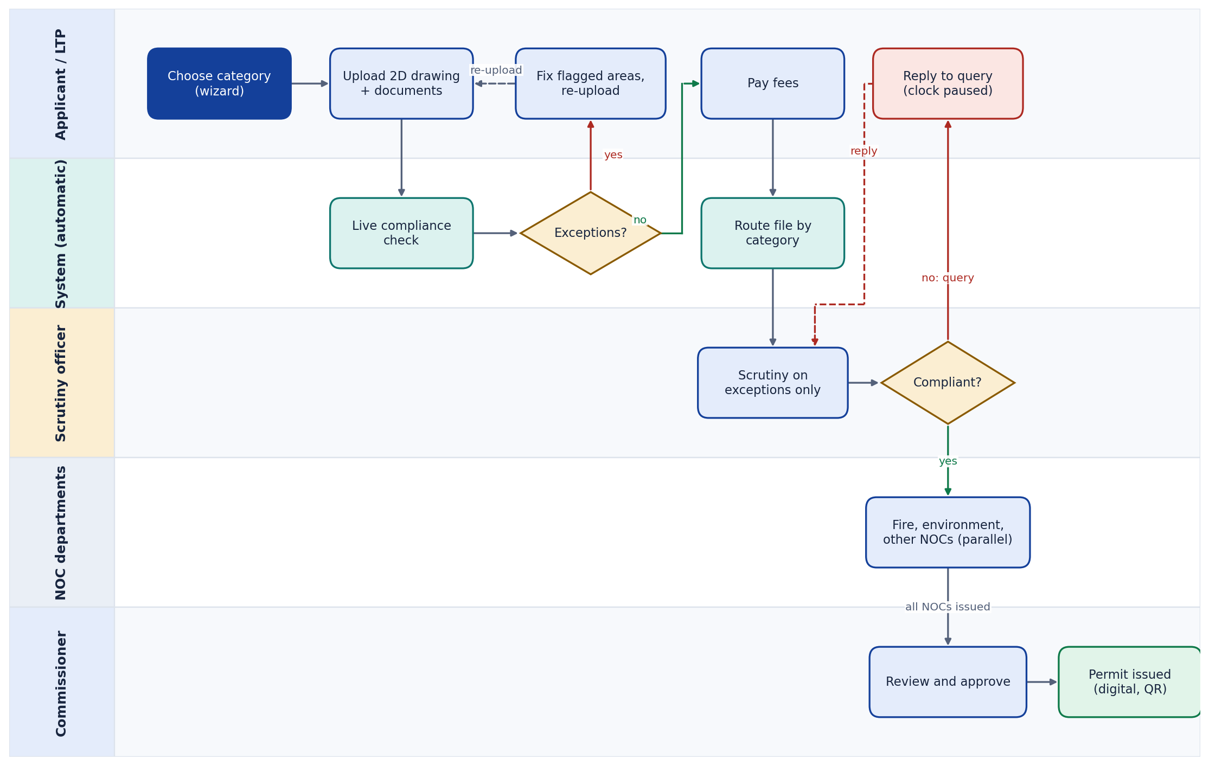
Figure 1. End-to-end journey across stakeholders

7. Workflow by stakeholder

7.1 Applicant or owner
The applicant should never need to understand the rules. The wizard decides the route, the workspace shows what to do next.
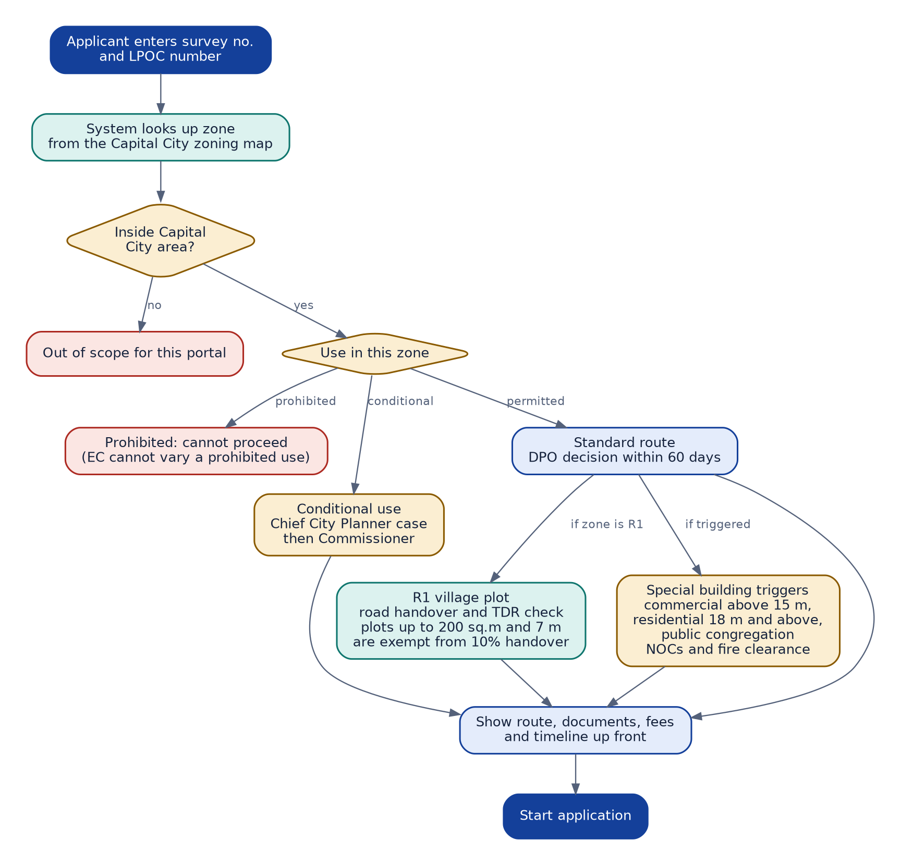
Figure 2. Zone and route check at the start
No. | Step | Screen | Result
1 | Enter survey number and ownership certificate number; the zone is looked up | Landing page, zoning check | Zone, use status, route, documents, fees and the 60-day limit shown
2 | Start application; four steps: project details, people, documents, review; then zoning check and, for R1 plots, road handover and TDR | New application (wizard), zoning check | Draft created with a reference number
3 | Appoint an LTP or upload through own LTP | Applicant workspace | LTP gets a consent request
4 | Pay scrutiny fee | Fees card, mobile Pay tab | Receipt; stage 3 done
5 | Reply to any officer query | Messages card | Clock resumes
6 | Download the permission order | Applicant workspace | Digital order with QR code
7 | Send commencement notice; later apply for the occupancy certificate | After the permission order | Line-out checked; certificate issued in 15 days
Ease features: one tracker instead of a separate status search; a single 'Needs your reply' card at the top; full-word dates; reply from a phone.

7.2 LTP or architect
This is the workflow that carries your unclassified-area clause. The check runs while the LTP is still on the upload screen.
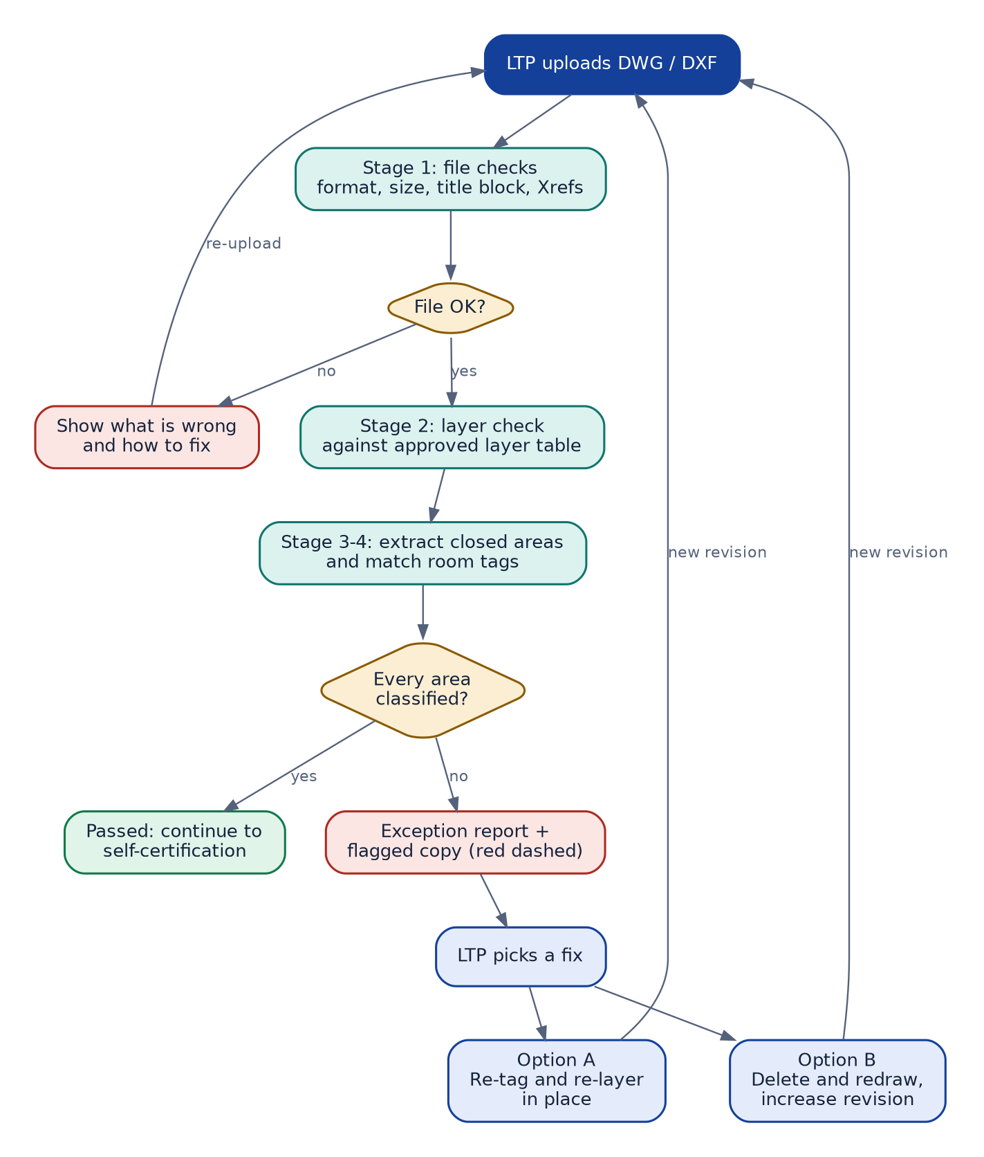
Figure 3. Upload, live check and fixing unclassified areas
No. | Step | Screen | Result
1 | Upload DWG or DXF and supporting documents | Upload and live check | Check starts immediately
2 | Read the check result: file, layers, room classification | Live check panel | Each item shows Passed or a count to fix
3 | Select an unclassified area | Findings list and drawing | Area highlighted with reason, size, layer and closest approved name
4 | Fix using Option A (re-tag, re-layer) or Option B (delete, redraw, increase revision) | Own CAD software | Revised file ready
5 | Upload the new revision | Upload and live check | Check re-runs; Continue unlocks at zero exceptions
6 | Self-certify and submit | Self-certification | File enters stage 3
Note: The system never changes the LTP's drawing. It draws flagged areas on a copy and lists them in an exception report. Corrections are always made by the LTP.

7.3 Developer
A developer runs several projects with several LTPs. The current portal has separate registration, renewal and consent links; the target is one project list.
No. | Step | Screen | Result
1 | Register or renew once | Developer profile | Valid registration shown on every project
2 | See all projects with stage and next action | Project portfolio | One row per project
3 | Give or withdraw consent for an LTP or TPA | Project detail | Consent recorded in audit log
4 | Pay fees for several projects together | Fees | One receipt, allocated per project
Note: The developer portfolio is in the prototype as the Developer screen.

7.4 Scrutiny officer
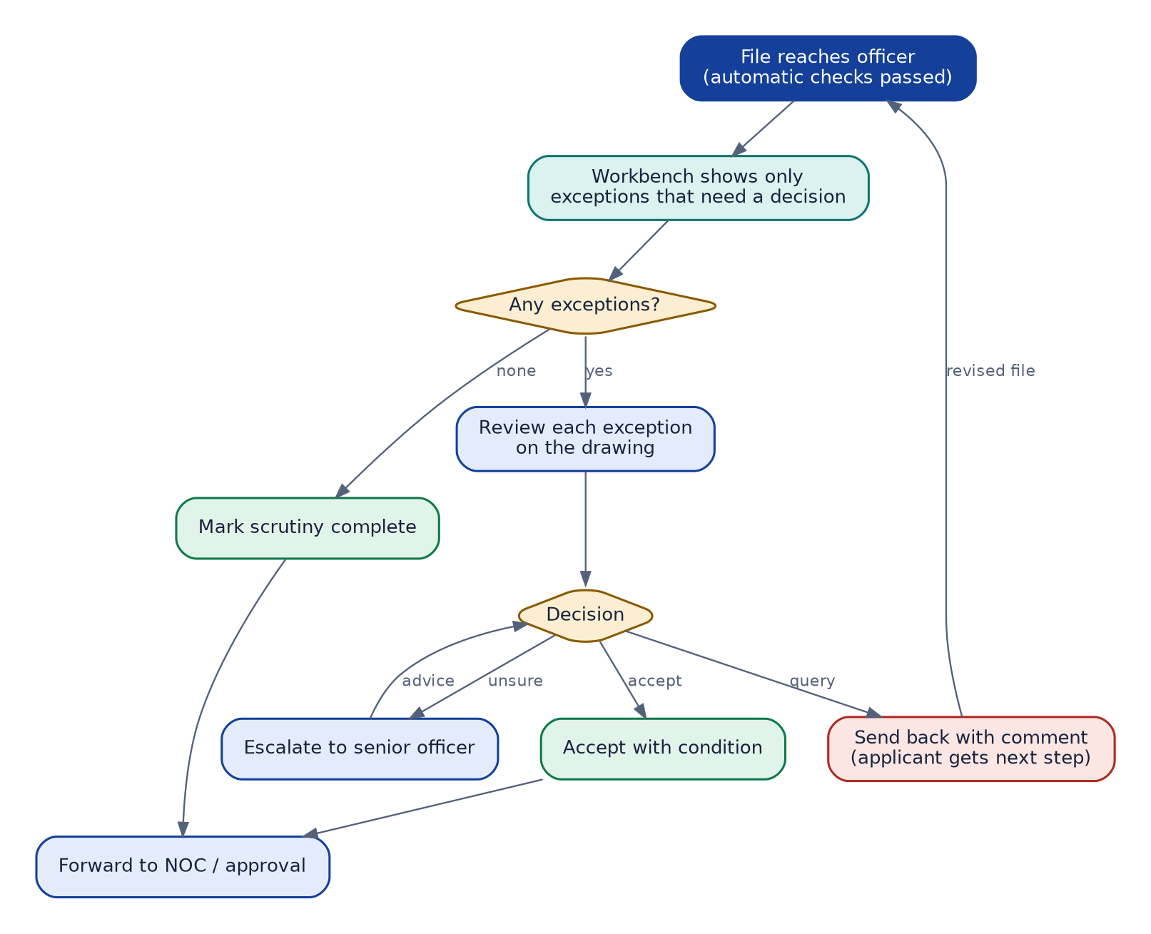
Figure 4. Officer scrutiny on exceptions
No. | Step | Screen | Result
1 | Open the workbench; queue is sorted by due date | Scrutiny workbench | Assigned, needs-decision and due-soon counts
2 | Open a file; see only exceptions needing a decision | File view | Automatic checks collapsed as Passed
3 | Inspect each exception on the drawing | Officer drawing review | Flagged line or area highlighted; layers can be toggled
4 | Accept with condition, send back with comment, or escalate | Decision buttons | Applicant gets the comment and next step
5 | Mark scrutiny complete | File view | Stage 4 done; NOC tasks open

7.5 NOC departments and Commissioner
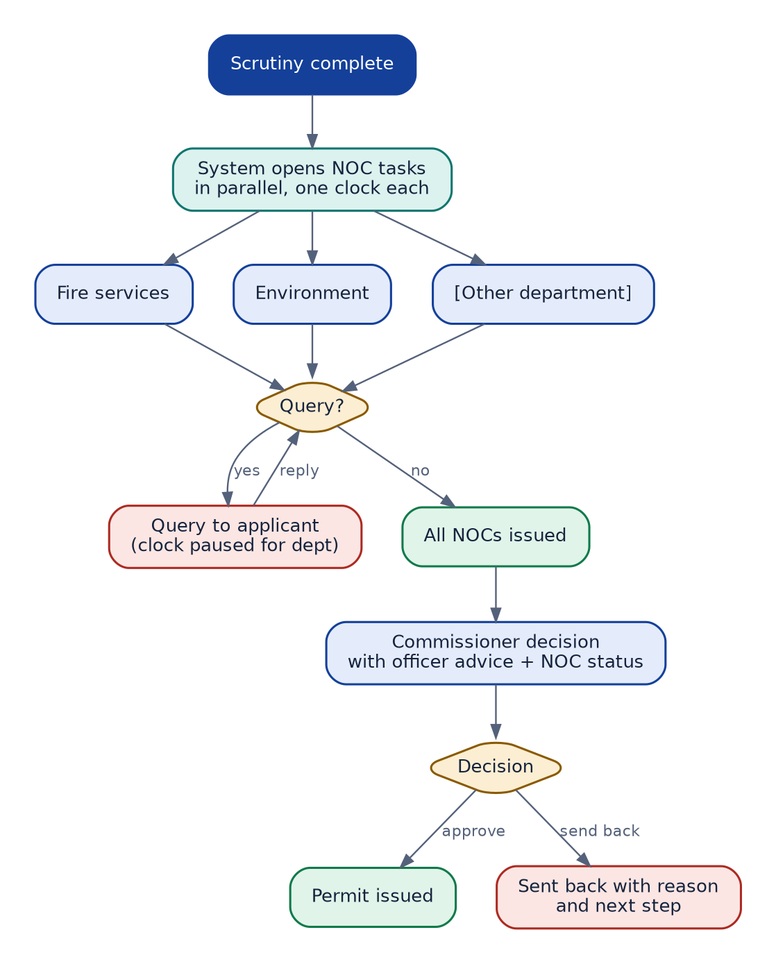
Figure 5. Parallel NOCs, then commissioner decision
No. | Step | Screen | Result
1 | Department opens its queue; files arrive in parallel | NOC queue | One row per file, own due date
2 | Review documents; issue NOC or raise a query | NOC review panel | Comment required for a query
3 | Commissioner sees officer advice and NOC status together | Approvals list | Approve, review or send back
4 | Send back always carries reason and applicant's next step | Approvals list | No unexplained rejections

7.6 Accounts
No. | Step | Screen | Result
1 | Fee received through payment gateway | Fees | Status updated on the applicant's tracker
2 | Reconcile daily; flag mismatches | Fees ledger | Exceptions list
3 | Issue refunds or adjustments with a reason | Fees ledger | Audit entry and applicant notification
Note: The fees ledger is in the prototype as the Accounts screen.

7.7 System admin (CAD and GIS cell)
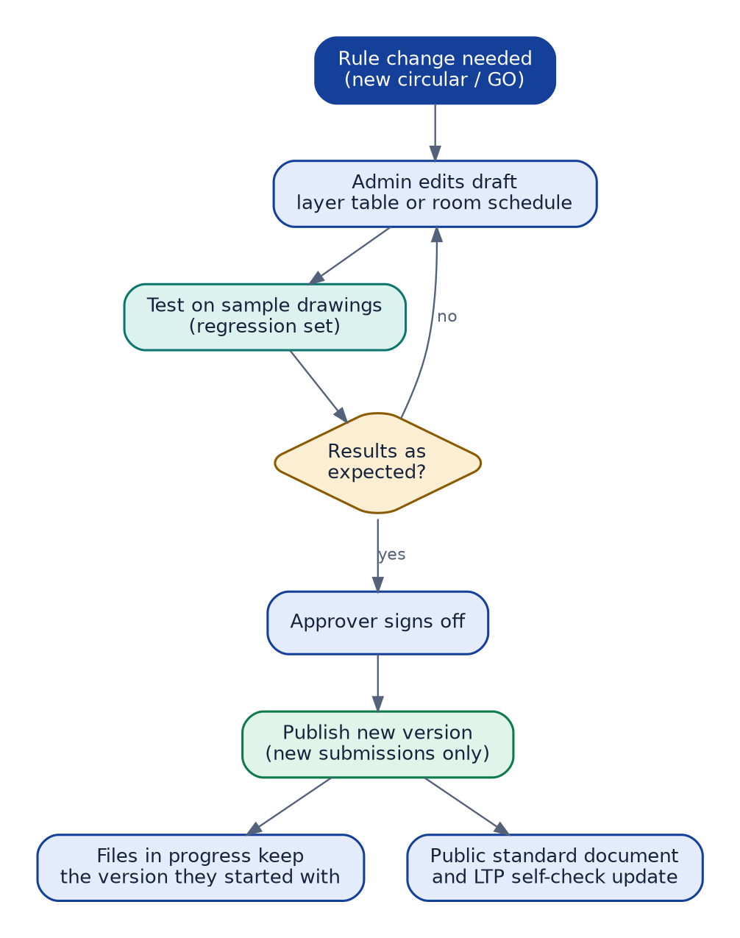
Figure 6. Changing standards safely
No. | Step | Screen | Result
1 | Edit draft layer table or room schedule | Rules and standards | Draft version created
2 | Test against sample drawings | Test panel | Results compared with expected
3 | Approver signs off | Rules and standards | Ready to publish
4 | Publish; applies to new submissions | Rules and standards | Public standard and LTP self-check update

7.8 After the permission order
The regulations continue after the order is issued. The owner must start within one year, mark the line-out, and later ask for an occupancy certificate. No one may occupy the building without it.
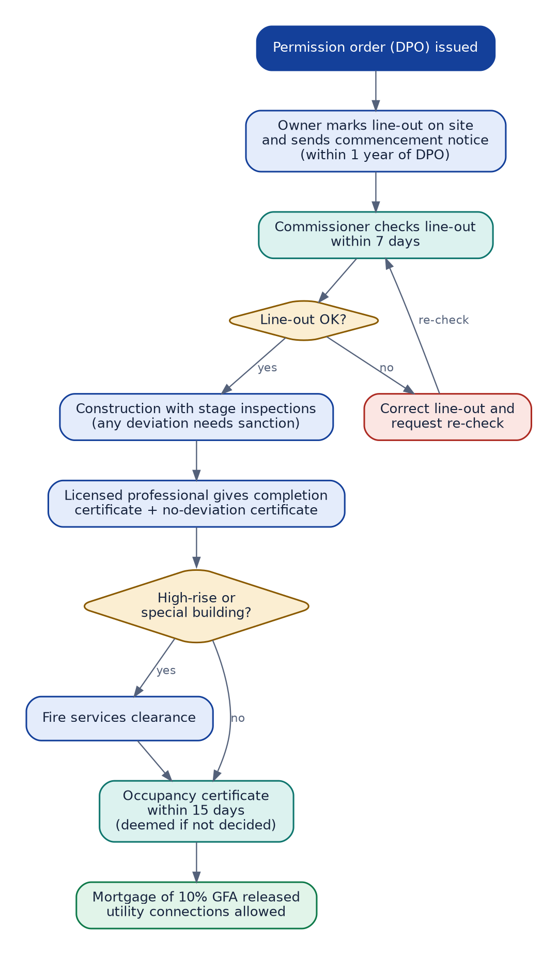
Figure 7. Commencement, inspection and occupancy
No. | Step | Screen | Result
1 | Mark the line-out on site and send the commencement notice | Commencement notice (A9) | Commissioner checks within 7 days
2 | Officer records the line-out result and later inspections | Line-out check and inspection (O6) | Deviations flagged for sanction
3 | Licensed professional certifies completion and no deviation | Completion and occupancy (A10) | Application for the occupancy certificate
4 | High-rise and special buildings get fire clearance first | Completion and occupancy (A10) | Clearance attached
5 | Authority issues the certificate within 15 days | Commissioner approvals | Mortgage released; utility connections allowed

7.9 Conditional use, variance and appeal
Some cases need a hearing. The Chief City Planner prepares the case, notice goes to neighbours and is posted on the site, and the Commissioner or Executive Committee decides. An appeal must be filed within 10 working days.
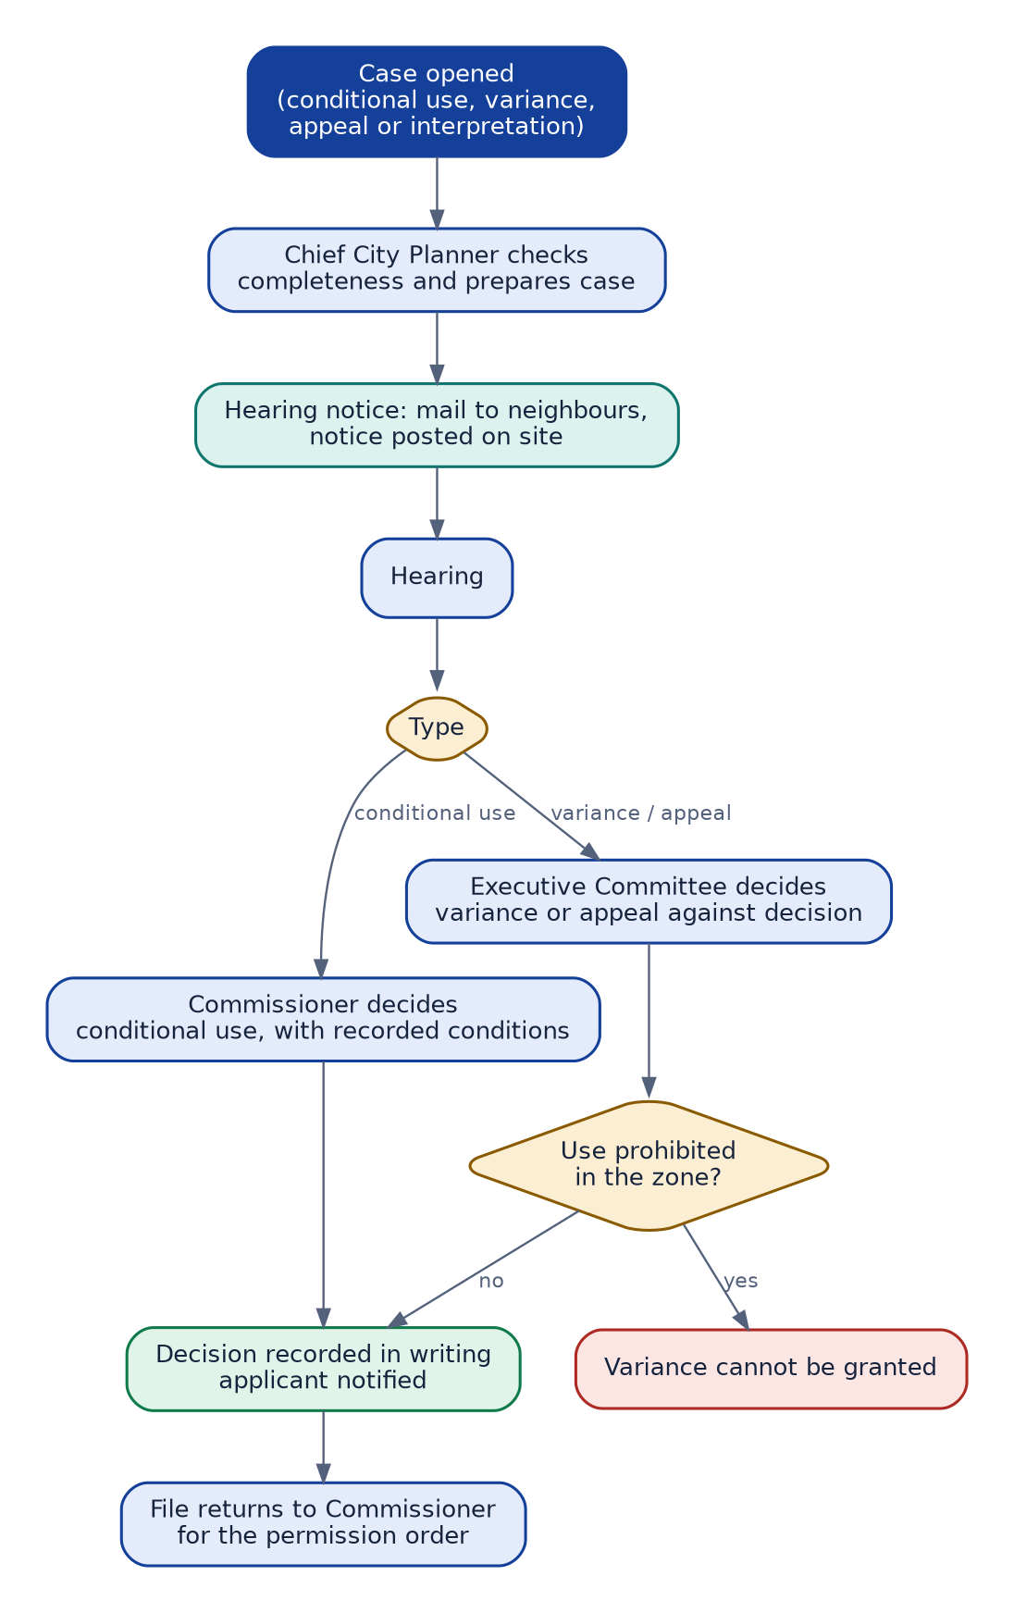
Figure 8. Case handling by the Chief City Planner and Executive Committee
No. | Step | Screen | Result
1 | Open the case and check it is complete | Open a case (E1) | Case ready for hearing
2 | Give hearing notice: mail to neighbours, notice on site | Hearing notice (E2) | Hearing date fixed
3 | Decide and record reasons in writing | Decision (E3) | Applicant notified; file returns to the Commissioner

8. Advanced features that make it easy
Feature | What the user gets | Where it appears
Zone and route check | Zone looked up from the map; route, documents, fees and the 60-day limit before any upload | Landing page, zoning check
Zoning table check | Use status, FSI, coverage, height, setbacks and parking shown for the plot | Zoning check
R1 village support | Road width, road handover, TDR and small-plot exemption in one place | Zoning check, admin village settings
Live drawing check | Problems found while the LTP is still on the upload screen | Upload and live check
Highlight on the drawing | Flagged areas outlined on the plan, with reason and closest approved name | Live check, officer viewer
Next best action | One card per role: what needs you right now | Every workspace
Single tracker | Same seven stages and clock for everyone | Applicant, mobile, officer
Exceptions only | Officials skip what the system verified | Scrutiny workbench, drawing review
Parallel NOCs | Departments work at the same time | NOC queue
Versioned standards | Rules change without redeploying software | Rules and standards
Rules assistant | Answers 'why was this flagged?' in plain language | Help panel (proposed)
Bilingual and accessible | Telugu and English, screen-reader friendly, adjustable text | All screens

9. Accessibility, language and mobile
- Buttons and links are at least 44px tall; keyboard focus is always visible.
- Text contrast meets 4.5:1; status never relies on colour alone.
- Telugu and English on every label; dates in full words.
- Track, pay and reply work on a phone. DWG upload is desktop only, with a clear message on mobile.
- Screen-reader access and text-size controls stay, as on the current portal.

10. How to measure success
Measure | Why it matters | Target
Share of files with zero exceptions on first upload | Shows the standard and live check are working | [target]
Average revisions per application | Fewer loops means less rework | [target]
Days per stage against SLA | Finds where files wait | [SLA days]
Officer time per file | Exceptions-only should reduce it | [target]
Applicant help requests per 100 files | Confusion signal | [target]
Mobile task completion (track, pay, reply) | Ease for citizens | [target]

11. Open items and placeholders
- R1 zoning table values (FSI, coverage, height, setbacks, parking) from Appendix II and III, and the same for other zones.
- The notified fee rates: application fee, development charges, impact fee, compounding fee and revalidation fee, with the order numbers.
- SLA days per stage and per department.
- The authoritative layer table and room classification schedule.
- Whether land records and the LPOC register can be checked automatically.
- Amendments to the 2016 regulations, including the environment-clearance gazette amendment and the R5 affordable housing zone.
- Whether the Amaravati Government Complex is in scope; it has its own 2024 zoning regulations.
- What the 'TPA' role in the current portal covers; it is not modelled yet.
- Payment gateway and receipt rules for Accounts.
- Developer portfolio and Accounts screens to be added to the prototype.

12. Suggested rollout
Phase | Scope | Exit test
1. Foundation | Landing wizard, applicant workspace, one tracker, LTP upload with live check | Pilot LTPs reach zero exceptions on first upload
2. Officials | Scrutiny workbench, drawing viewer, NOC queue, commissioner approvals | Officer time per file falls against baseline
3. Complete | Rules assistant, mobile polish, full data integration | All stakeholders on one login

13. Screen map
Every screen has an ID. The same IDs are used in the prototype board titles and in the specifications that follow. Screens marked 'Described here only' are specified but not yet drawn in the prototype.
ID | Screen | Stakeholder | Prototype board
A1 | Find your zone and route | Applicant or owner | Landing with category wizard
A2 | Project details | Applicant or owner | New application, four steps
A2b | Zoning check | Applicant or owner | ZoningCheck.dc.html
A2c | Road handover and TDR (R1) | Applicant or owner | ZoningCheck.dc.html
A3 | People | Applicant or owner | New application, four steps
A4 | Documents | Applicant or owner | New application, four steps
A5 | Review and submit | Applicant or owner | New application, four steps
A6 | Fee summary | Applicant or owner | Pay fees, 3 steps
A6b | Pay | Applicant or owner | Pay fees, 3 steps
A6c | Receipt | Applicant or owner | Pay fees, 3 steps
A7 | Track and reply | Applicant or owner | Applicant workspace
A8 | Download permission order | Applicant or owner | Applicant workspace
A9 | Commencement notice | Applicant or owner | PostPermitSteps.dc.html
A10 | Completion and occupancy | Applicant or owner | PostPermitSteps.dc.html
L1 | Consent request | LTP or architect | Described here only
L2 | Upload drawing | LTP or architect | LTP upload and live check
L3 | Live check and fix | LTP or architect | LTP upload and live check
L4 | Declarations | LTP or architect | LTP self-certify and submit
L4b | Sign | LTP or architect | LTP self-certify and submit
L5 | Submit | LTP or architect | LTP self-certify and submit
L6 | Answer an officer query | LTP or architect | Described here only
D1 | Register or renew | Developer | Described here only
D2 | Project portfolio | Developer | Developer project portfolio
D3 | Consent management | Developer | Described here only
D4 | Pay for several projects | Developer | Described here only
O1 | Workbench queue | Scrutiny officer | Scrutiny workbench
O2 | File summary | Scrutiny officer | Officer scrutiny, 4 steps
O3 | Review exceptions | Scrutiny officer | Officer scrutiny, 4 steps; Officer drawing review
O4 | Decide | Scrutiny officer | Officer scrutiny, 4 steps
O5 | Forward | Scrutiny officer | Officer scrutiny, 4 steps
O6 | Line-out check and inspection | Scrutiny officer | Described here only
N1 | NOC queue | NOC departments | NOC department queue
N2 | Check documents | NOC departments | NOC review and issue
N3 | Assess | NOC departments | NOC review and issue
N4 | Issue NOC | NOC departments | NOC review and issue
C1 | Decision list | Commissioner | Commissioner approvals
C2 | Review file | Commissioner | Commissioner decide and issue
C3 | Decide | Commissioner | Commissioner decide and issue
C4 | Sign and issue | Commissioner | Commissioner decide and issue
E1 | Open a case | Chief City Planner and Executive Committee | VarianceSteps.dc.html
E2 | Hearing notice | Chief City Planner and Executive Committee | VarianceSteps.dc.html
E3 | Decision | Chief City Planner and Executive Committee | VarianceSteps.dc.html
AC1 | Payments list | Accounts | Accounts fees ledger
AC2 | Match payment | Accounts | Accounts resolve payment
AC3 | Resolve | Accounts | Accounts resolve payment
AC4 | Confirm | Accounts | Accounts resolve payment
AC5 | Daily report | Accounts | Described here only
AD1 | Users and roles | System admin | Admin users and roles
AD1a | Add user: person | System admin | Admin add user, 4 steps
AD1b | Add user: role and office | System admin | Admin add user, 4 steps
AD1c | Add user: access | System admin | Admin add user, 4 steps
AD1d | Add user: confirm | System admin | Admin add user, 4 steps
AD2 | Offices and jurisdictions | System admin | Admin offices and jurisdictions
AD3 | Workflow and SLA | System admin | Admin workflow and SLA
AD4 | Route and trigger rules | System admin | Admin category rules
AD5 | Fee schedule | System admin | Admin fee schedule
AD5b | Deposits and security | System admin | Admin fee schedule
AD10 | Zoning table | System admin | AdminZoning.dc.html
AD11 | Village (R1) settings | System admin | AdminVillage.dc.html
AD12 | Zoning map and land records | System admin | AdminMap.dc.html
AD6 | Layer table and room schedule | System admin | Admin: room schedule
AD7 | Notification templates | System admin | Admin notification templates
AD8 | Audit log and reports | System admin | Admin audit log
AD9 | Publish a version | System admin | Admin: room schedule

14. Screen specifications by stakeholder
Each screen starts with a simple page layout drawn from its field list, followed by the fields, the actions available and what happens next. In the layouts, a red star marks a required field and multi-page tasks show their steps across the top. Field types describe the control the user sees. 'Required' means the user cannot move on without it. Values in [brackets] are set by CRDA.
Note: Rules such as file size limits, thresholds and SLA days are placeholders. Field lists are a starting point for review with each office, not a final data dictionary.

14.1 Applicant or owner (Citizen)
Page sequence: A1 > A2 > A2b > A2c > A3 > A4 > A5 > A6 > A6b > A6c > A7 > A8 > A9 > A10. Each page below starts with a simple layout, then lists its fields, actions and next step.

A1 Find your zone and route
Prototype: Landing with category wizard
Enter the plot and the proposal. The portal looks up the zone from the Capital City zoning map and shows the route, documents, fees and the 60-day decision limit before anything is uploaded.
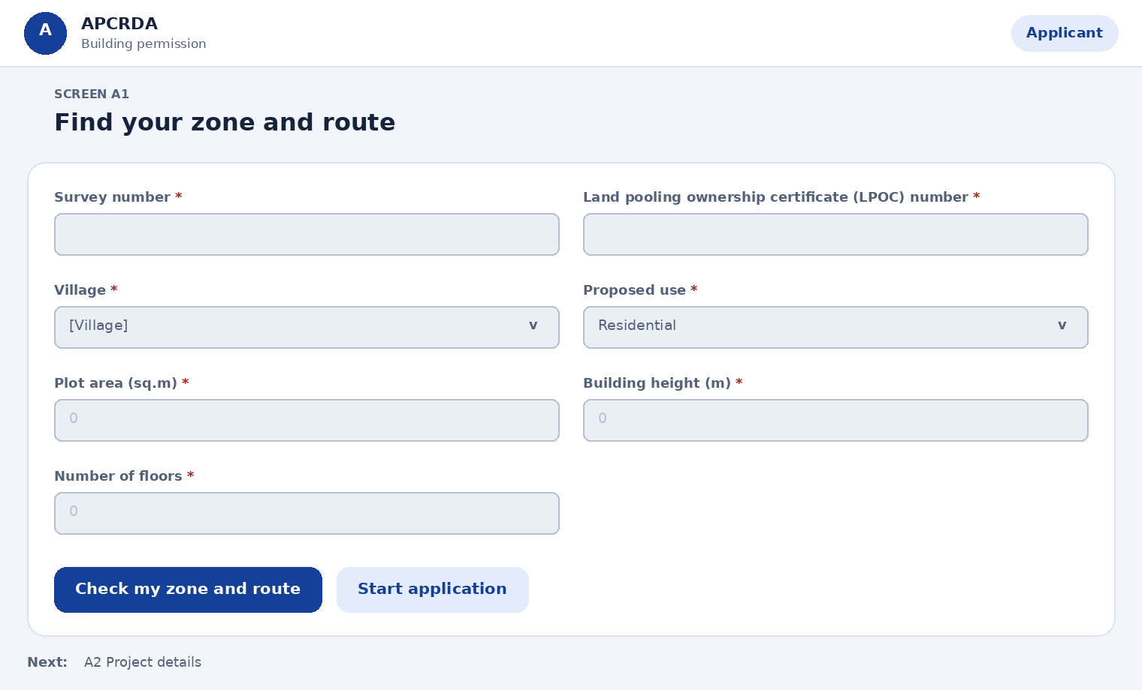
Fields on this page
Field | Type | Required | Notes
Survey number | Text | Yes | Zone is looked up from the Capital City zoning map
Land pooling ownership certificate (LPOC) number | Text | Yes | Or an equivalent ownership document for land outside land pooling
Village | Choose one | Yes | Villages inside the Capital City area. Options: [Village]
Proposed use | Choose one | Yes | Options: Residential, Commercial, Institutional, Industrial, Mixed use
Plot area (sq.m) | Number | Yes | -
Building height (m) | Number | Yes | -
Number of floors | Number | Yes | -
Actions
Action | What happens
Check my zone and route | Shows zone, whether the use is permitted, conditional or prohibited, route, documents, fees and timeline
Start application | Creates a draft with a reference number
Next step: A2 Project details

A2 Project details
Prototype: New application, four steps
Confirm the site facts. Zone and plot area come from records; you add the rest.
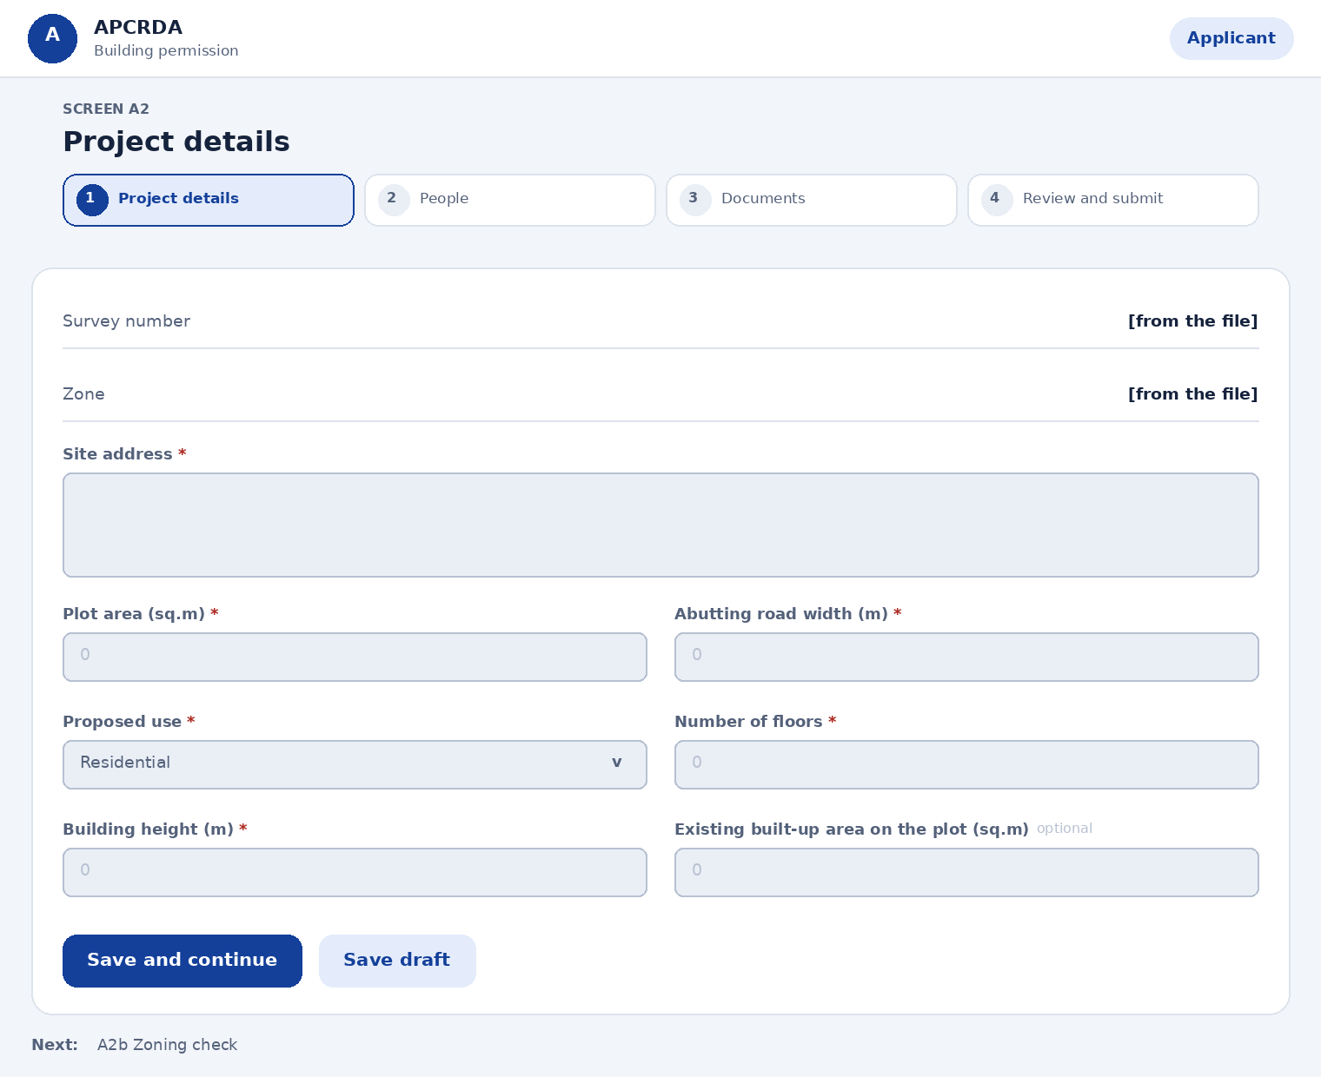
Fields on this page
Field | Type | Required | Notes
Survey number | Shown, not editable | Yes | From the previous step
Zone | Shown, not editable | Yes | Looked up from the zoning map
Site address | Long text | Yes | -
Plot area (sq.m) | Number | Yes | Pre-filled from records where available
Abutting road width (m) | Number | Yes | R1 needs an abutting road of at least 9 m; apartments need access by a 12 m wide existing road (Reg 401.5)
Proposed use | Choose one | Yes | Options: Residential, Commercial, Institutional, Mixed use
Number of floors | Number | Yes | -
Building height (m) | Number | Yes | Measured as defined in the regulations, including stilt parking
Existing built-up area on the plot (sq.m) | Number | No | Existing buildings count toward gross floor area and coverage
Actions
Action | What happens
Save and continue | Saves the draft and opens People
Save draft | Saves without moving on
Next step: A2b Zoning check

A2b Zoning check
Prototype: ZoningCheck.dc.html
The system compares your proposal with the zoning table for your zone and shows the result before you go further.
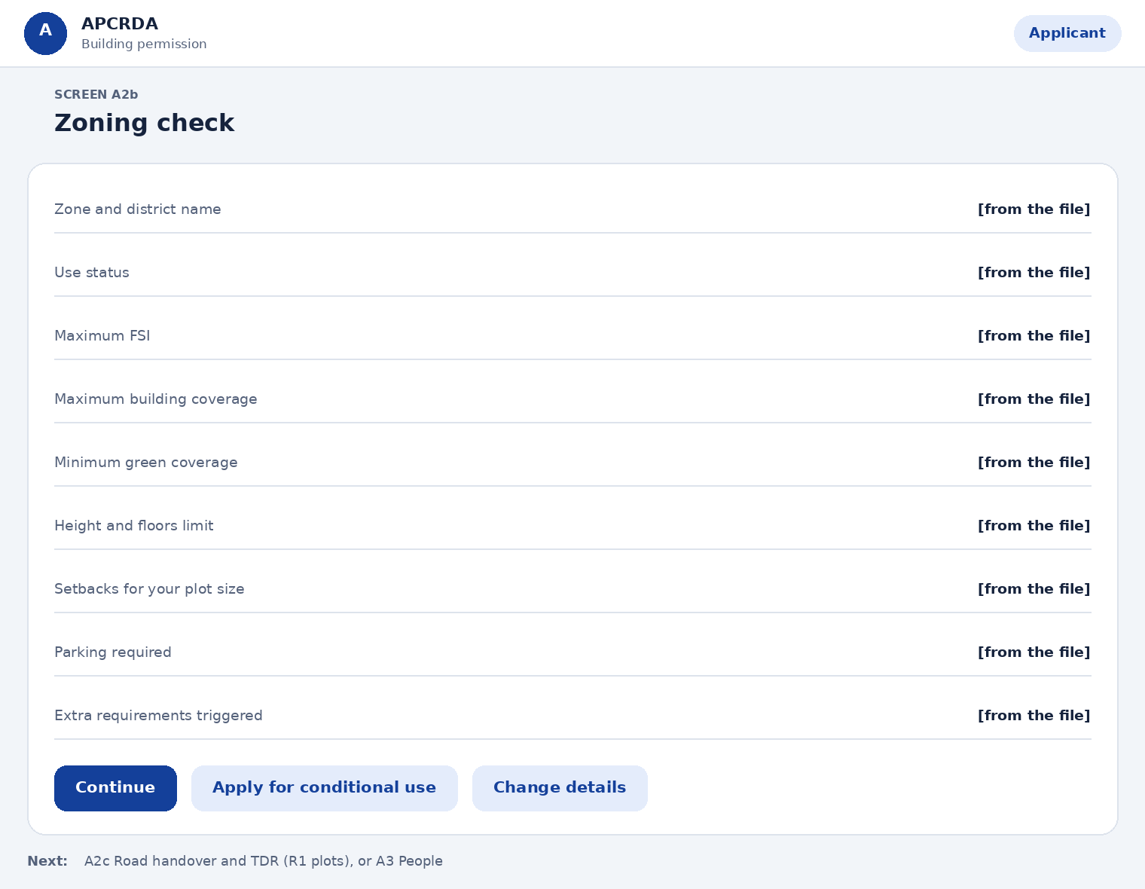
Fields on this page
Field | Type | Required | Notes
Zone and district name | Shown, not editable | Yes | From the zoning map
Use status | Shown, not editable | Yes | Permitted, conditional or prohibited
Maximum FSI | Shown, not editable | Yes | From the zoning table
Maximum building coverage | Shown, not editable | Yes | From the zoning table
Minimum green coverage | Shown, not editable | Yes | From the zoning table
Height and floors limit | Shown, not editable | Yes | From the zoning table
Setbacks for your plot size | Shown, not editable | Yes | Front, side and rear
Parking required | Shown, not editable | Yes | From the zoning table
Extra requirements triggered | Shown, not editable | Yes | For example NOCs or a design brief
Actions
Action | What happens
Continue | Opens Road handover if the plot is in R1, otherwise People
Apply for conditional use | Opens a conditional-use case with the Chief City Planner
Change details | Returns to Project details
Next step: A2c Road handover and TDR (R1 plots), or A3 People

A2c Road handover and TDR (R1)
Prototype: ZoningCheck.dc.html
In R1 villages, land needed for the approved village road width is handed over free of cost. In return you can take a transferable development right, an extra floor of equal built area, or a setback concession.
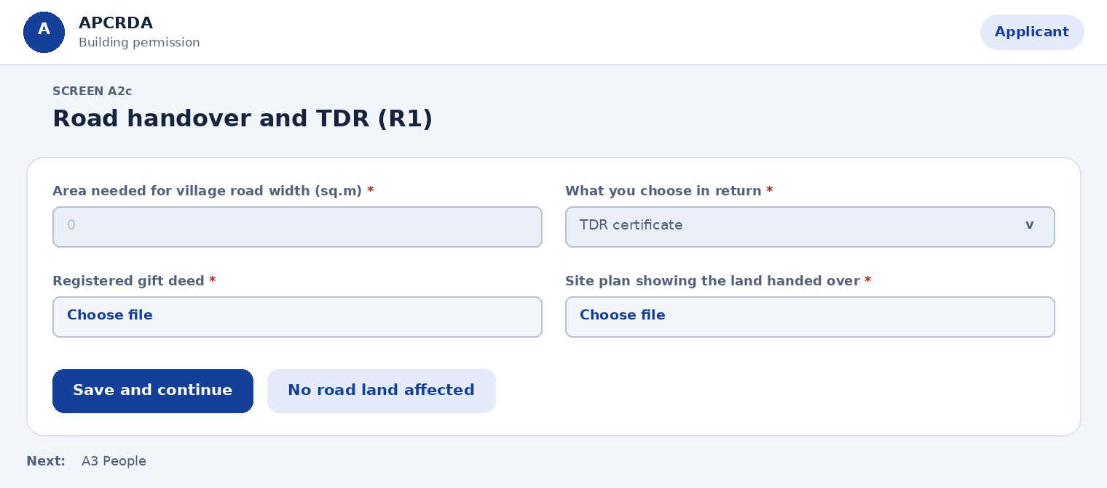
Fields on this page
Field | Type | Required | Notes
Area needed for village road width (sq.m) | Number | Yes | As per the village circulation plan approved by the Commissioner
What you choose in return | Choose one | Yes | Regulation 215.1. Options: TDR certificate, Extra floor of equal built area, Setback concession
Registered gift deed | File upload | Yes | TDR is awarded only after the land is transferred by registered gift deed (Reg 215.2)
Site plan showing the land handed over | File upload | Yes | With dimensions and location
Actions
Action | What happens
Save and continue | Opens People
No road land affected | Skips this step
Next step: A3 People

A3 People
Prototype: New application, four steps
Say who owns the plot and who will submit the drawing. The LTP receives a consent request.
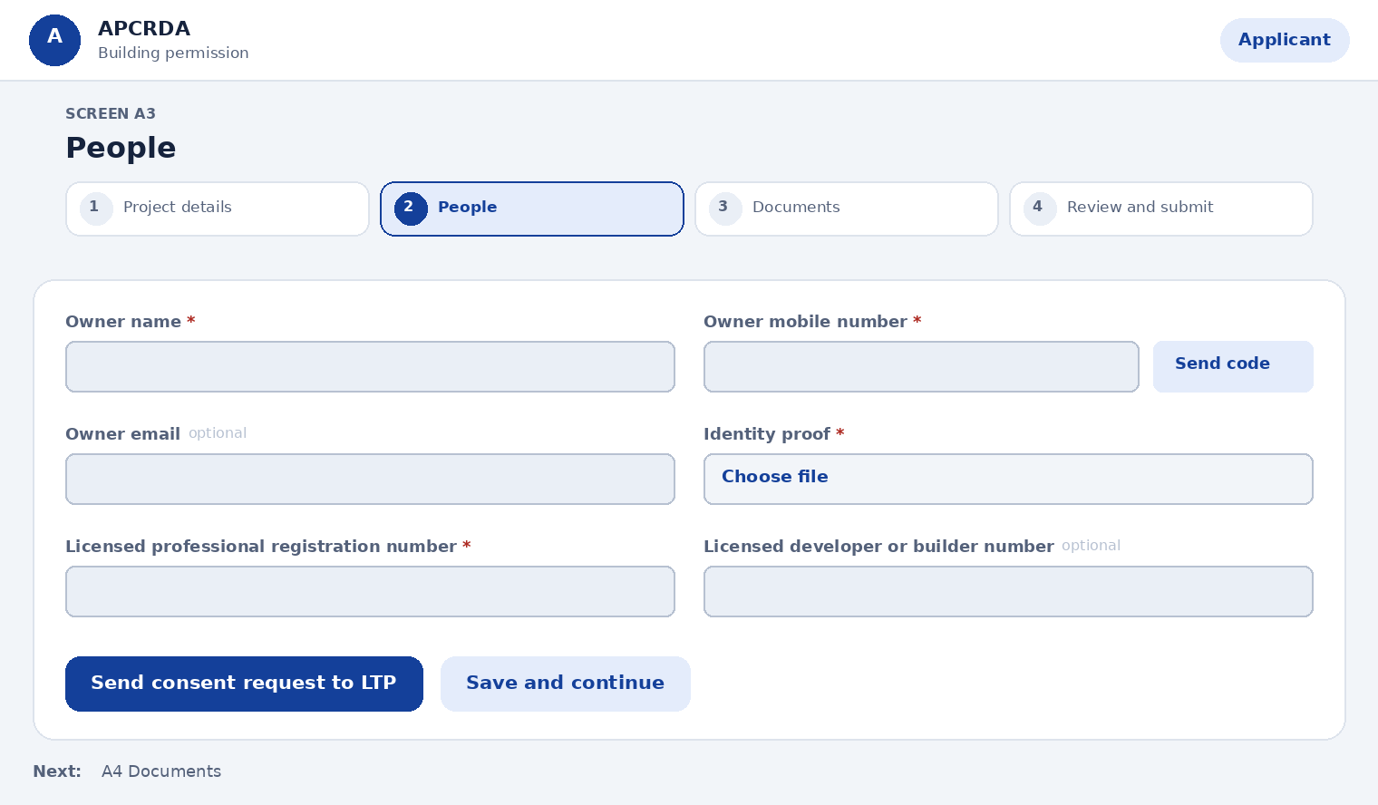
Fields on this page
Field | Type | Required | Notes
Owner name | Text | Yes | -
Owner mobile number | Text plus one-time code | Yes | Verified with a one-time code
Owner email | Text | No | -
Identity proof | File upload | Yes | PDF or image, up to [size] MB
Licensed professional registration number | Text | Yes | Looked up; architects must be registered with the Council of Architecture
Licensed developer or builder number | Text | No | Mandatory for apartments, group developments, high-rise and commercial complexes (Reg 215.6)
Actions
Action | What happens
Send consent request to LTP | LTP is notified by SMS, email and in-app
Save and continue | Opens Documents
Next step: A4 Documents

A4 Documents
Prototype: New application, four steps
Upload the ownership and supporting documents the regulations ask for. The 2D drawing is uploaded by the licensed professional.
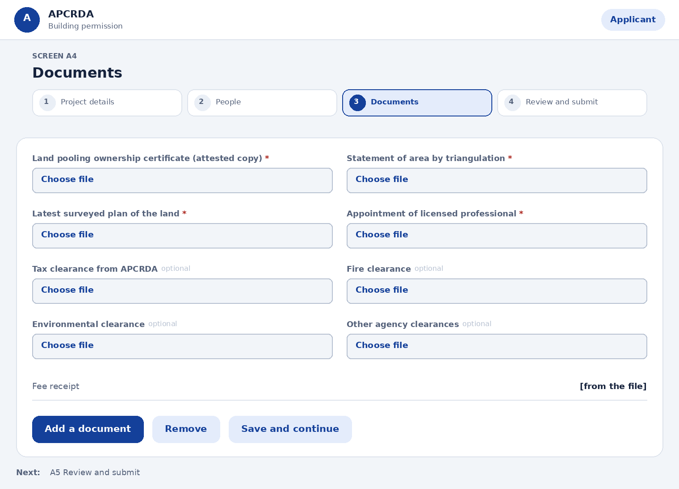
Fields on this page
Field | Type | Required | Notes
Land pooling ownership certificate (attested copy) | File upload | Yes | Or equivalent ownership document outside land pooling (Reg 209.12)
Statement of area by triangulation | File upload | Yes | From the licensed professional, with the owner's affidavit
Latest surveyed plan of the land | File upload | Yes | With structures, trees and all side dimensions
Appointment of licensed professional | File upload | Yes | In the prescribed form
Tax clearance from APCRDA | File upload | No | Where tax arrears apply
Fire clearance | File upload | No | For buildings that need it
Environmental clearance | File upload | No | Where required under the EIA notification
Other agency clearances | File upload | No | For example Airports Authority, railways or electricity company
Fee receipt | Shown, not editable | Yes | Added automatically after payment
Actions
Action | What happens
Add a document | Opens the file picker
Remove | Removes the file after confirmation
Save and continue | Opens Review and submit
Next step: A5 Review and submit

A5 Review and submit
Prototype: New application, four steps
Check the summary. Some items are only needed before the permission order is released; upload them now to avoid a delay.
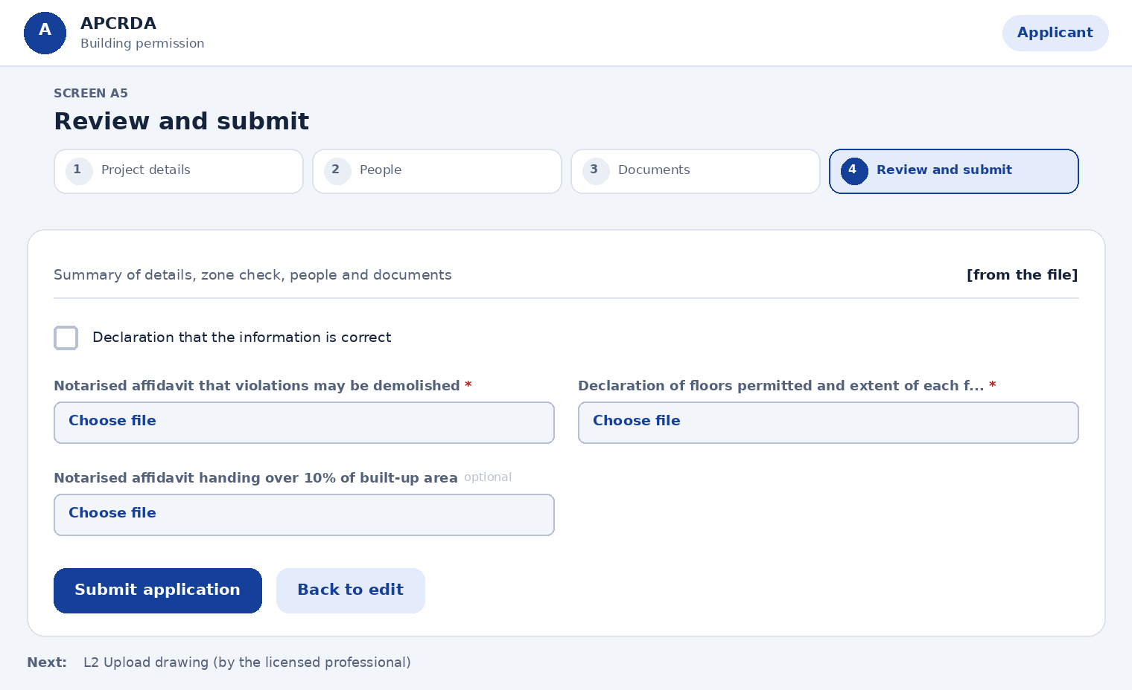
Fields on this page
Field | Type | Required | Notes
Summary of details, zone check, people and documents | Shown, not editable | Yes | Missing items are flagged
Declaration that the information is correct | Tick box | Yes | Must be ticked to submit
Notarised affidavit that violations may be demolished | File upload | Yes | Needed before the permission order (Reg 215.3)
Declaration of floors permitted and extent of each floor | File upload | Yes | Needed before the permission order
Notarised affidavit handing over 10% of built-up area | File upload | No | 5% of units for row, detached or cluster housing. Not needed for an individual residential building on an R1 plot up to 200 sq.m and 7 m high
Actions
Action | What happens
Submit application | Application enters stage 2; LTP is asked to upload the drawing
Back to edit | Returns to the step you choose
Next step: L2 Upload drawing (by the licensed professional)

A6 Fee summary
Prototype: Pay fees, 3 steps
Show every fee due and how it was worked out.
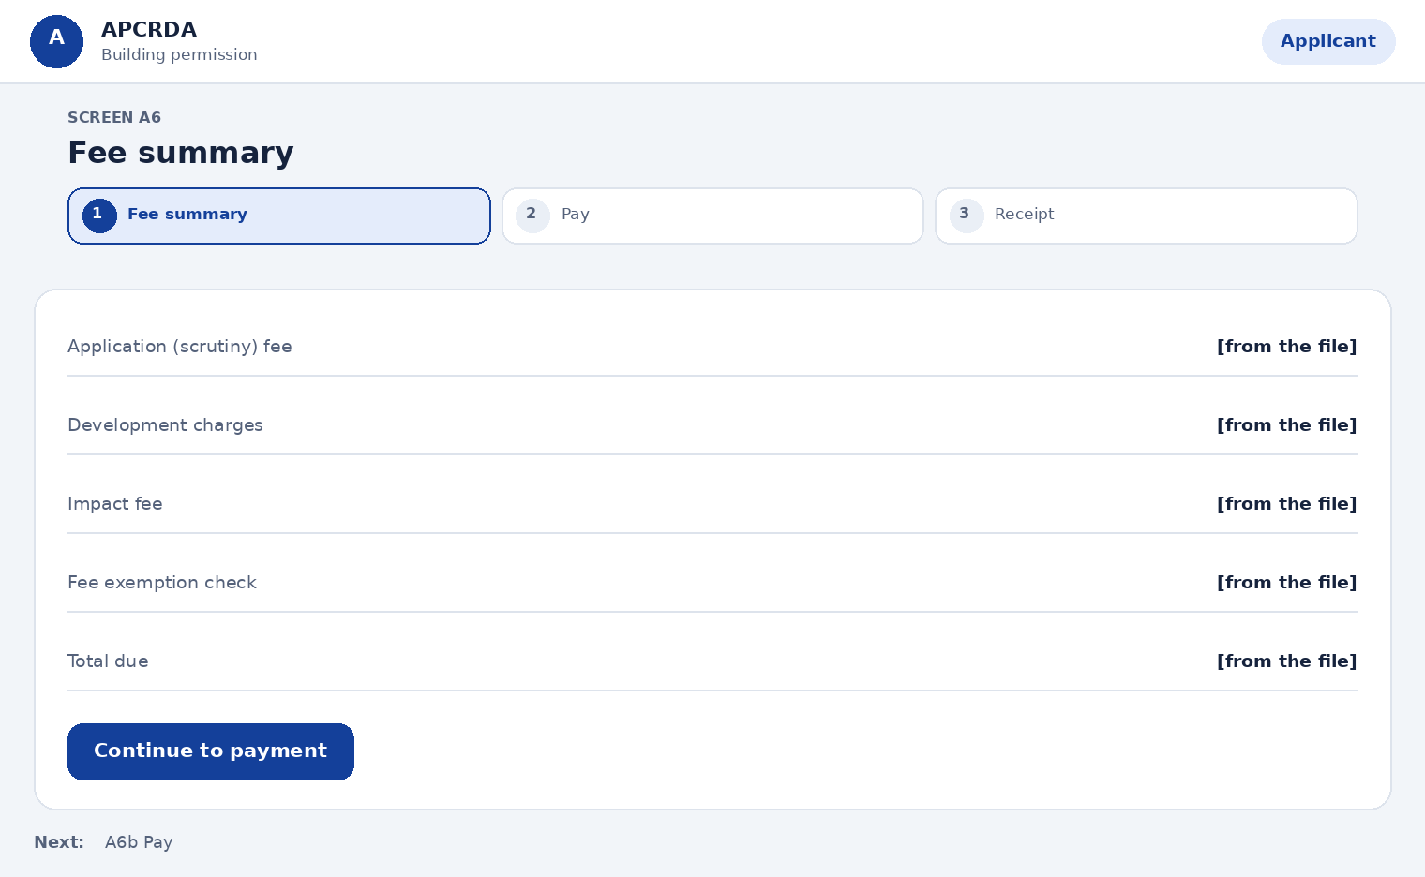
Fields on this page
Field | Type | Required | Notes
Application (scrutiny) fee | Shown, not editable | Yes | Based on gross floor area, including basement and accessory buildings, excluding parking
Development charges | Shown, not editable | Yes | As notified by APCRDA
Impact fee | Shown, not editable | Yes | Only where FSI is above 1.75
Fee exemption check | Shown, not editable | Yes | No fee for EWS, LIG or slum redevelopment schemes with tenement carpet area up to 50 sq.m
Total due | Shown, not editable | Yes | Sum of items
Actions
Action | What happens
Continue to payment | Opens Pay
Next step: A6b Pay

A6b Pay
Prototype: Pay fees, 3 steps
Choose how to pay.
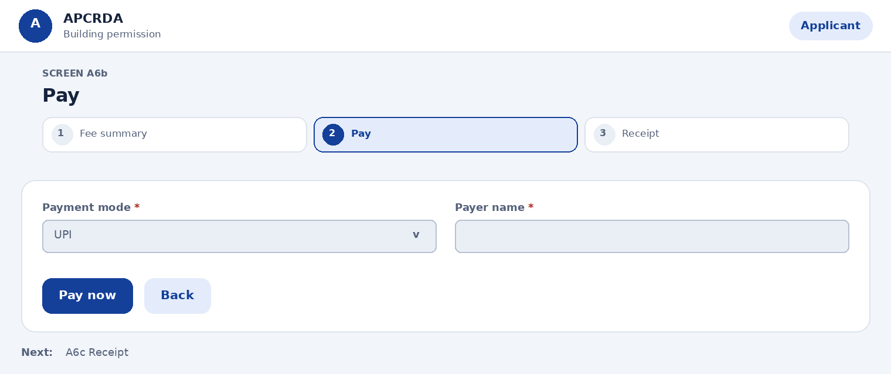
Fields on this page
Field | Type | Required | Notes
Payment mode | Choose one | Yes | Options: UPI, Net banking, Card
Payer name | Text | Yes | Printed on the receipt
Actions
Action | What happens
Pay now | Opens the payment gateway
Back | Returns to Fee summary
Next step: A6c Receipt

A6c Receipt
Prototype: Pay fees, 3 steps
Confirm payment and keep the receipt. The scrutiny fee is forfeited if the proposal is rejected.
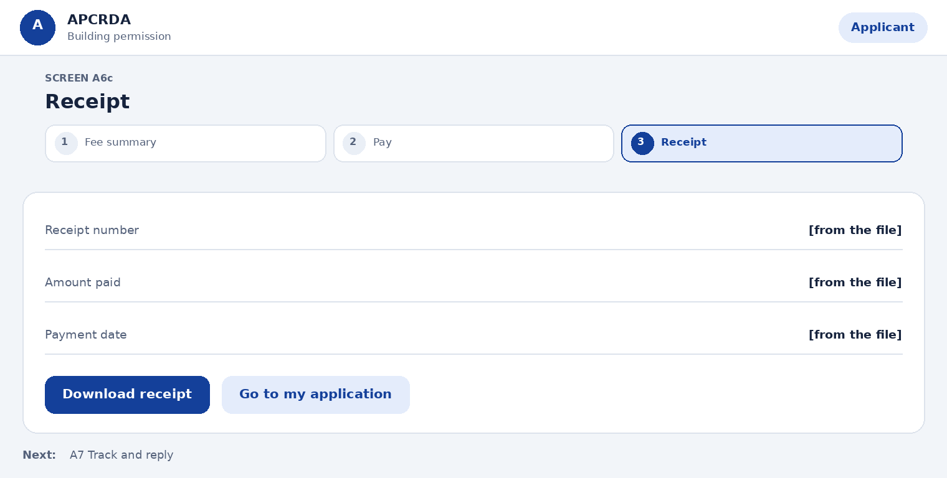
Fields on this page
Field | Type | Required | Notes
Receipt number | Shown, not editable | Yes | -
Amount paid | Shown, not editable | Yes | -
Payment date | Shown, not editable | Yes | -
Actions
Action | What happens
Download receipt | Downloads a PDF
Go to my application | Opens the tracker
Next step: A7 Track and reply

A7 Track and reply
Prototype: Applicant workspace
See the seven-stage tracker and answer any query.
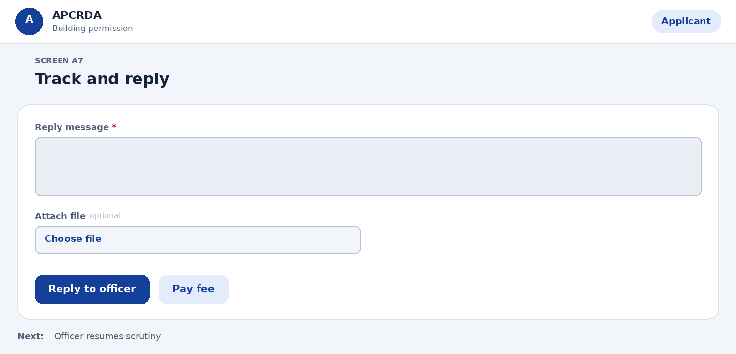
Fields on this page
Field | Type | Required | Notes
Reply message | Long text | Yes | Required to send a reply
Attach file | File upload | No | -
Actions
Action | What happens
Reply to officer | Sends the reply and resumes the stage clock
Pay fee | Opens Fee summary
Next step: Officer resumes scrutiny

A8 Download permission order
Prototype: Applicant workspace
Get the Development Permission Order (DPO) once approved. It is issued only after all fees, deposits and charges are paid.
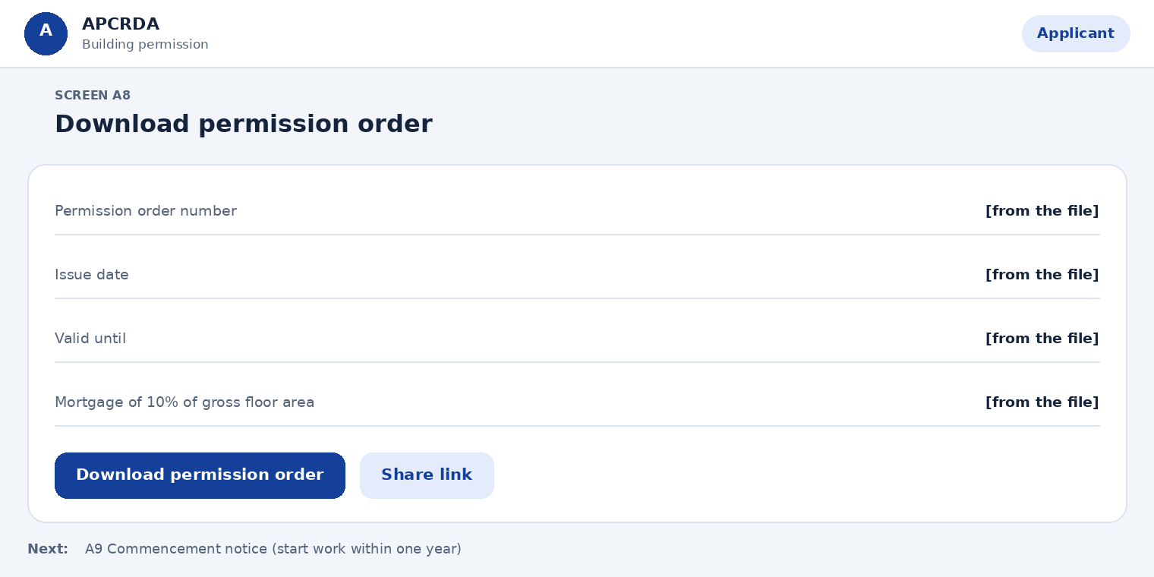
Fields on this page
Field | Type | Required | Notes
Permission order number | Shown, not editable | Yes | -
Issue date | Shown, not editable | Yes | -
Valid until | Shown, not editable | Yes | Set under section 111 of the Act
Mortgage of 10% of gross floor area | Shown, not editable | Yes | Registered mortgage deed; released when the occupancy certificate is issued
Actions
Action | What happens
Download permission order | PDF with QR code
Share link | Copies a verification link
Next step: A9 Commencement notice (start work within one year)

A9 Commencement notice
Prototype: PostPermitSteps.dc.html
Tell the Commissioner you are about to start work. Work must begin within one year of the permission order.
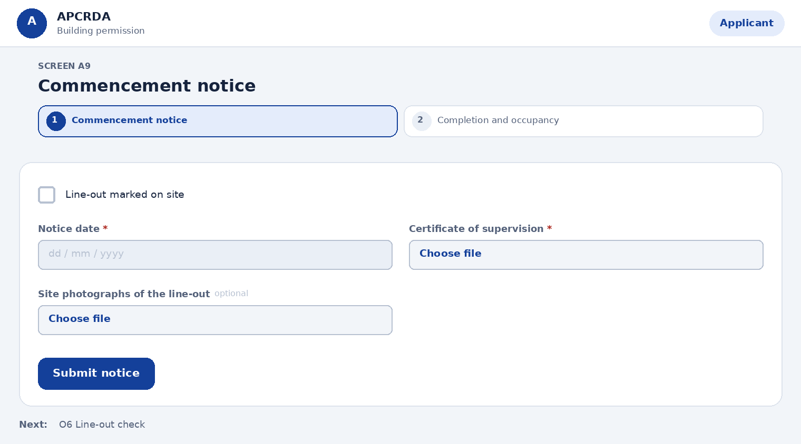
Fields on this page
Field | Type | Required | Notes
Line-out marked on site | Tick box | Yes | Centre lines of all external walls and columns on the ground floor
Notice date | Date | Yes | -
Certificate of supervision | File upload | Yes | Signed by the licensed professional
Site photographs of the line-out | File upload | No | -
Actions
Action | What happens
Submit notice | The Commissioner checks the line-out within 7 days; you may start after 7 days or earlier if permitted
Next step: O6 Line-out check

A10 Completion and occupancy
Prototype: PostPermitSteps.dc.html
Tell the authority the work is complete and ask for the occupancy certificate. No one may occupy the building without it.
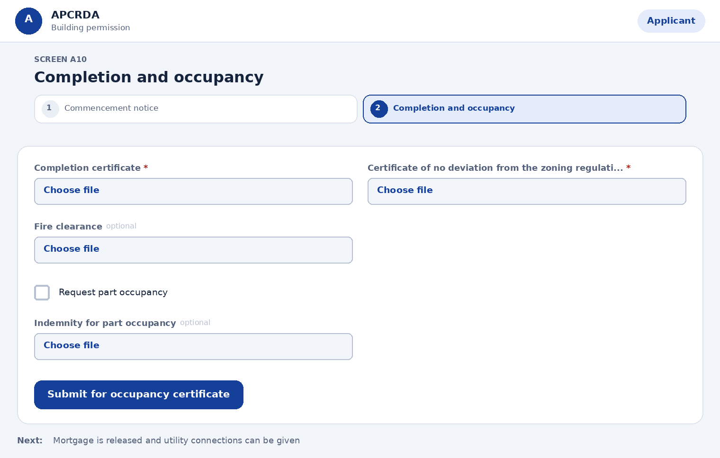
Fields on this page
Field | Type | Required | Notes
Completion certificate | File upload | Yes | Prescribed form, with completion plans
Certificate of no deviation from the zoning regulations | File upload | Yes | From the supervising licensed professional
Fire clearance | File upload | No | Required for high-rise and special buildings
Request part occupancy | Tick box | No | Needs an indemnity in the prescribed form
Indemnity for part occupancy | File upload | No | Required if part occupancy is requested
Actions
Action | What happens
Submit for occupancy certificate | The authority decides within 15 days; if not decided, it is deemed approved for occupation when built as sanctioned
Next step: Mortgage is released and utility connections can be given

14.2 LTP or architect (Licensed technical person)
Page sequence: L1 > L2 > L3 > L4 > L4b > L5 > L6. Each page below starts with a simple layout, then lists its fields, actions and next step.

L1 Consent request
Prototype: Described here only
Accept or decline to act on an application.
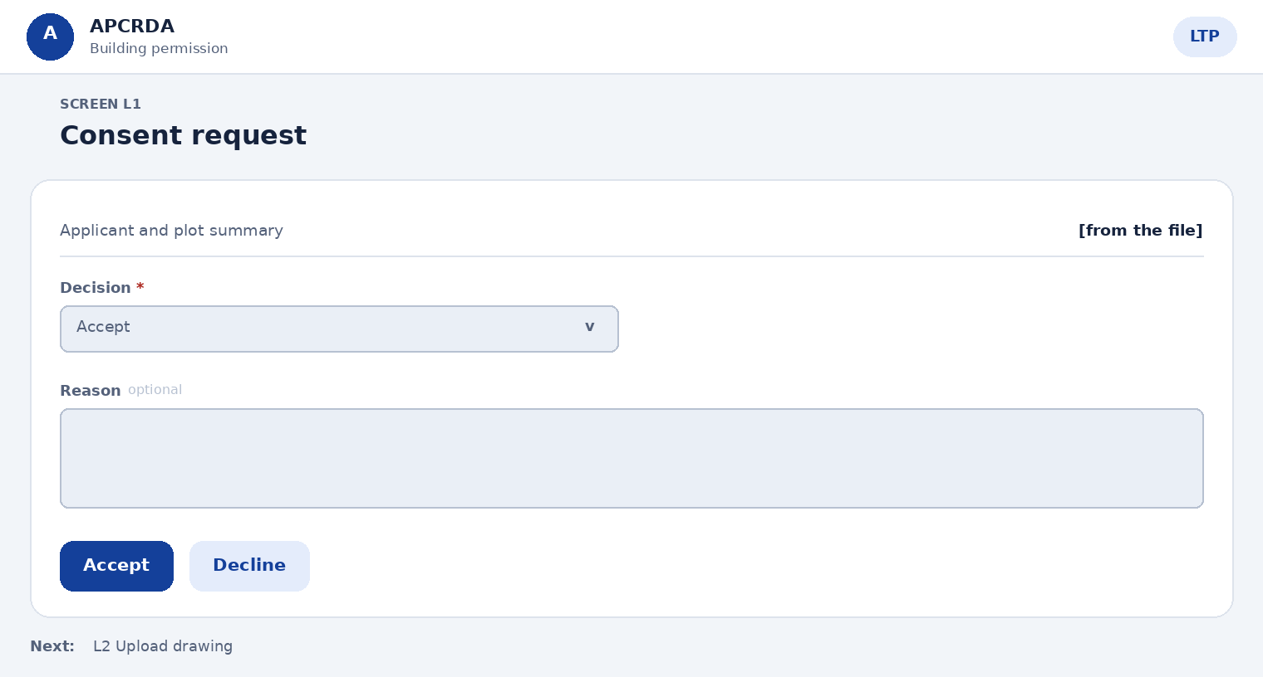
Fields on this page
Field | Type | Required | Notes
Applicant and plot summary | Shown, not editable | Yes | -
Decision | Choose one | Yes | Options: Accept, Decline
Reason | Long text | No | Required when declining
Actions
Action | What happens
Accept | Opens Upload drawing
Decline | Applicant is told to choose another LTP
Next step: L2 Upload drawing

L2 Upload drawing
Prototype: LTP upload and live check
Upload each sheet as DWG or DXF. The check starts at once.
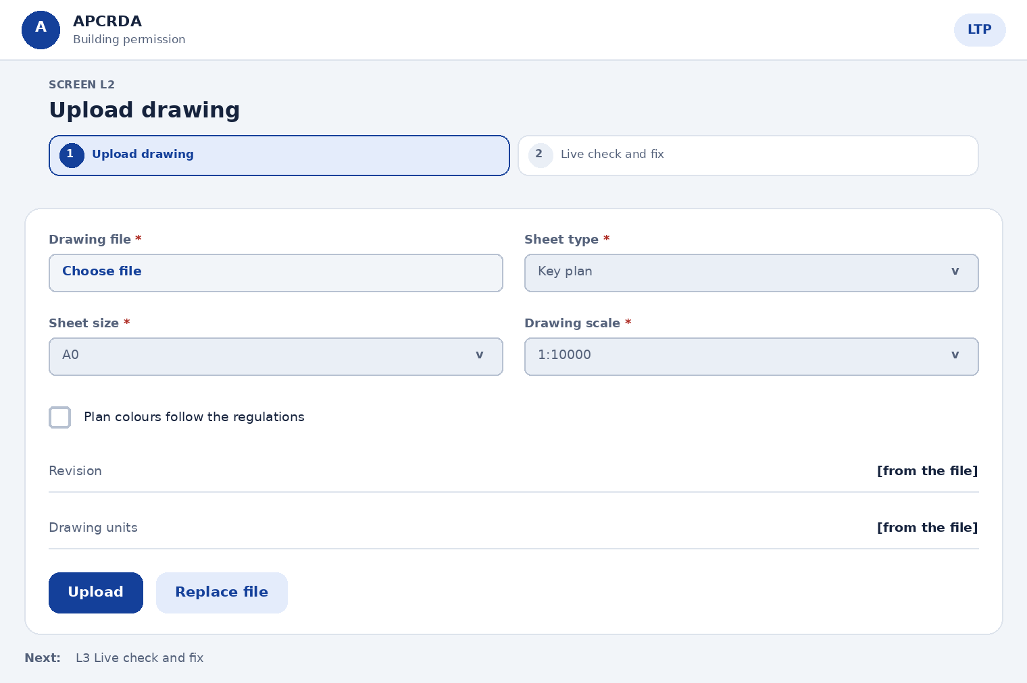
Fields on this page
Field | Type | Required | Notes
Drawing file | File upload | Yes | DWG (2013 or later) or DXF, up to [size] MB
Sheet type | Choose one | Yes | Options: Key plan, Site plan, Floor plan, Elevation, Section, Terrace plan
Sheet size | Choose one | Yes | Sizes A0 to A5 (Reg 208.2, Table 1). Options: A0, A1, A2, A3, A4, A5
Drawing scale | Choose one | Yes | Key plan not less than 1:10000, site plan 1:500, building plans 1:100. Options: 1:10000, 1:500, 1:100
Plan colours follow the regulations | Tick box | Yes | Colour notation in Table 3 of the zoning regulations
Revision | Shown, not editable | Yes | R0 first time, increases on each re-upload
Drawing units | Shown, not editable | Yes | Metric, millimetres
Actions
Action | What happens
Upload | Starts the live check
Replace file | Uploads a new revision
Next step: L3 Live check and fix

L3 Live check and fix
Prototype: LTP upload and live check
See what passed and what needs fixing, on the drawing itself.
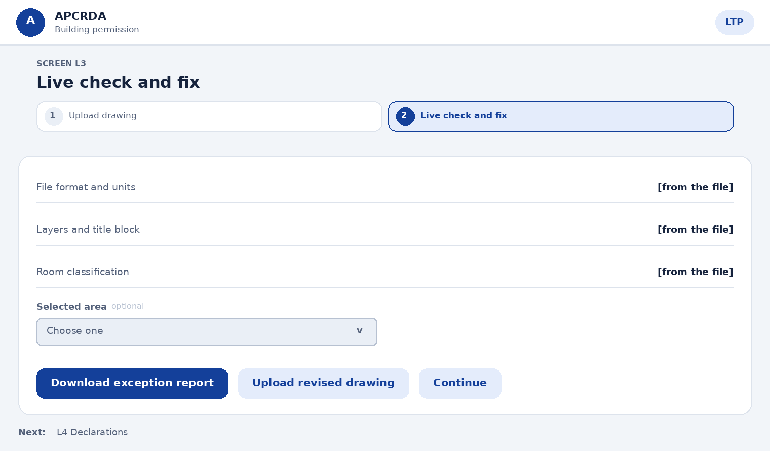
Fields on this page
Field | Type | Required | Notes
File format and units | Shown, not editable | Yes | Passed or a count to fix
Layers and title block | Shown, not editable | Yes | -
Room classification | Shown, not editable | Yes | Lists unclassified areas
Selected area | Choose one | No | Shows reason, size, layer and closest approved name
Actions
Action | What happens
Download exception report | Gets the full list
Upload revised drawing | Runs the check again on the new revision
Continue | Enabled only at zero exceptions
Next step: L4 Declarations

L4 Declarations
Prototype: LTP self-certify and submit
Confirm the drawing meets the submission standard.
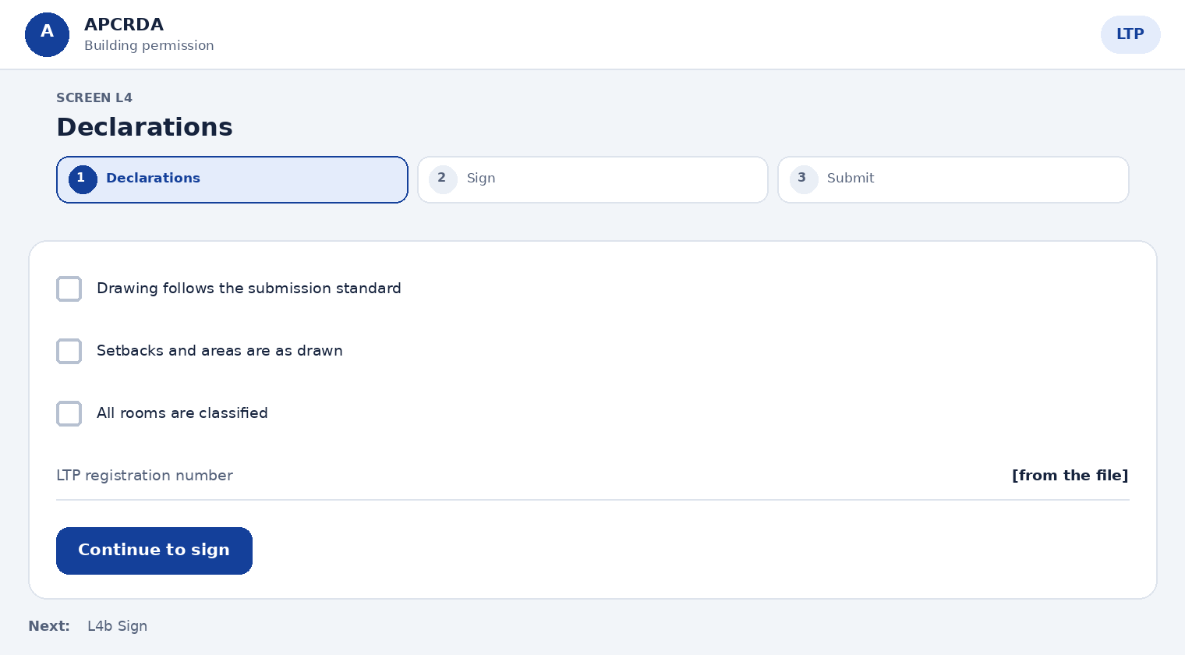
Fields on this page
Field | Type | Required | Notes
Drawing follows the submission standard | Tick box | Yes | -
Setbacks and areas are as drawn | Tick box | Yes | -
All rooms are classified | Tick box | Yes | -
LTP registration number | Shown, not editable | Yes | Pre-filled
Actions
Action | What happens
Continue to sign | Opens Sign
Next step: L4b Sign

L4b Sign
Prototype: LTP self-certify and submit
Sign the declaration with a one-time code.
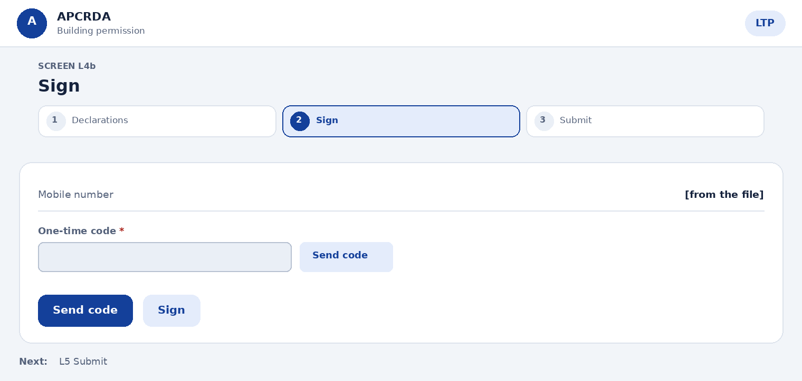
Fields on this page
Field | Type | Required | Notes
Mobile number | Shown, not editable | Yes | Registered LTP number
One-time code | Text plus one-time code | Yes | Sent when you choose Send code
Actions
Action | What happens
Send code | Sends the code
Sign | Records the signature with date and revision
Next step: L5 Submit

L5 Submit
Prototype: LTP self-certify and submit
Send the signed drawing to the authority.
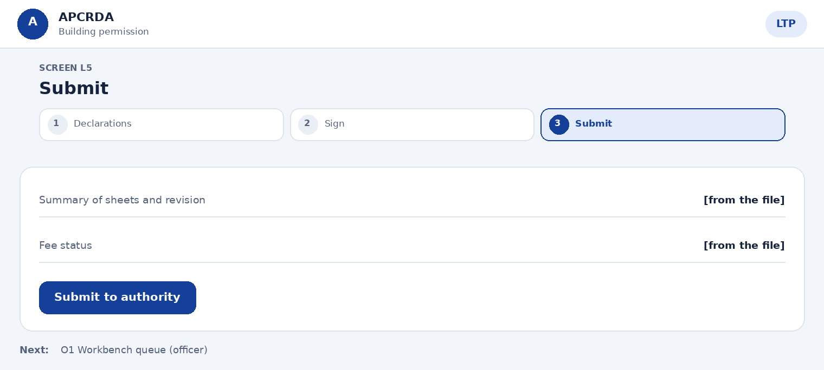
Fields on this page
Field | Type | Required | Notes
Summary of sheets and revision | Shown, not editable | Yes | -
Fee status | Shown, not editable | Yes | Shows if the applicant has paid
Actions
Action | What happens
Submit to authority | File moves to scrutiny once fees are paid
Next step: O1 Workbench queue (officer)

L6 Answer an officer query
Prototype: Described here only
Reply to a query with a message or a revised drawing.
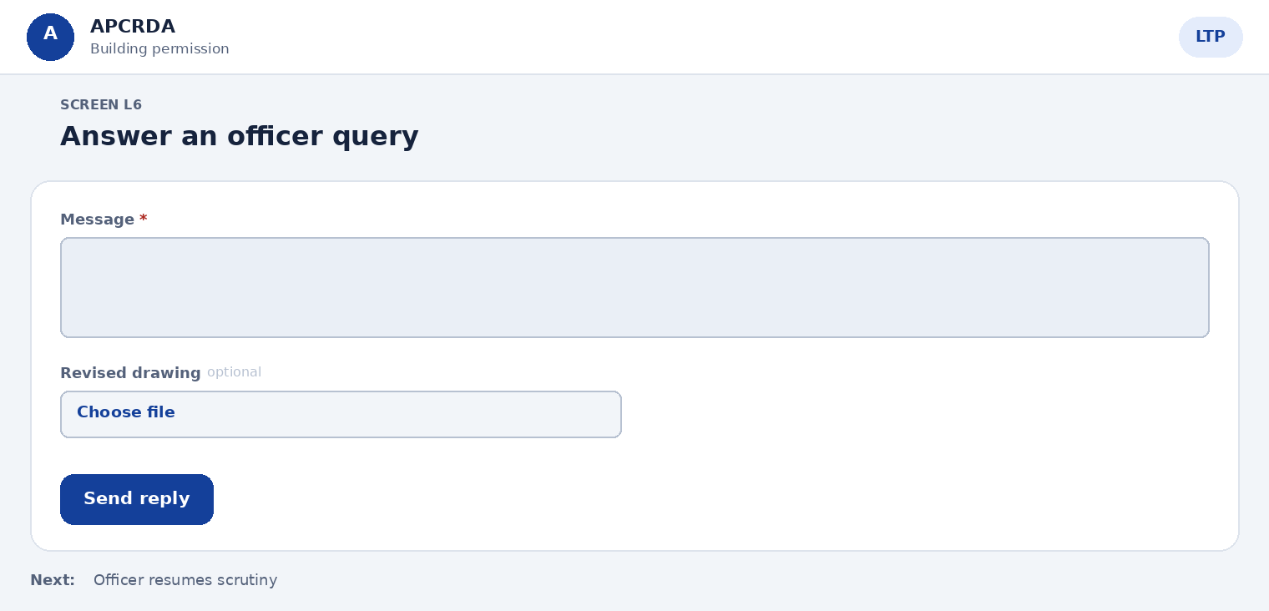
Fields on this page
Field | Type | Required | Notes
Message | Long text | Yes | -
Revised drawing | File upload | No | Uploads as a new revision and re-runs the check
Actions
Action | What happens
Send reply | Officer is notified; the stage clock resumes
Next step: Officer resumes scrutiny

14.3 Developer (Developer)
Page sequence: D1 > D2 > D3 > D4. Each page below starts with a simple layout, then lists its fields, actions and next step.

D1 Register or renew
Prototype: Described here only
Keep the developer registration valid.
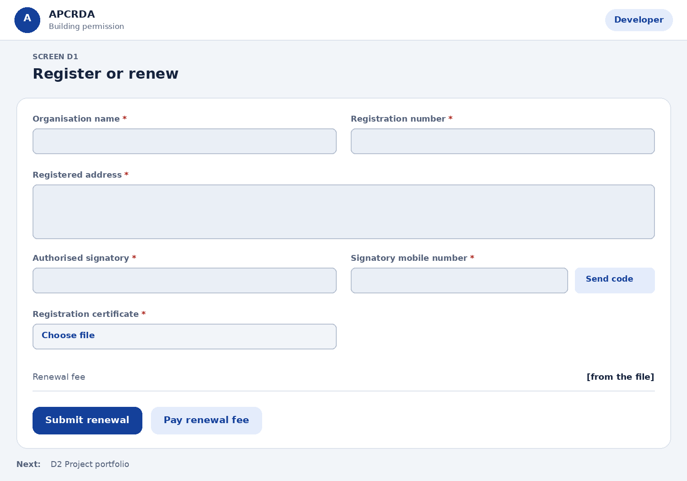
Fields on this page
Field | Type | Required | Notes
Organisation name | Text | Yes | -
Registration number | Text | Yes | Read-only when renewing
Registered address | Long text | Yes | -
Authorised signatory | Text | Yes | -
Signatory mobile number | Text plus one-time code | Yes | -
Registration certificate | File upload | Yes | -
Renewal fee | Shown, not editable | Yes | Shown when renewing
Actions
Action | What happens
Submit renewal | Sent for approval
Pay renewal fee | Opens the payment gateway
Next step: D2 Project portfolio

D2 Project portfolio
Prototype: Developer project portfolio
See every project, its stage and the next action in one list.
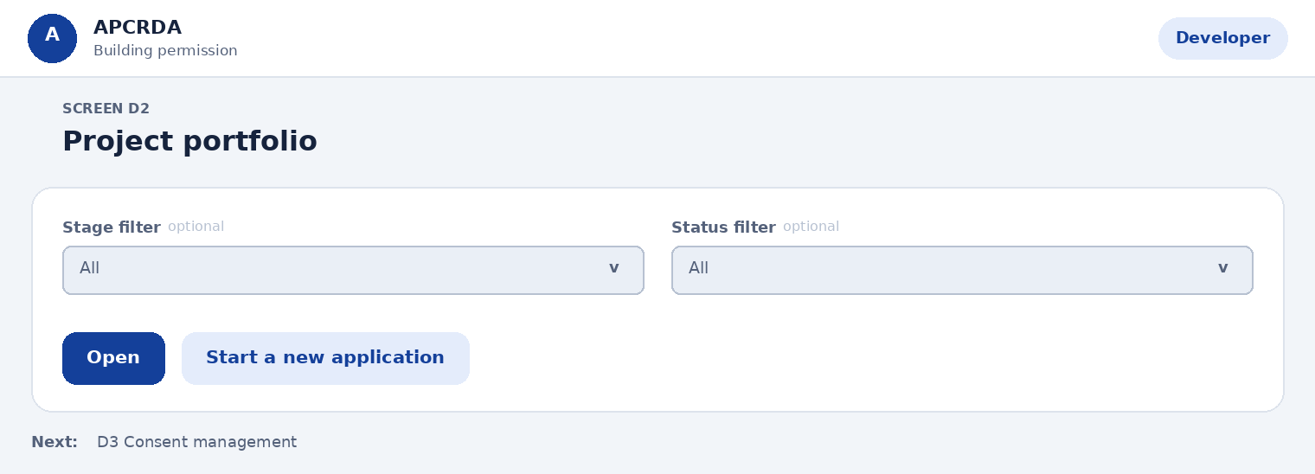
Fields on this page
Field | Type | Required | Notes
Stage filter | Choose one | No | Options: All, Upload, Scrutiny, NOCs, Approval, Permit
Status filter | Choose one | No | Options: All, Waiting for you, In progress, Returned, Issued
Actions
Action | What happens
Open | Opens the project
Start a new application | Opens the wizard
Next step: D3 Consent management

D3 Consent management
Prototype: Described here only
Approve or withdraw consent for LTPs and TPAs.
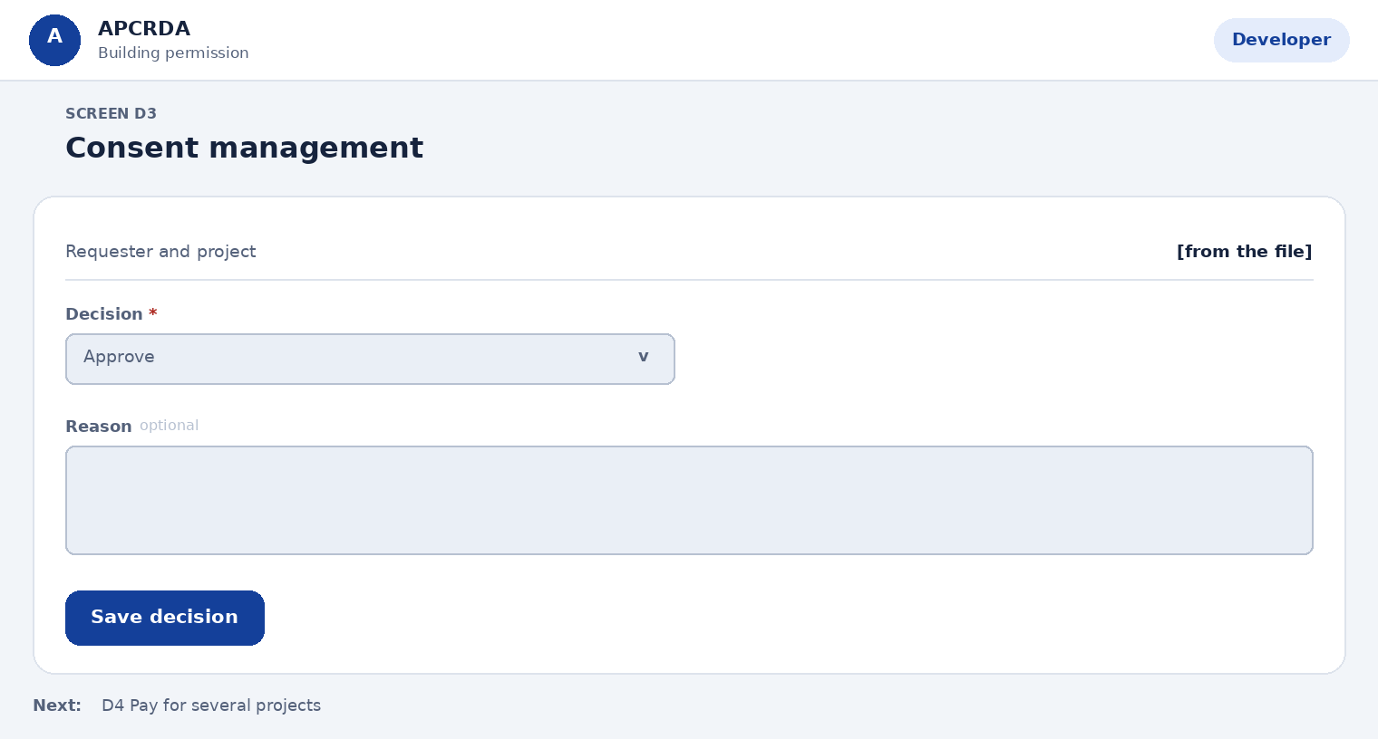
Fields on this page
Field | Type | Required | Notes
Requester and project | Shown, not editable | Yes | -
Decision | Choose one | Yes | Options: Approve, Decline, Withdraw
Reason | Long text | No | Required when withdrawing
Actions
Action | What happens
Save decision | Recorded in the audit log; requester is notified
Next step: D4 Pay for several projects

D4 Pay for several projects
Prototype: Described here only
Pay fees for more than one project in one go.
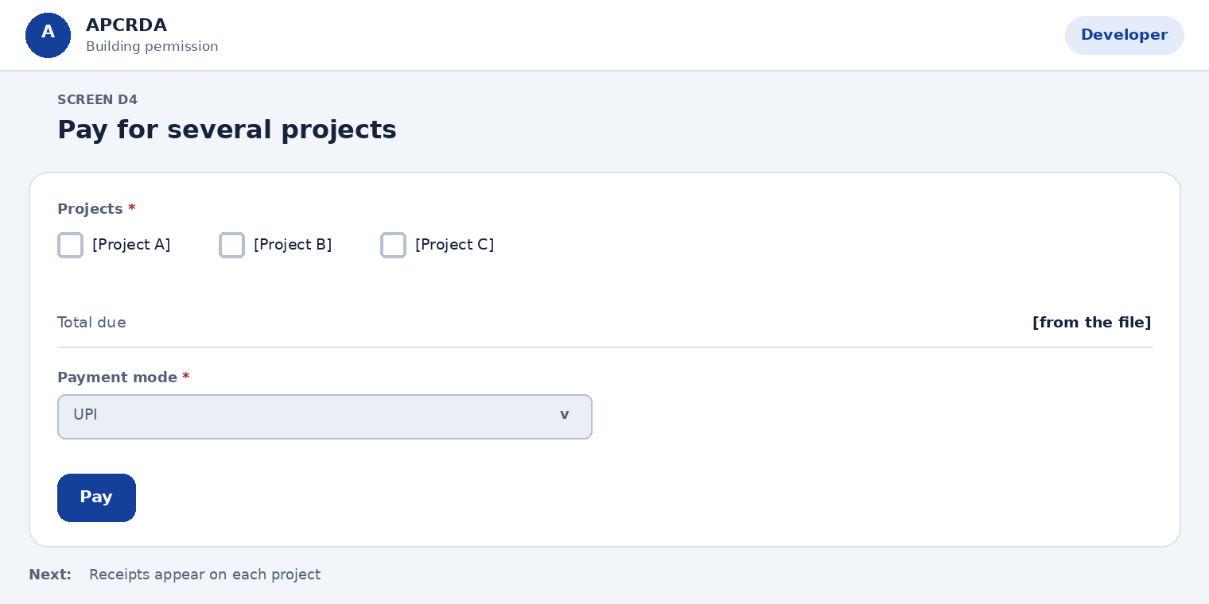
Fields on this page
Field | Type | Required | Notes
Projects | Choose several | Yes | At least one. Options: [Project A], [Project B], [Project C]
Total due | Shown, not editable | Yes | -
Payment mode | Choose one | Yes | Options: UPI, Net banking, Card
Actions
Action | What happens
Pay | One payment; one receipt per project
Next step: Receipts appear on each project

14.4 Scrutiny officer (Scrutiny office (town planning))
Page sequence: O1 > O2 > O3 > O4 > O5 > O6. Each page below starts with a simple layout, then lists its fields, actions and next step.

O1 Workbench queue
Prototype: Scrutiny workbench
Pick the next file. Sorted by due date.
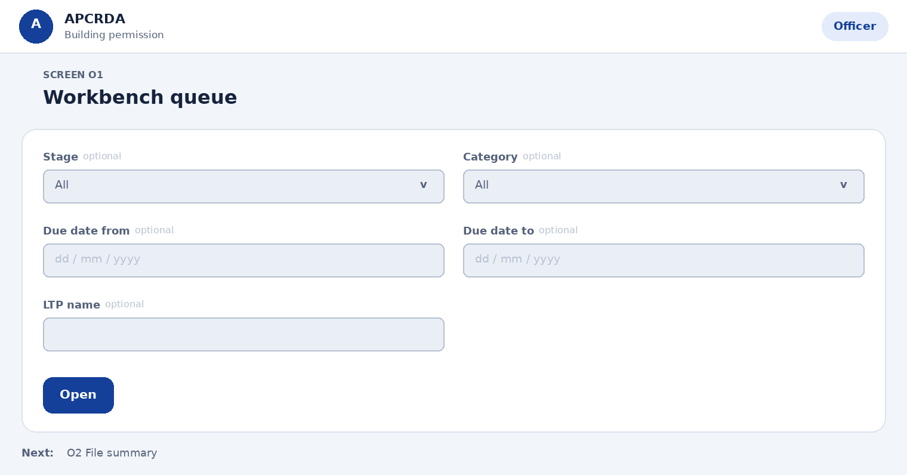
Fields on this page
Field | Type | Required | Notes
Stage | Choose one | No | Options: All, Scrutiny, Waiting for LTP
Category | Choose one | No | Options: All, Self-certified, Standard, Single window
Due date from | Date | No | -
Due date to | Date | No | -
LTP name | Text | No | -
Actions
Action | What happens
Open | Opens File summary
Next step: O2 File summary

O2 File summary
Prototype: Officer scrutiny, 4 steps
Confirm what the system already checked.
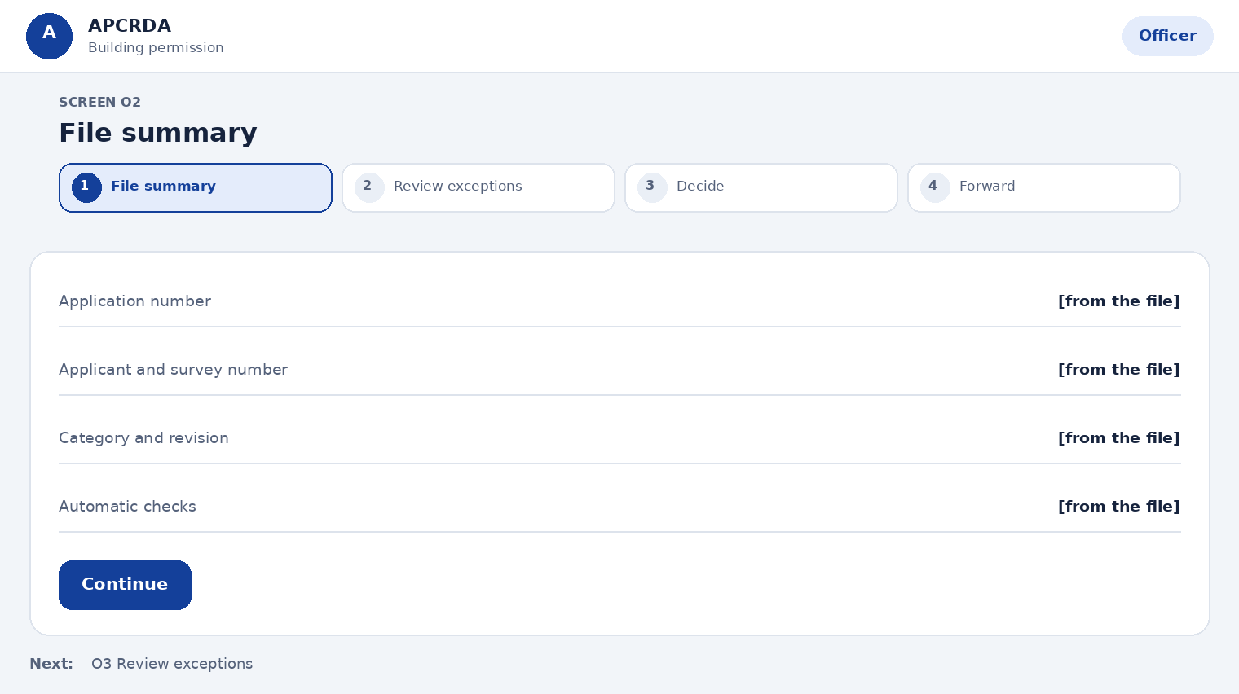
Fields on this page
Field | Type | Required | Notes
Application number | Shown, not editable | Yes | -
Applicant and survey number | Shown, not editable | Yes | -
Category and revision | Shown, not editable | Yes | -
Automatic checks | Shown, not editable | Yes | File, layers, rooms, area statement, fee
Actions
Action | What happens
Continue | Opens Review exceptions
Next step: O3 Review exceptions

O3 Review exceptions
Prototype: Officer scrutiny, 4 steps; Officer drawing review
Go through only the items that need judgement, on the drawing.
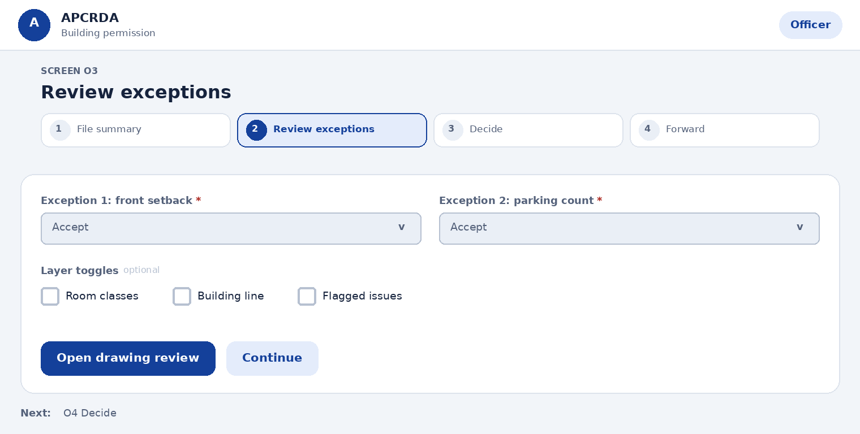
Fields on this page
Field | Type | Required | Notes
Exception 1: front setback | Choose one | Yes | Your response. Options: Accept, Accept with condition, Query
Exception 2: parking count | Choose one | Yes | Your response. Options: Accept, Accept with condition, Query
Layer toggles | Choose several | No | Room classes, building line, flagged issues. Options: Room classes, Building line, Flagged issues
Actions
Action | What happens
Open drawing review | Shows the plan with flagged items highlighted
Continue | Opens Decide
Next step: O4 Decide

O4 Decide
Prototype: Officer scrutiny, 4 steps
Record the decision for the whole file.
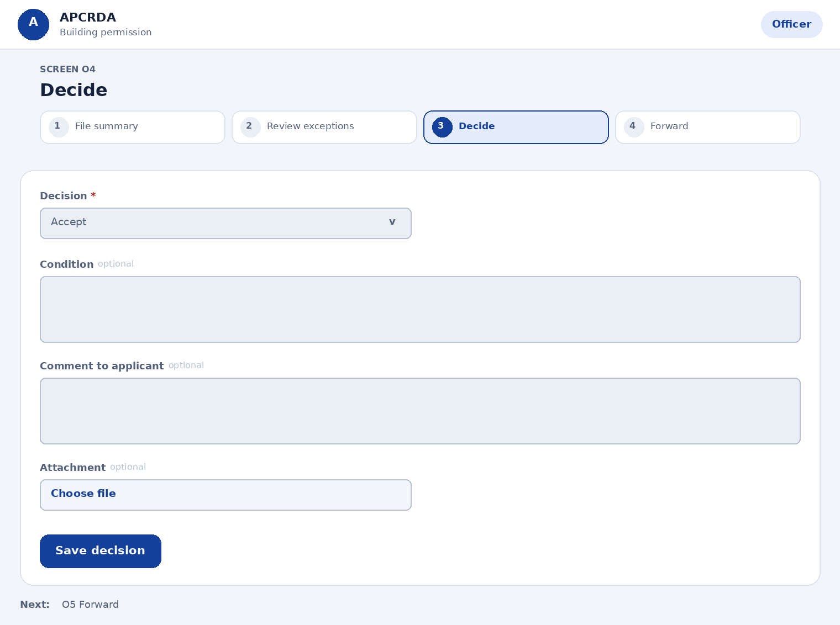
Fields on this page
Field | Type | Required | Notes
Decision | Choose one | Yes | Options: Accept, Accept with condition, Send back, Escalate
Condition | Long text | No | Required for Accept with condition
Comment to applicant | Long text | No | Required for Send back; must state the next step
Attachment | File upload | No | -
Actions
Action | What happens
Save decision | Stored; opens Forward
Next step: O5 Forward

O5 Forward
Prototype: Officer scrutiny, 4 steps
Send the file on or back.
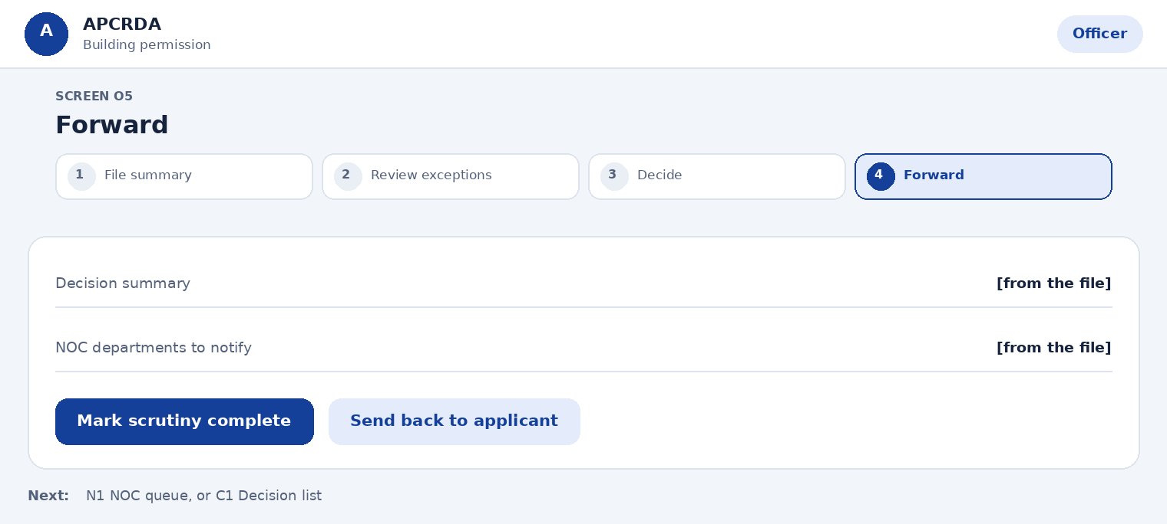
Fields on this page
Field | Type | Required | Notes
Decision summary | Shown, not editable | Yes | -
NOC departments to notify | Shown, not editable | Yes | Set by the category rules
Actions
Action | What happens
Mark scrutiny complete | Opens NOC tasks in parallel, or goes to the Commissioner if none are needed
Send back to applicant | Applicant gets the comment and next step
Next step: N1 NOC queue, or C1 Decision list

O6 Line-out check and inspection
Prototype: Described here only
Check the line-out after the commencement notice and record inspections during construction.
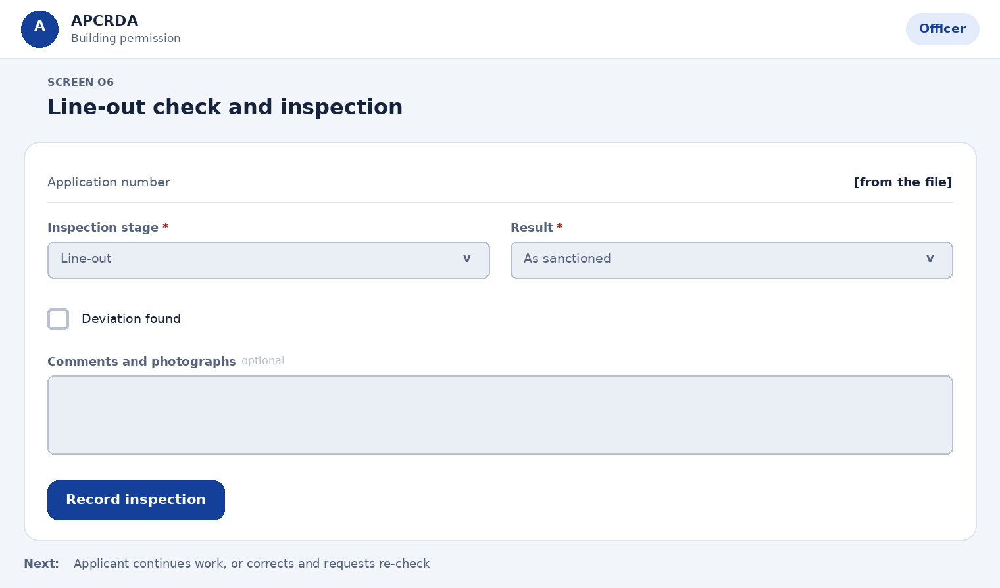
Fields on this page
Field | Type | Required | Notes
Application number | Shown, not editable | Yes | -
Inspection stage | Choose one | Yes | Options: Line-out, Plinth, Structure, Completion
Result | Choose one | Yes | Options: As sanctioned, Needs correction
Deviation found | Tick box | No | Any departure from the sanctioned plan needs the Commissioner's sanction
Comments and photographs | Long text | No | -
Actions
Action | What happens
Record inspection | Applicant is told the result; deviations are flagged to the Commissioner
Next step: Applicant continues work, or corrects and requests re-check

14.5 NOC departments (Fire, environment and other departments)
Page sequence: N1 > N2 > N3 > N4. Each page below starts with a simple layout, then lists its fields, actions and next step.

N1 NOC queue
Prototype: NOC department queue
See the files waiting for your department.
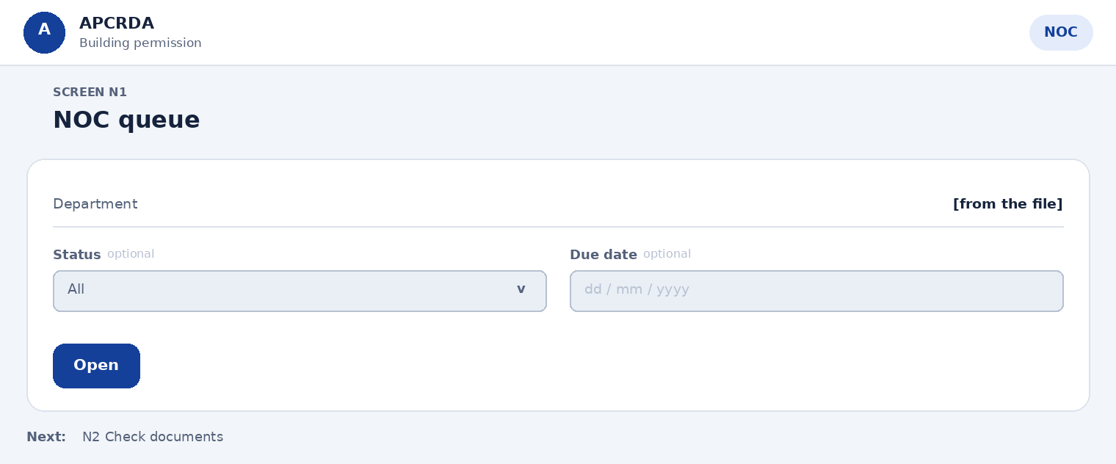
Fields on this page
Field | Type | Required | Notes
Department | Shown, not editable | Yes | Fixed to your office
Status | Choose one | No | Options: All, Waiting for you, Query with LTP, Issued
Due date | Date | No | -
Actions
Action | What happens
Open | Opens Check documents
Next step: N2 Check documents

N2 Check documents
Prototype: NOC review and issue
Look at each document the department needs.
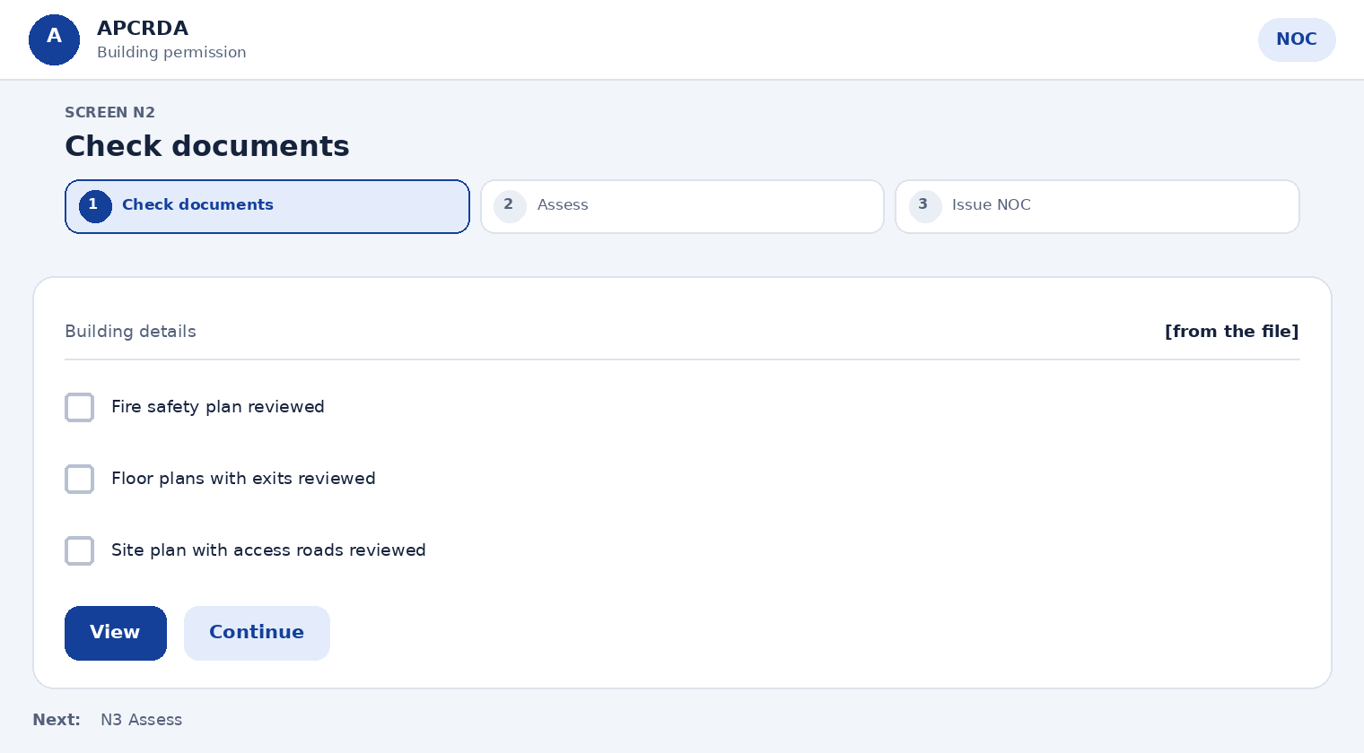
Fields on this page
Field | Type | Required | Notes
Building details | Shown, not editable | Yes | -
Fire safety plan reviewed | Tick box | Yes | -
Floor plans with exits reviewed | Tick box | Yes | -
Site plan with access roads reviewed | Tick box | Yes | -
Actions
Action | What happens
View | Opens the document
Continue | Opens Assess
Next step: N3 Assess

N3 Assess
Prototype: NOC review and issue
Decide the outcome.
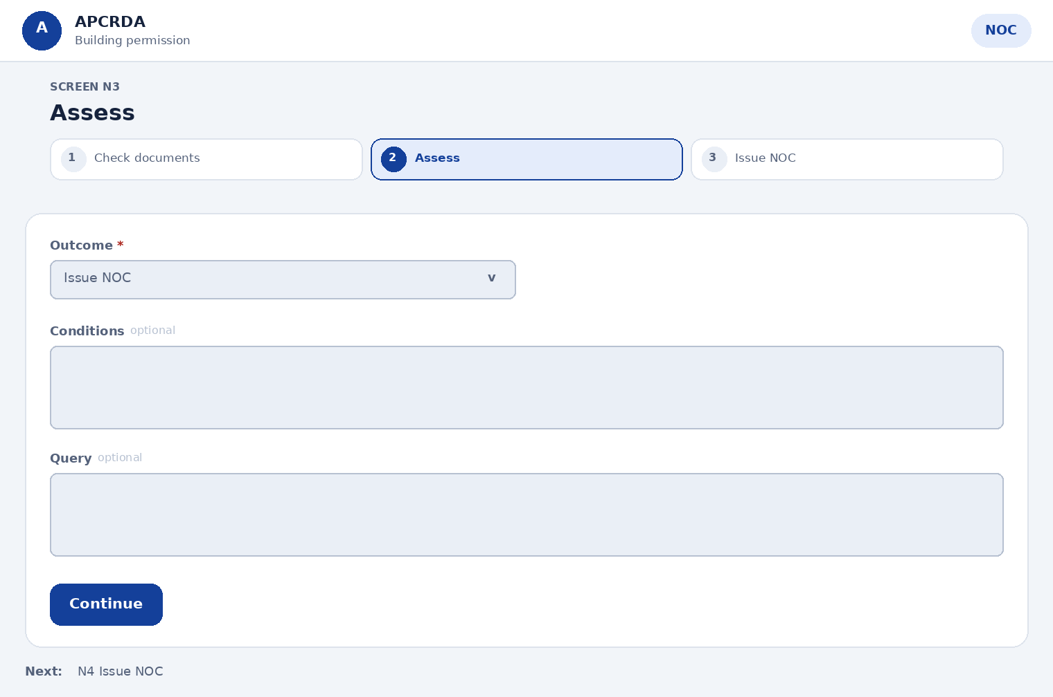
Fields on this page
Field | Type | Required | Notes
Outcome | Choose one | Yes | Options: Issue NOC, Issue with conditions, Raise query
Conditions | Long text | No | Required for Issue with conditions
Query | Long text | No | Required for Raise query; tells the applicant what to send
Actions
Action | What happens
Continue | Opens Issue NOC, or sends the query
Next step: N4 Issue NOC

N4 Issue NOC
Prototype: NOC review and issue
Record the NOC.
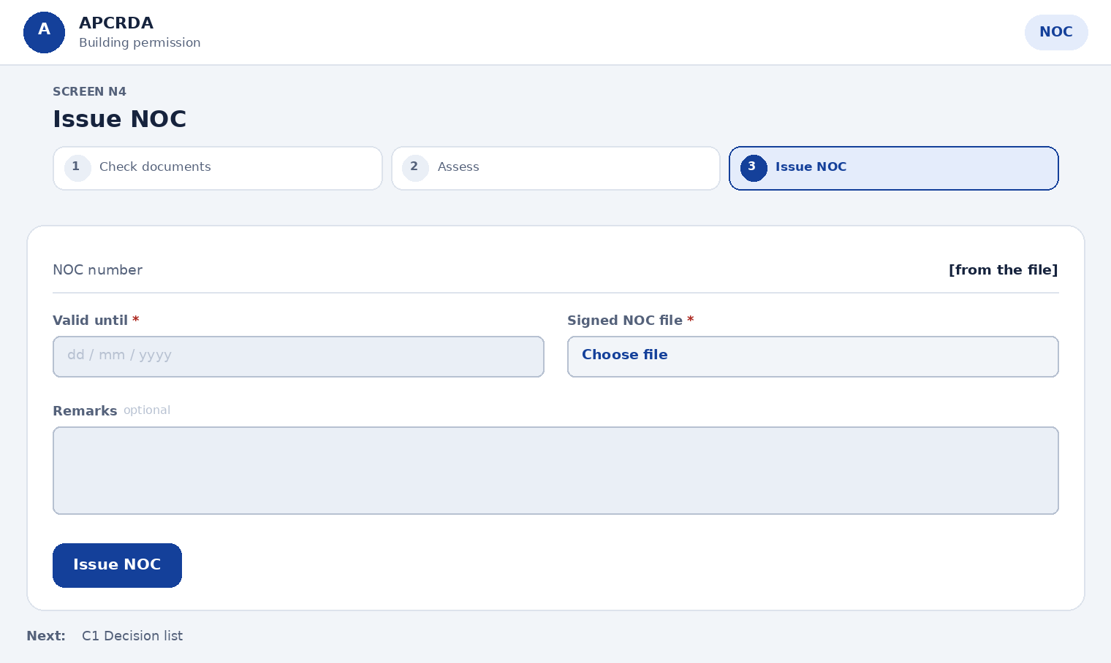
Fields on this page
Field | Type | Required | Notes
NOC number | Shown, not editable | Yes | Generated
Valid until | Date | Yes | -
Signed NOC file | File upload | Yes | PDF
Remarks | Long text | No | -
Actions
Action | What happens
Issue NOC | Department status turns Issued; when all are issued the file goes to the Commissioner
Next step: C1 Decision list

14.6 Commissioner (Commissioner's office)
Page sequence: C1 > C2 > C3 > C4. Each page below starts with a simple layout, then lists its fields, actions and next step.

C1 Decision list
Prototype: Commissioner approvals
See files ready for decision, with advice and NOC status side by side.
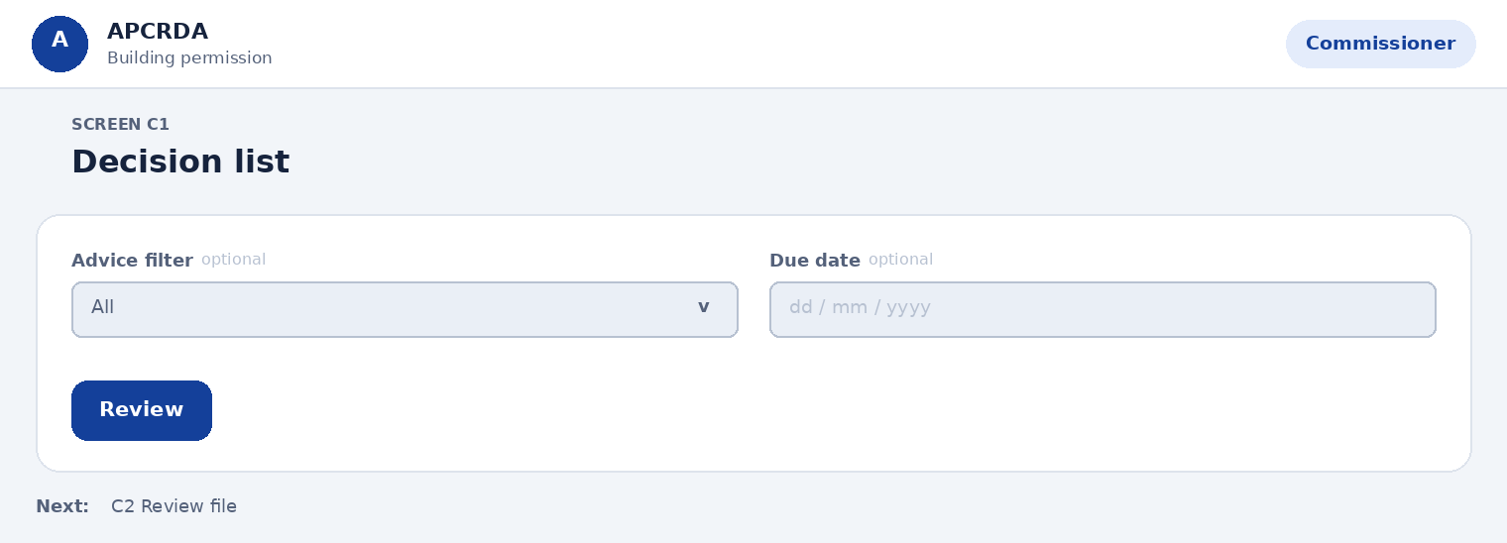
Fields on this page
Field | Type | Required | Notes
Advice filter | Choose one | No | Options: All, Approve, Approve with condition, Send back
Due date | Date | No | -
Actions
Action | What happens
Review | Opens Review file
Next step: C2 Review file

C2 Review file
Prototype: Commissioner decide and issue
Read the summary, officer advice and NOC status.
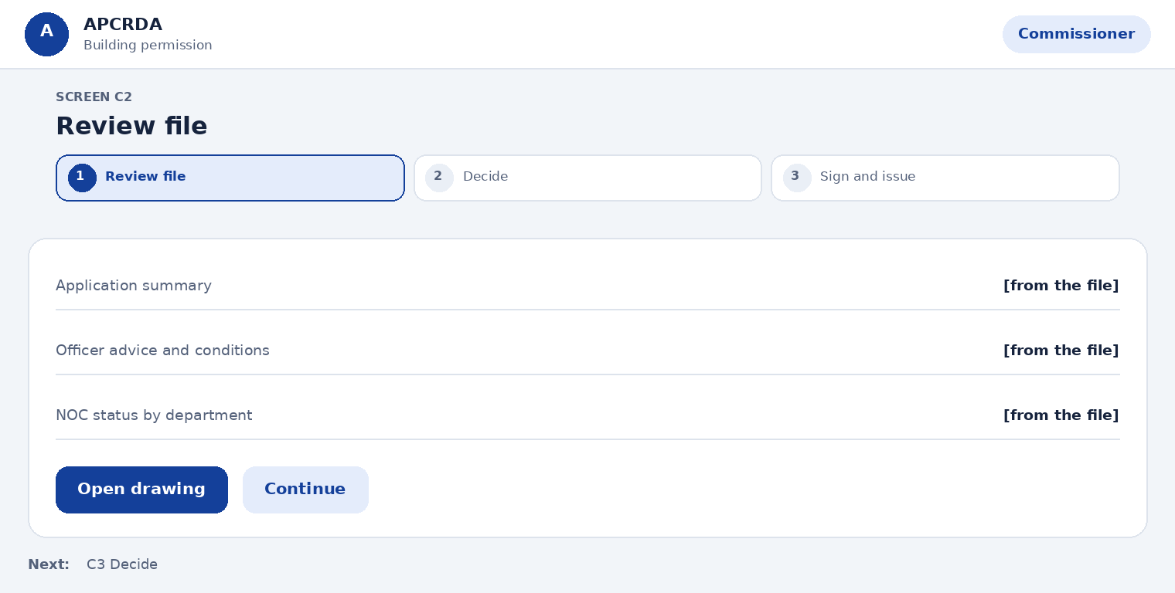
Fields on this page
Field | Type | Required | Notes
Application summary | Shown, not editable | Yes | -
Officer advice and conditions | Shown, not editable | Yes | -
NOC status by department | Shown, not editable | Yes | -
Actions
Action | What happens
Open drawing | Opens the drawing review
Continue | Opens Decide
Next step: C3 Decide

C3 Decide
Prototype: Commissioner decide and issue
Record the decision.
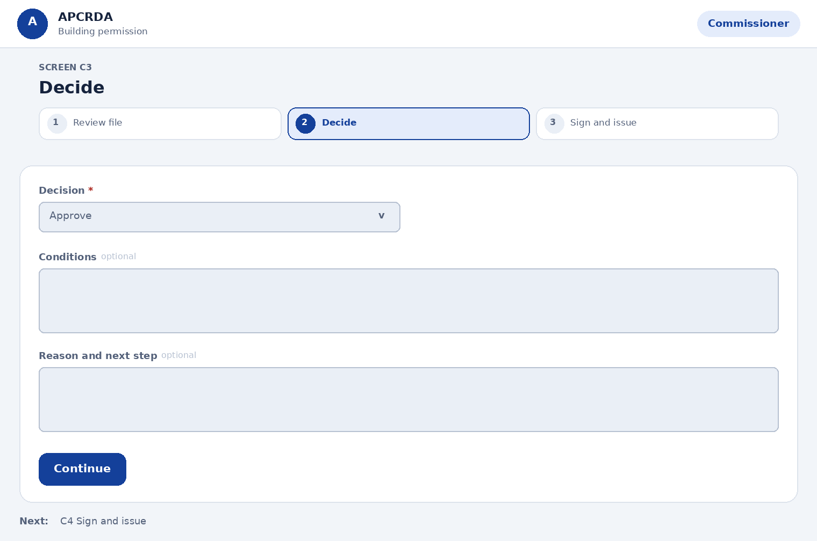
Fields on this page
Field | Type | Required | Notes
Decision | Choose one | Yes | Options: Approve, Approve with conditions, Send back
Conditions | Long text | No | Required for Approve with conditions
Reason and next step | Long text | No | Required for Send back
Actions
Action | What happens
Continue | Opens Sign and issue, or sends the file back with the reason
Next step: C4 Sign and issue

C4 Sign and issue
Prototype: Commissioner decide and issue
Sign digitally and release the Development Permission Order (DPO).
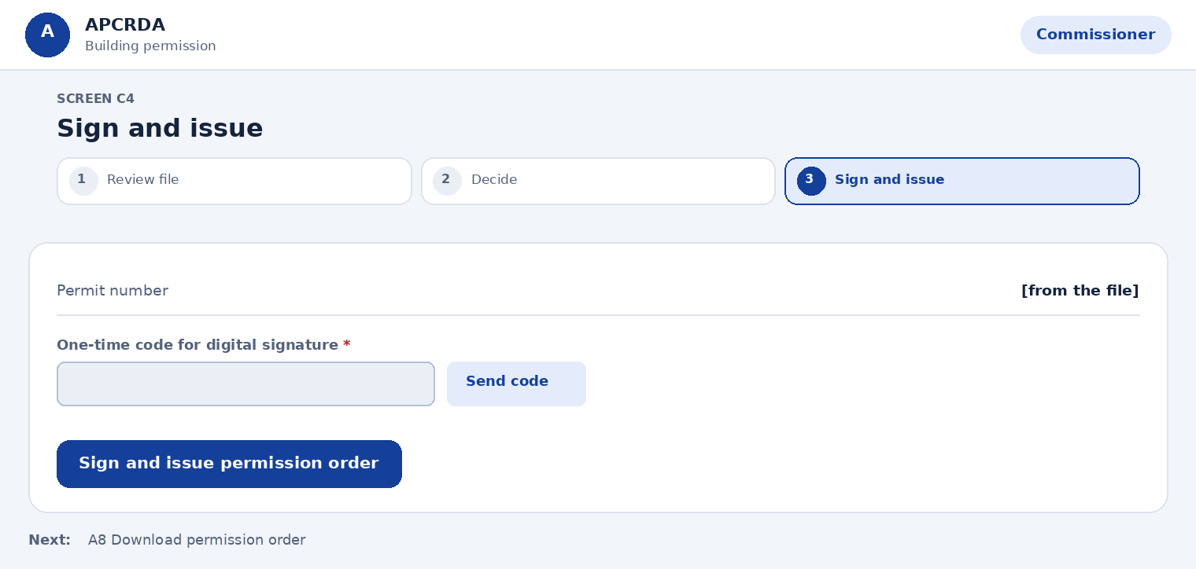
Fields on this page
Field | Type | Required | Notes
Permit number | Shown, not editable | Yes | Generated
One-time code for digital signature | Text plus one-time code | Yes | -
Actions
Action | What happens
Sign and issue permission order | DPO with QR code appears on the applicant's tracker; issued only after fees, deposits and charges are paid
Next step: A8 Download permission order

14.7 Chief City Planner and Executive Committee (Chief City Planner's office / Executive Committee)
Page sequence: E1 > E2 > E3. Each page below starts with a simple layout, then lists its fields, actions and next step.

E1 Open a case
Prototype: VarianceSteps.dc.html
Handle conditional uses, variances, appeals and interpretations. The Chief City Planner receives the case and prepares it for decision.
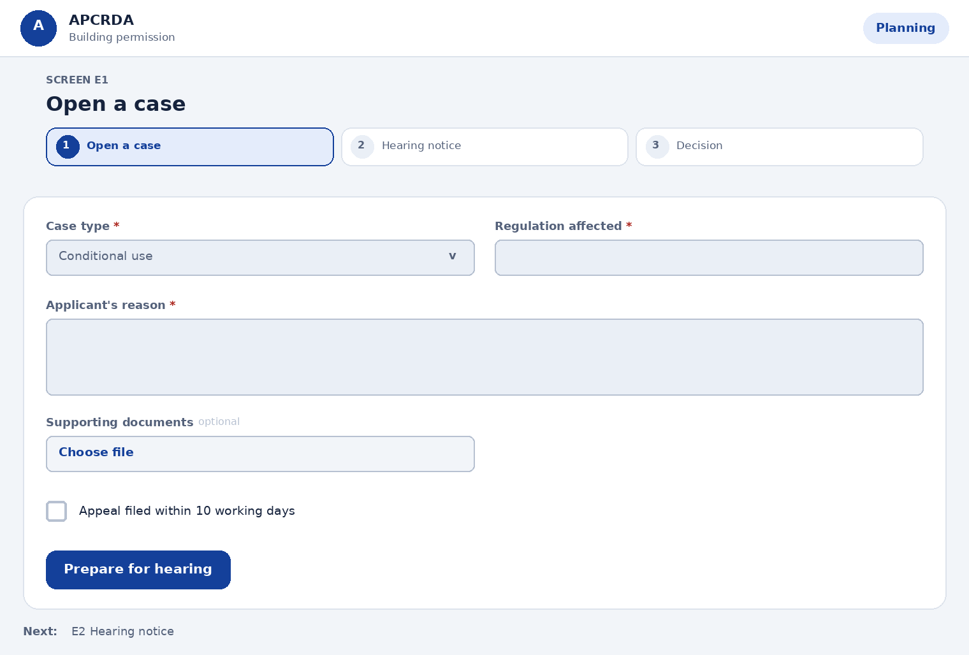
Fields on this page
Field | Type | Required | Notes
Case type | Choose one | Yes | Options: Conditional use, Variance, Appeal, Interpretation, Amendment request
Regulation affected | Text | Yes | -
Applicant's reason | Long text | Yes | -
Supporting documents | File upload | No | -
Appeal filed within 10 working days | Tick box | No | Appeals after 10 working days are not considered (Reg 205.2)
Actions
Action | What happens
Prepare for hearing | Opens Hearing notice
Next step: E2 Hearing notice

E2 Hearing notice
Prototype: VarianceSteps.dc.html
Give notice of the hearing to the applicant and neighbours.
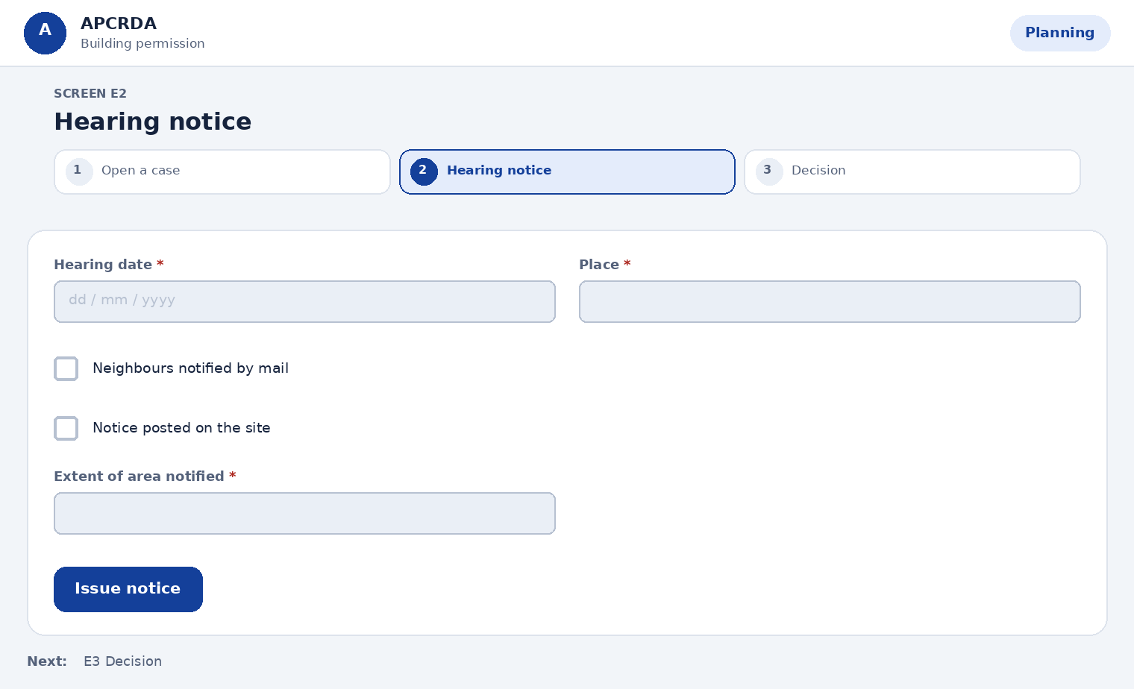
Fields on this page
Field | Type | Required | Notes
Hearing date | Date | Yes | -
Place | Text | Yes | -
Neighbours notified by mail | Tick box | Yes | Reasonable effort to notify surrounding owners
Notice posted on the site | Tick box | Yes | Posted in a conspicuous manner
Extent of area notified | Text | Yes | Set by the Chief City Planner
Actions
Action | What happens
Issue notice | Applicant and neighbours are told; case waits for the hearing
Next step: E3 Decision

E3 Decision
Prototype: VarianceSteps.dc.html
Record the decision. The Executive Committee cannot allow a use that the zone prohibits.
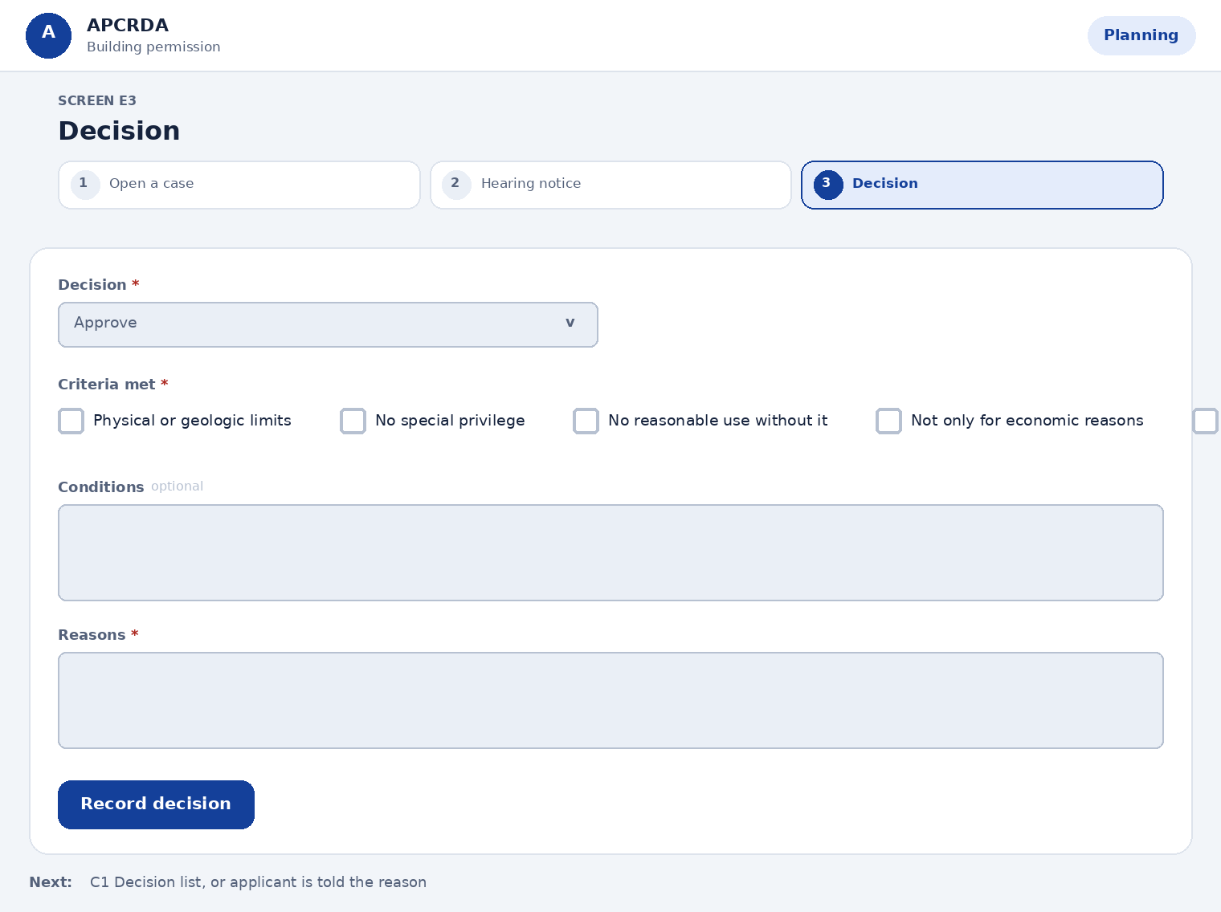
Fields on this page
Field | Type | Required | Notes
Decision | Choose one | Yes | Options: Approve, Approve with conditions, Deny
Criteria met | Choose several | Yes | Regulation 204.3. Options: Physical or geologic limits, No special privilege, No reasonable use without it, Not only for economic reasons, Not created by owner, Minimum variance needed, Not harmful to public, Unique property
Conditions | Long text | No | Required for Approve with conditions
Reasons | Long text | Yes | Recorded in writing
Actions
Action | What happens
Record decision | Applicant is notified; the file returns to the Commissioner
Next step: C1 Decision list, or applicant is told the reason

14.8 Accounts (Accounts office)
Page sequence: AC1 > AC2 > AC3 > AC4 > AC5. Each page below starts with a simple layout, then lists its fields, actions and next step.

AC1 Payments list
Prototype: Accounts fees ledger
See payments and their reconciliation status.
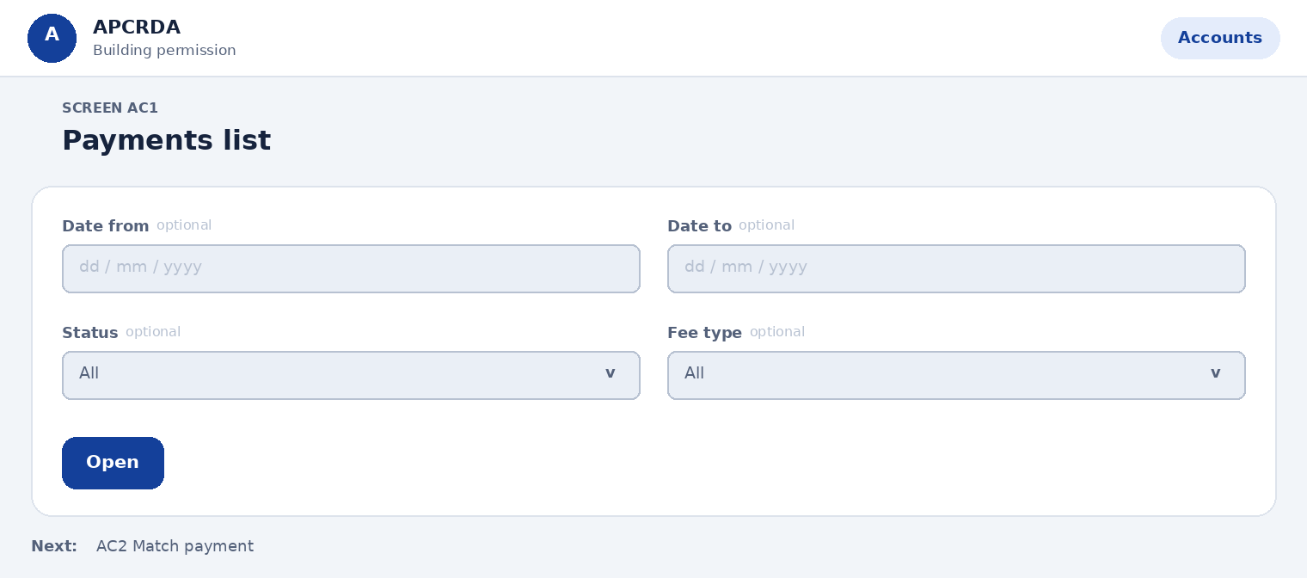
Fields on this page
Field | Type | Required | Notes
Date from | Date | No | -
Date to | Date | No | -
Status | Choose one | No | Options: All, Reconciled, Awaiting bank file, Amount mismatch
Fee type | Choose one | No | Options: All, Scrutiny fee, Development charges
Actions
Action | What happens
Open | Opens Match payment
Next step: AC2 Match payment

AC2 Match payment
Prototype: Accounts resolve payment
Compare what was due with what was paid.
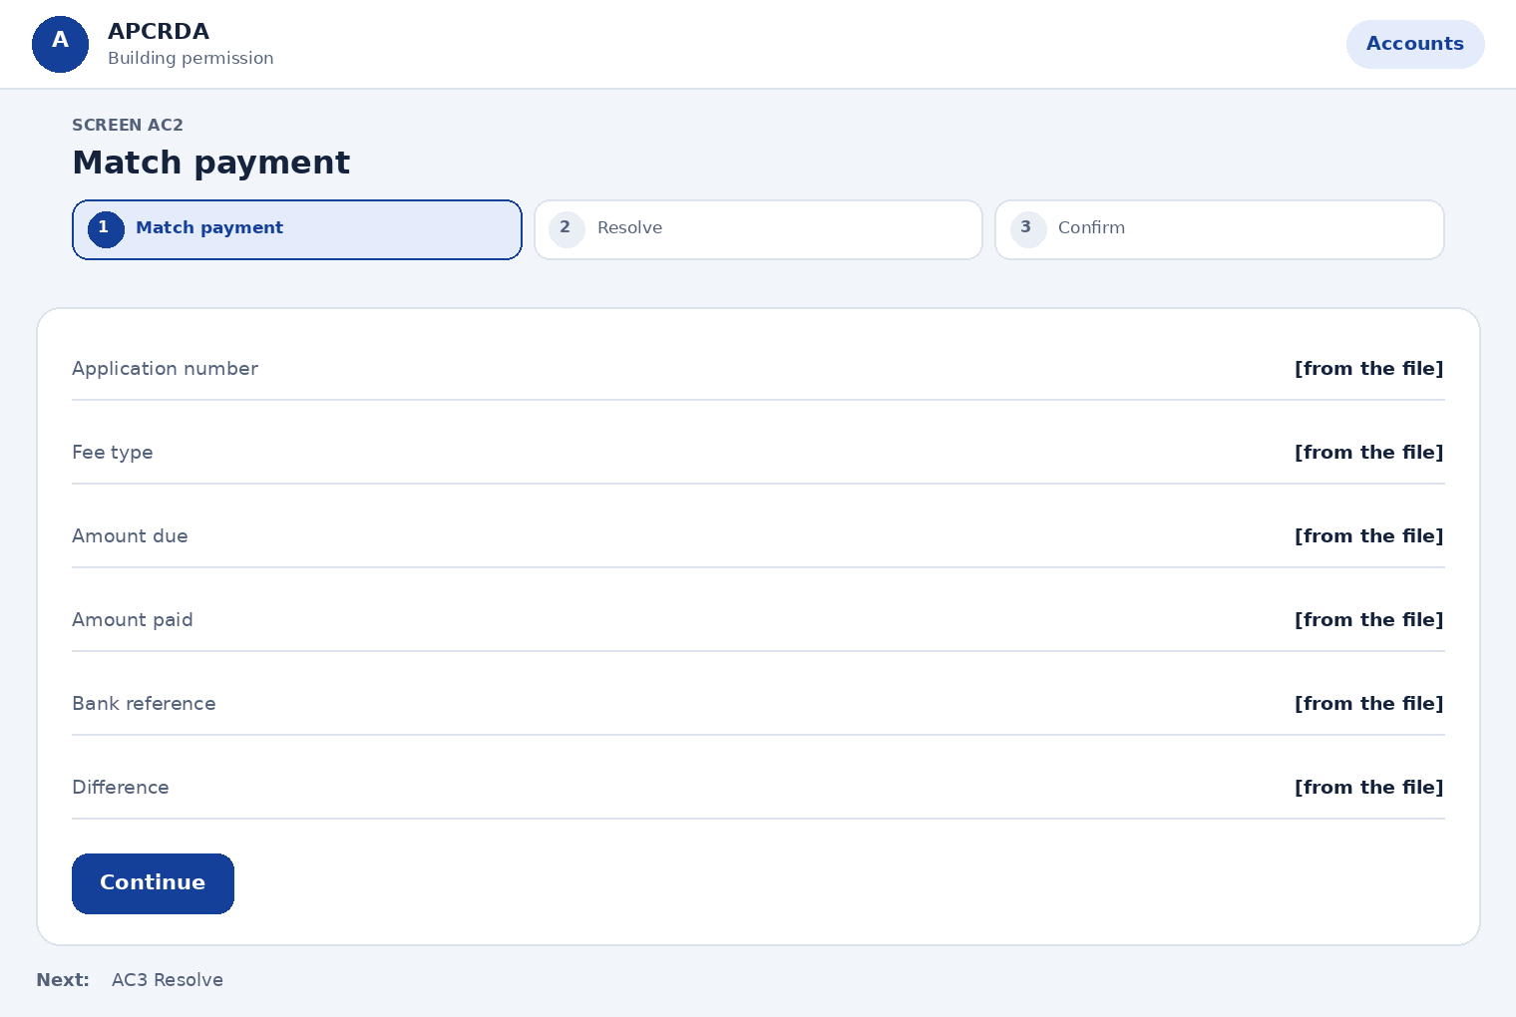
Fields on this page
Field | Type | Required | Notes
Application number | Shown, not editable | Yes | -
Fee type | Shown, not editable | Yes | -
Amount due | Shown, not editable | Yes | -
Amount paid | Shown, not editable | Yes | -
Bank reference | Shown, not editable | Yes | -
Difference | Shown, not editable | Yes | Calculated
Actions
Action | What happens
Continue | Opens Resolve
Next step: AC3 Resolve

AC3 Resolve
Prototype: Accounts resolve payment
Choose how to close the item. Mortgage is tracked separately and is released only after the occupancy certificate.
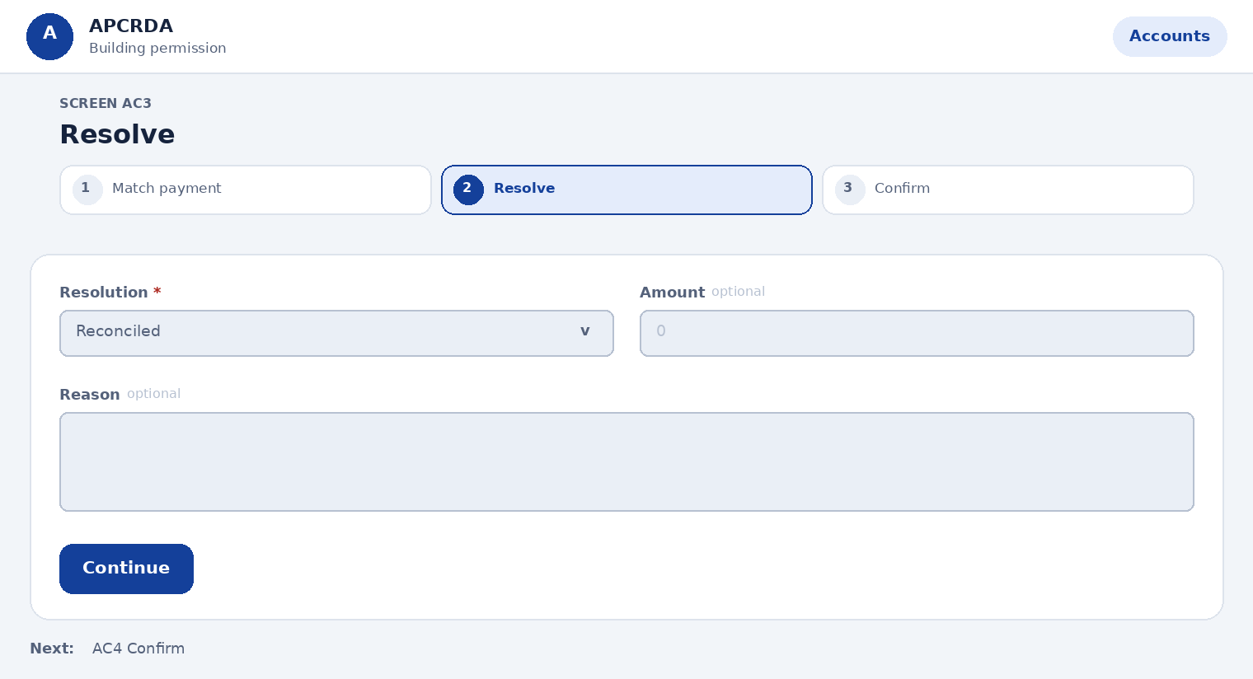
Fields on this page
Field | Type | Required | Notes
Resolution | Choose one | Yes | Options: Reconciled, Request difference, Record adjustment, Refund
Amount | Number | No | Required for adjustment or refund
Reason | Long text | No | Required except for Reconciled
Actions
Action | What happens
Continue | Opens Confirm
Next step: AC4 Confirm

AC4 Confirm
Prototype: Accounts resolve payment
Check and record.
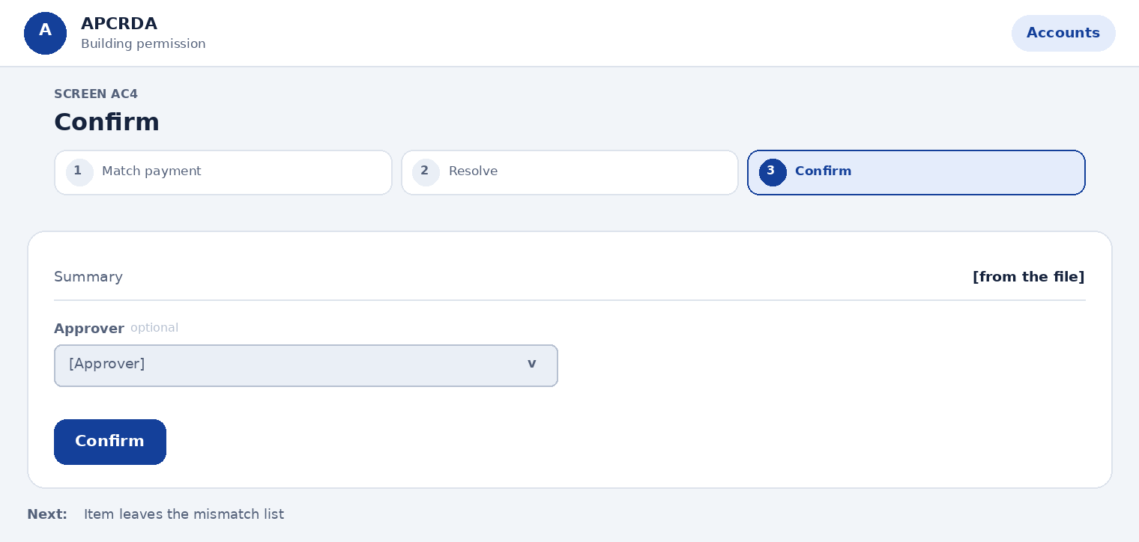
Fields on this page
Field | Type | Required | Notes
Summary | Shown, not editable | Yes | -
Approver | Choose one | No | Required for adjustment or refund. Options: [Approver]
Actions
Action | What happens
Confirm | Writes the audit entry; the applicant's tracker and notifications update
Next step: Item leaves the mismatch list

AC5 Daily report
Prototype: Described here only
Export the day's reconciliation.
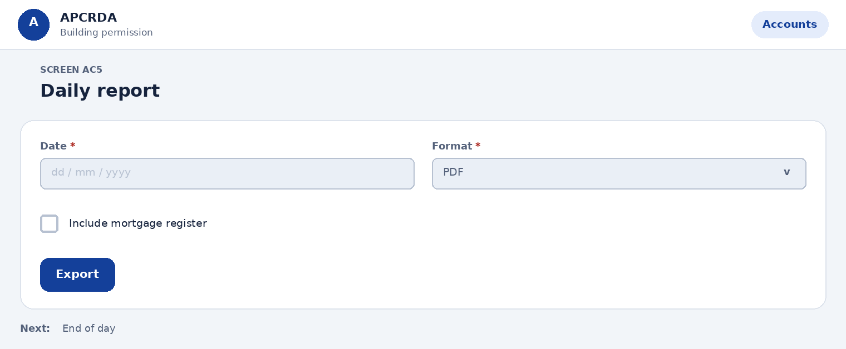
Fields on this page
Field | Type | Required | Notes
Date | Date | Yes | -
Format | Choose one | Yes | Options: PDF, Excel
Include mortgage register | Tick box | No | Lists mortgages held and those due for release
Actions
Action | What happens
Export | Downloads the report
Next step: End of day

14.9 System admin (CAD and GIS cell / IT)
Page sequence: AD1 > AD1a > AD1b > AD1c > AD1d > AD2 > AD3 > AD4 > AD5 > AD5b > AD10 > AD11 > AD12 > AD6 > AD7 > AD8 > AD9. Each page below starts with a simple layout, then lists its fields, actions and next step.

AD1 Users and roles
Prototype: Admin users and roles
See and manage every official user.
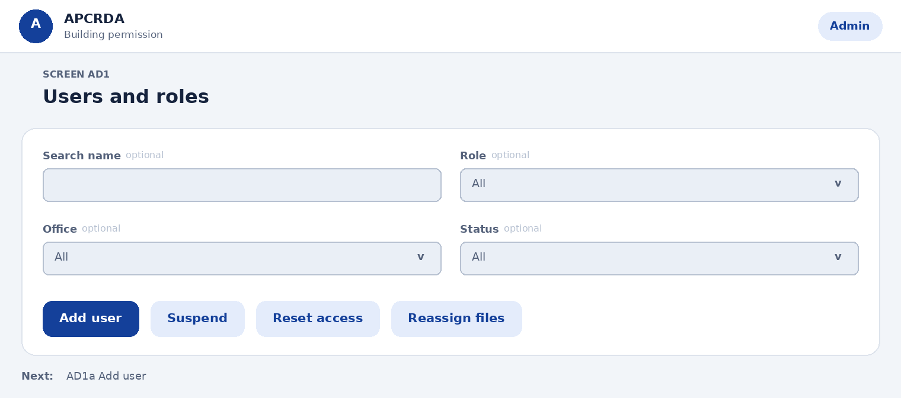
Fields on this page
Field | Type | Required | Notes
Search name | Text | No | -
Role | Choose one | No | Options: All, Scrutiny officer, Chief City Planner, Executive Committee member, NOC officer, Commissioner, Accounts, Admin
Office | Choose one | No | Options: All, [Office]
Status | Choose one | No | Options: All, Active, Suspended
Actions
Action | What happens
Add user | Opens the four-step Add user flow
Suspend | Blocks sign-in; open files are offered for reassignment
Reset access | Sends a new sign-in link
Reassign files | Moves open files to another user
Next step: AD1a Add user

AD1a Add user: person
Prototype: Admin add user, 4 steps
Enter who the user is.
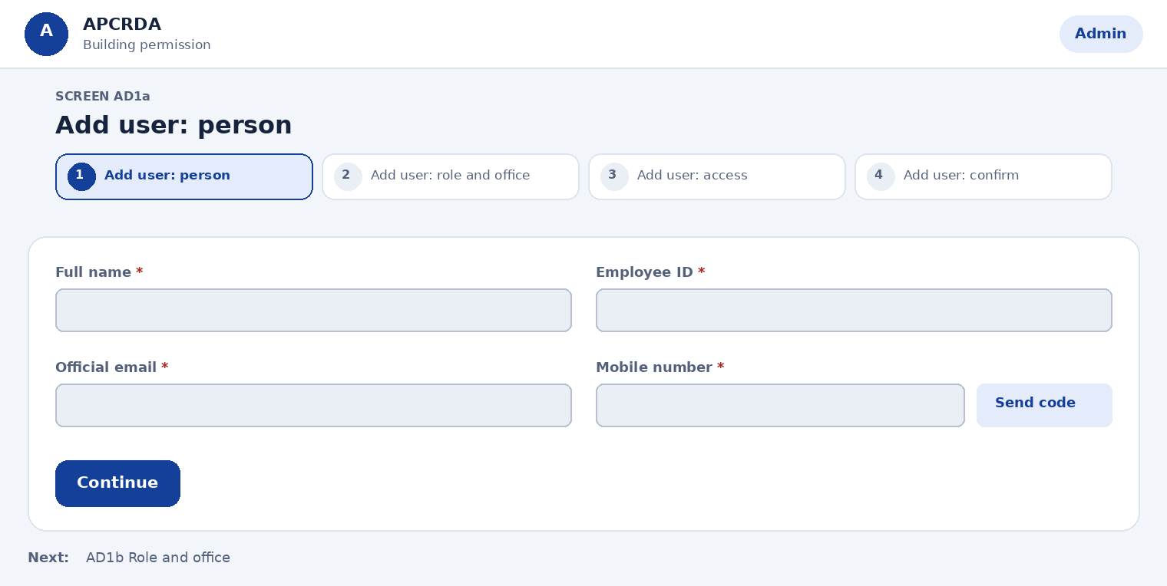
Fields on this page
Field | Type | Required | Notes
Full name | Text | Yes | -
Employee ID | Text | Yes | -
Official email | Text | Yes | -
Mobile number | Text plus one-time code | Yes | Verified with a one-time code
Actions
Action | What happens
Continue | Opens Role and office
Next step: AD1b Role and office

AD1b Add user: role and office
Prototype: Admin add user, 4 steps
Decide what the user can do and where.
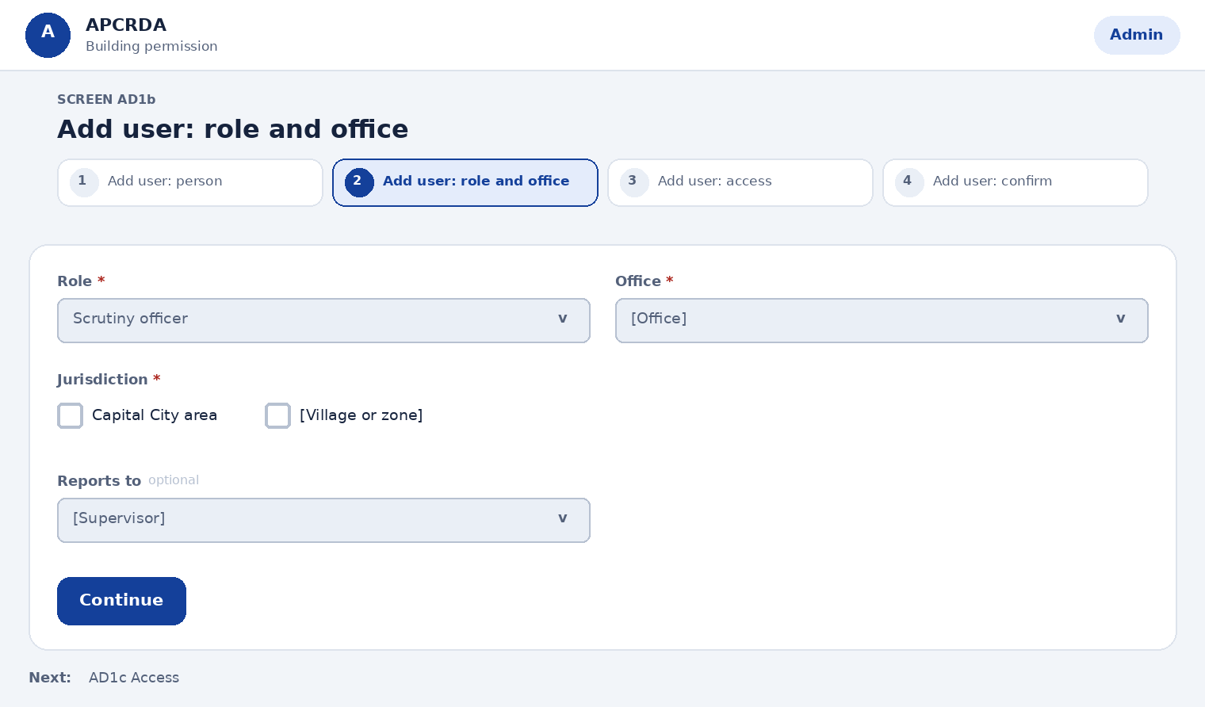
Fields on this page
Field | Type | Required | Notes
Role | Choose one | Yes | Options: Scrutiny officer, Chief City Planner, Executive Committee member, NOC officer, Commissioner, Accounts, Admin
Office | Choose one | Yes | Options: [Office]
Jurisdiction | Choose several | Yes | At least one. Options: Capital City area, [Village or zone]
Reports to | Choose one | No | Options: [Supervisor]
Actions
Action | What happens
Continue | Opens Access
Next step: AD1c Access

AD1c Add user: access
Prototype: Admin add user, 4 steps
Set access limits.
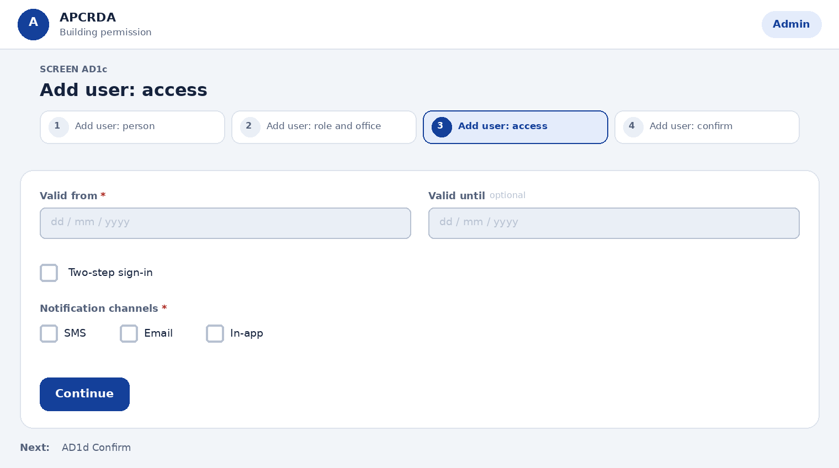
Fields on this page
Field | Type | Required | Notes
Valid from | Date | Yes | -
Valid until | Date | No | Leave empty for no end date
Two-step sign-in | Tick box | Yes | Must be on
Notification channels | Choose several | Yes | Options: SMS, Email, In-app
Actions
Action | What happens
Continue | Opens Confirm
Next step: AD1d Confirm

AD1d Add user: confirm
Prototype: Admin add user, 4 steps
Check and send the invitation.
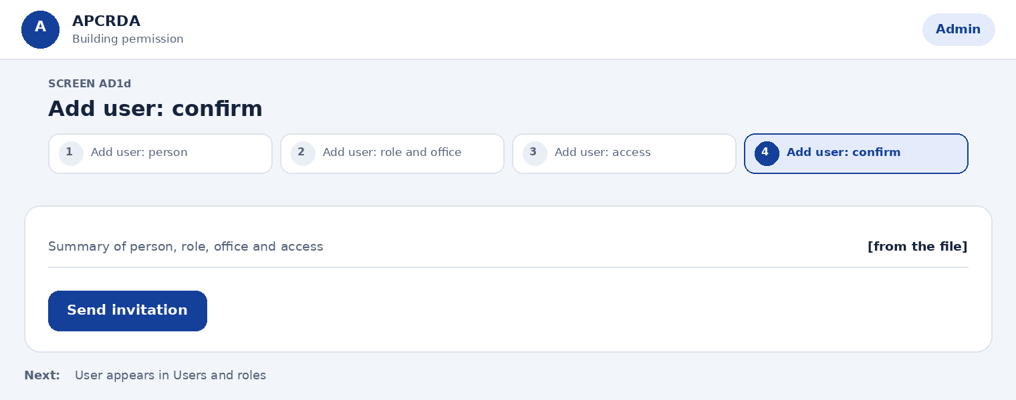
Fields on this page
Field | Type | Required | Notes
Summary of person, role, office and access | Shown, not editable | Yes | -
Actions
Action | What happens
Send invitation | User gets a sign-in link; an audit entry is written
Next step: User appears in Users and roles

AD2 Offices and jurisdictions
Prototype: Admin offices and jurisdictions
Manage offices, who heads them and what areas they cover.
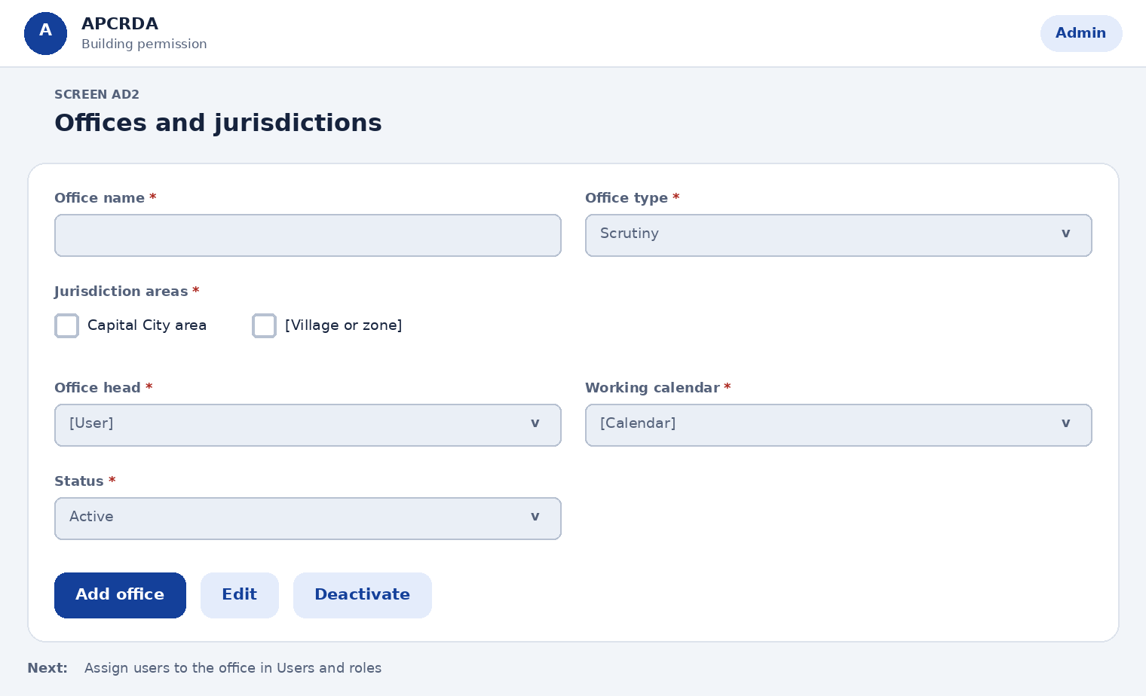
Fields on this page
Field | Type | Required | Notes
Office name | Text | Yes | -
Office type | Choose one | Yes | Options: Scrutiny, Planning (Chief City Planner), Executive Committee, NOC department, Commissioner, Accounts
Jurisdiction areas | Choose several | Yes | Options: Capital City area, [Village or zone]
Office head | Choose one | Yes | Options: [User]
Working calendar | Choose one | Yes | Holidays pause stage clocks. Options: [Calendar]
Status | Choose one | Yes | Options: Active, Inactive
Actions
Action | What happens
Add office | Creates the office
Edit | Changes apply to new files
Deactivate | Open files are offered for reassignment
Next step: Assign users to the office in Users and roles

AD3 Workflow and SLA
Prototype: Admin workflow and SLA
Set the time limit, reminders and escalation for each stage. Regulatory limits are fixed and shown alongside.
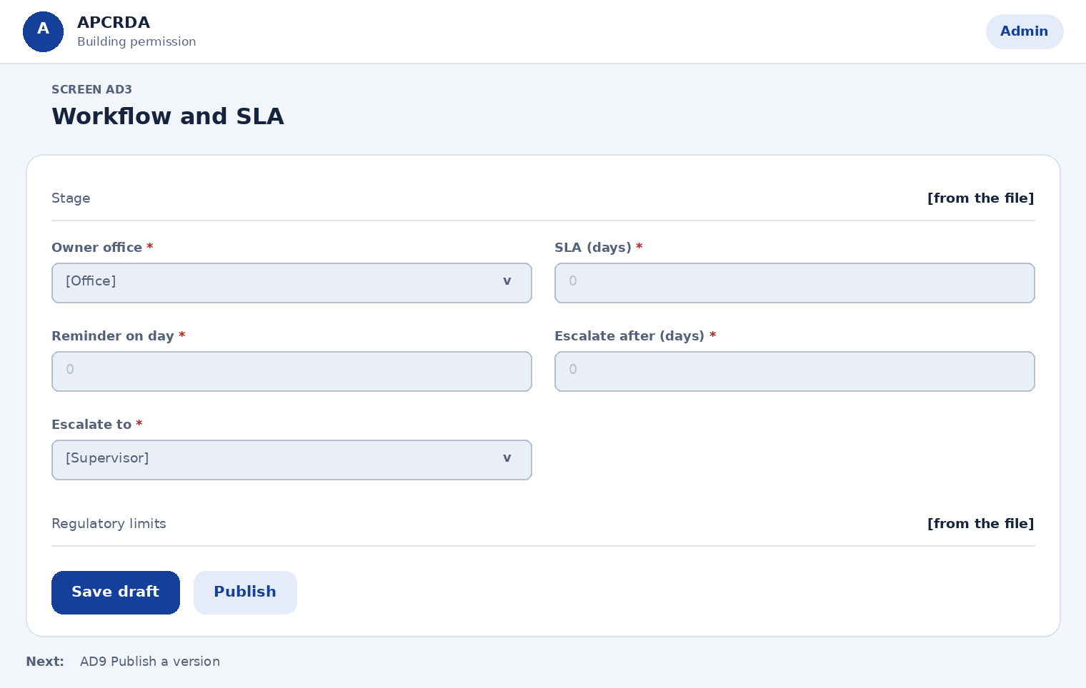
Fields on this page
Field | Type | Required | Notes
Stage | Shown, not editable | Yes | Permit journey plus commencement, completion and occupancy
Owner office | Choose one | Yes | Options: [Office]
SLA (days) | Number | Yes | Decision on application: 60 days from application or from the applicant's reply (Reg 212.2)
Reminder on day | Number | Yes | -
Escalate after (days) | Number | Yes | -
Escalate to | Choose one | Yes | Options: [Supervisor]
Regulatory limits | Shown, not editable | Yes | Line-out check 7 days (213.1). Occupancy certificate 15 days (213.6). Appeal 10 working days (205.2). Delay penalty of Rs 10,000 per responsible staff member (212.2)
Actions
Action | What happens
Save draft | Keeps changes private
Publish | Applies to new files only
Next step: AD9 Publish a version

AD4 Route and trigger rules
Prototype: Admin category rules
Define what an application needs when it crosses a threshold: NOCs, a design brief, exemptions or a Chief City Planner review.
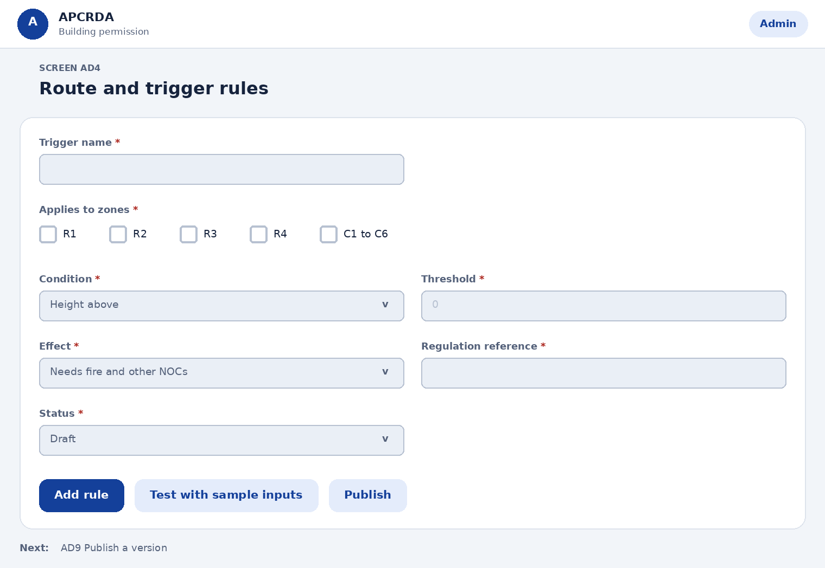
Fields on this page
Field | Type | Required | Notes
Trigger name | Text | Yes | -
Applies to zones | Choose several | Yes | Options: R1, R2, R3, R4, C1 to C6, I1 to I3, P, S and U
Condition | Choose one | Yes | Options: Height above, Plot area above, Plot area up to, Use is, Building is public congregation
Threshold | Number | Yes | [threshold]
Effect | Choose one | Yes | Options: Needs fire and other NOCs, Needs a design brief, Exempt from 10% handover, Needs Chief City Planner review, Needs environmental clearance
Regulation reference | Text | Yes | For example 209.7, 209.8, 215.3(5)
Status | Choose one | Yes | Options: Draft, Active, Retired
Actions
Action | What happens
Add rule | Creates a draft rule
Test with sample inputs | Shows which rules a sample project triggers
Publish | Applies to new files only
Next step: AD9 Publish a version

AD5 Fee schedule
Prototype: Admin fee schedule
Manage the fees, deposits and charges the regulations allow. Rates are taken from APCRDA notifications; enter the source order for each.
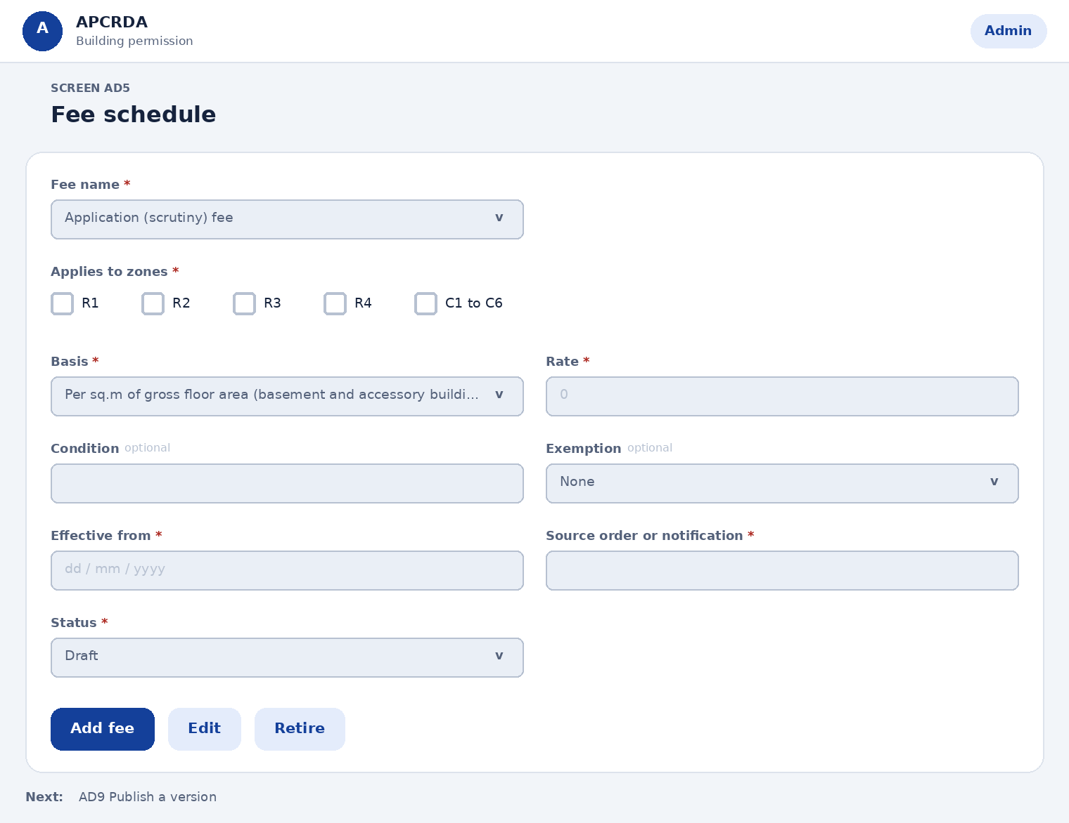
Fields on this page
Field | Type | Required | Notes
Fee name | Choose one | Yes | Options: Application (scrutiny) fee, Development charges, Impact fee, Compounding fee, Revalidation fee, Temporary structure scrutiny fee
Applies to zones | Choose several | Yes | Options: R1, R2, R3, R4, C1 to C6, I1 to I3, P, S and U
Basis | Choose one | Yes | Options: Per sq.m of gross floor area (basement and accessory buildings included, parking excluded), Flat amount, Percent of land value, Percent of built-up value
Rate | Number | Yes | [rate]
Condition | Text | No | For example FSI above 1.75 for the impact fee
Exemption | Choose one | No | Options: None, EWS, LIG or slum scheme with tenement carpet area up to 50 sq.m
Effective from | Date | Yes | -
Source order or notification | Text | Yes | Government order or APCRDA notification number
Status | Choose one | Yes | Options: Draft, Active, Retired
Actions
Action | What happens
Add fee | Creates a draft fee
Edit | Creates a new version; old versions stay on old files
Retire | Stops use for new files
Next step: AD9 Publish a version

AD5b Deposits and security
Prototype: Admin fee schedule
Set the security and compounding rules that sit alongside fees.
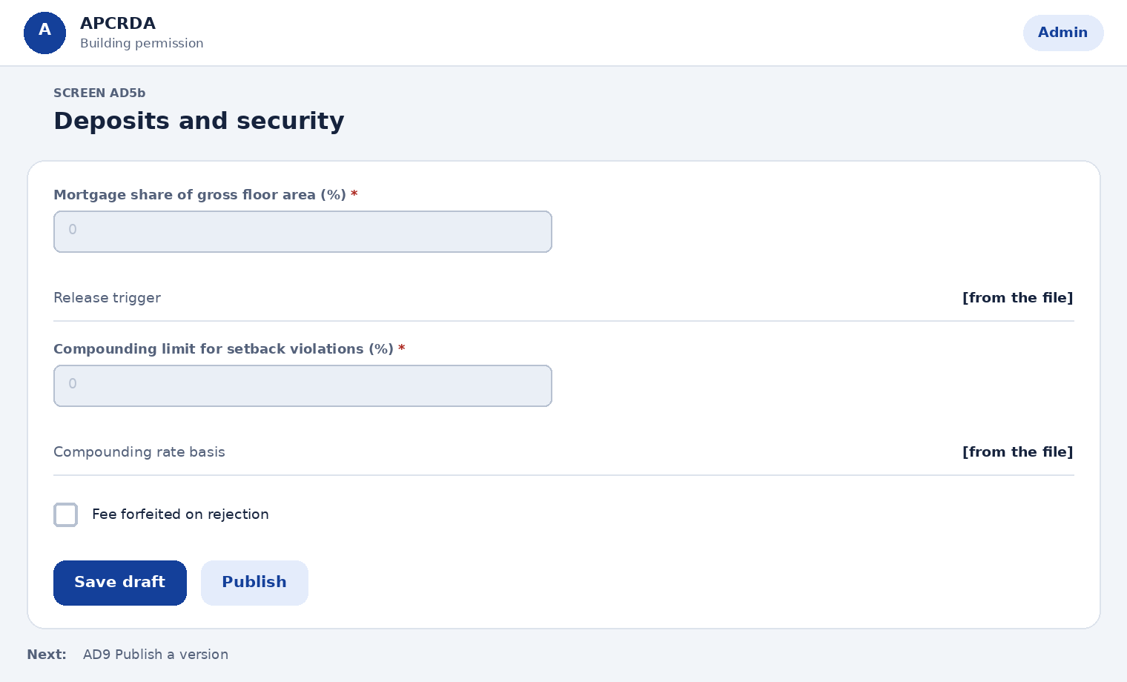
Fields on this page
Field | Type | Required | Notes
Mortgage share of gross floor area (%) | Number | Yes | Regulation 210.4 sets ten percent
Release trigger | Shown, not editable | Yes | Occupancy certificate for the entire development (Reg 213.9)
Compounding limit for setback violations (%) | Number | Yes | Other than front setback, non-high-rise only, up to 10% (Reg 215.4)
Compounding rate basis | Shown, not editable | Yes | 100% of registered land value of the violated portion, as revised by Government
Fee forfeited on rejection | Tick box | Yes | Regulation 210.3
Actions
Action | What happens
Save draft | Keeps changes private
Publish | Applies to new files only
Next step: AD9 Publish a version

AD10 Zoning table
Prototype: AdminZoning.dc.html
Keep the zoning rules the system checks against. One row per zone and plot-size band.
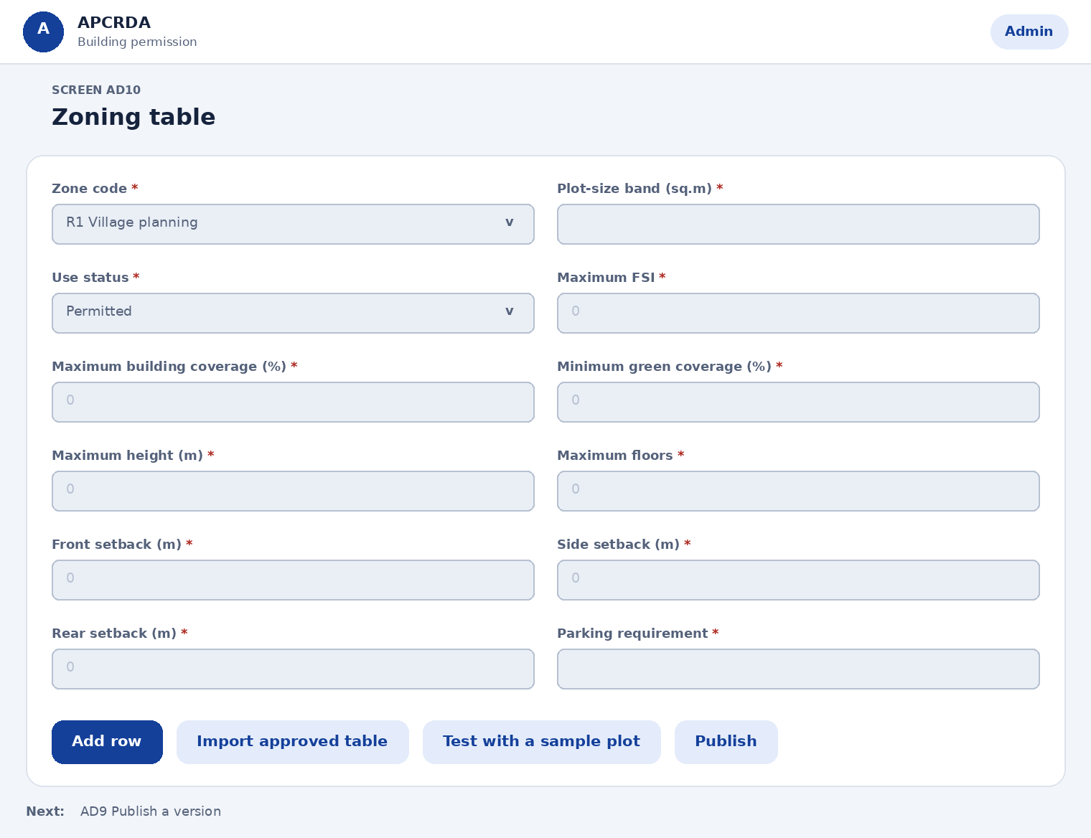
Fields on this page
Field | Type | Required | Notes
Zone code | Choose one | Yes | Table 5 of the regulations. Options: R1 Village planning, R2 Low density, R3 Medium to high density, R4 High density, C1 Mixed use, C2 General commercial, C3 Neighbourhood centre, C4 Town centre, C5 Regional centre, C6 Central business district, I1 Business park, I2 Logistics, I3 Non-polluting industry, P1 Passive, P2 Active, P3 Protected, S1 Government, S2 Education, S3 Special, U1 Reserve, U2 Road reserve
Plot-size band (sq.m) | Text | Yes | From the zoning table
Use status | Choose one | Yes | Where Appendix II and III differ, Appendix II prevails (Reg 304.1). Options: Permitted, Conditional, Prohibited
Maximum FSI | Number | Yes | [from table]
Maximum building coverage (%) | Number | Yes | [from table]
Minimum green coverage (%) | Number | Yes | [from table]
Maximum height (m) | Number | Yes | [from table]
Maximum floors | Number | Yes | [from table]
Front setback (m) | Number | Yes | [from table]
Side setback (m) | Number | Yes | [from table]
Rear setback (m) | Number | Yes | [from table]
Parking requirement | Text | Yes | [from table]
Actions
Action | What happens
Add row | Adds a draft row
Import approved table | Loads rows from a checked spreadsheet
Test with a sample plot | Shows what the applicant would see on the Zoning check screen
Publish | Applies to new files only
Next step: AD9 Publish a version

AD11 Village (R1) settings
Prototype: AdminVillage.dc.html
Set the rules that apply to villages inside the Capital City area.
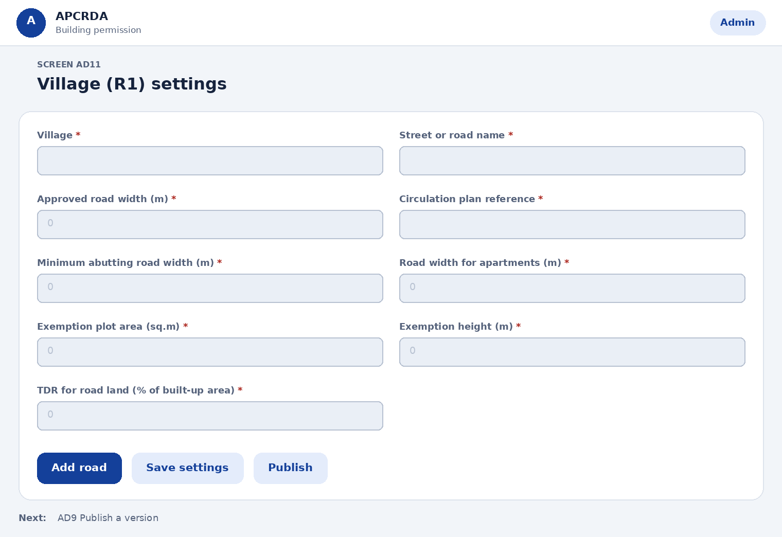
Fields on this page
Field | Type | Required | Notes
Village | Text | Yes | -
Street or road name | Text | Yes | -
Approved road width (m) | Number | Yes | From the village circulation plan approved by the Commissioner
Circulation plan reference | Text | Yes | -
Minimum abutting road width (m) | Number | Yes | Nine metres (Reg 401.5)
Road width for apartments (m) | Number | Yes | Twelve metres existing road (Reg 401.5)
Exemption plot area (sq.m) | Number | Yes | Up to 200 sq.m, with height up to 7 m, exempt from the 10% handover (Reg 215.3)
Exemption height (m) | Number | Yes | -
TDR for road land (% of built-up area) | Number | Yes | Up to 200% (Reg 215.2)
Actions
Action | What happens
Add road | Adds a street with its approved width
Save settings | Applies to new files only
Publish | Applies to new files only
Next step: AD9 Publish a version

AD12 Zoning map and land records
Prototype: AdminMap.dc.html
Load the zoning map and the ownership records the portal checks against.
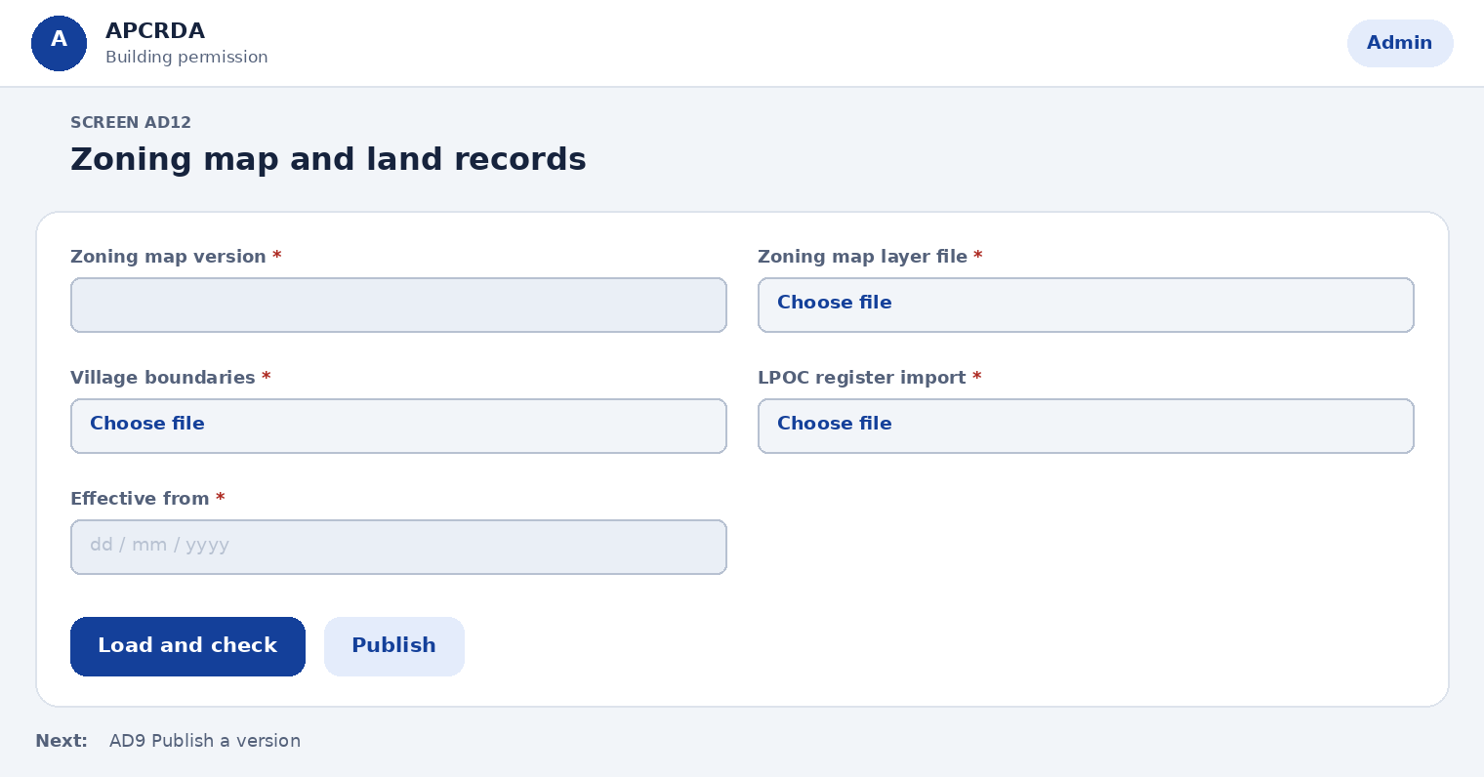
Fields on this page
Field | Type | Required | Notes
Zoning map version | Text | Yes | Include amendments notified after February 2016
Zoning map layer file | File upload | Yes | -
Village boundaries | File upload | Yes | -
LPOC register import | File upload | Yes | For checking land pooling ownership certificates
Effective from | Date | Yes | -
Actions
Action | What happens
Load and check | Validates files and lists errors
Publish | New map applies to new files only
Next step: AD9 Publish a version

AD6 Layer table and room schedule
Prototype: Admin: room schedule
Keep the standards the drawing check uses.
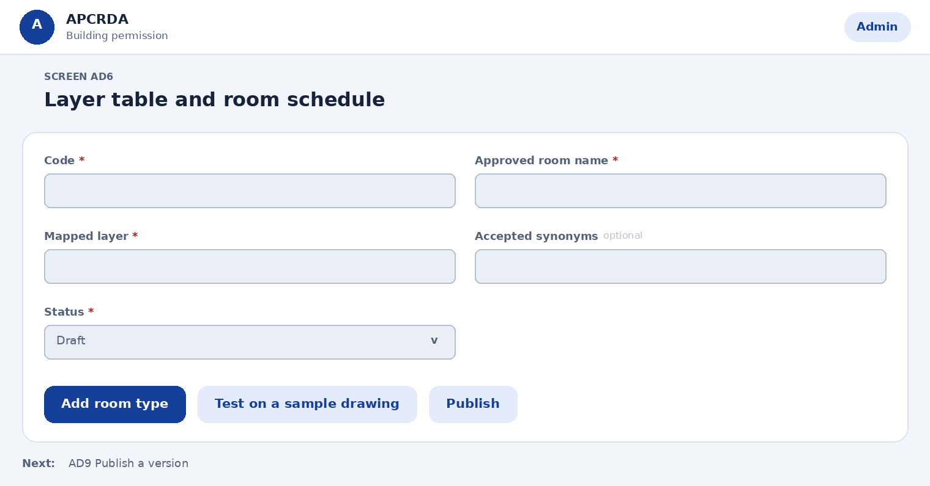
Fields on this page
Field | Type | Required | Notes
Code | Text | Yes | -
Approved room name | Text | Yes | Spelled exactly as shown to applicants
Mapped layer | Text | Yes | -
Accepted synonyms | Text | No | Separated by commas
Status | Choose one | Yes | Options: Draft, Active, Retired
Actions
Action | What happens
Add room type | Adds a draft row
Test on a sample drawing | Runs the check against sample files
Publish | Applies to new submissions only
Next step: AD9 Publish a version

AD7 Notification templates
Prototype: Admin notification templates
Control the messages people receive.
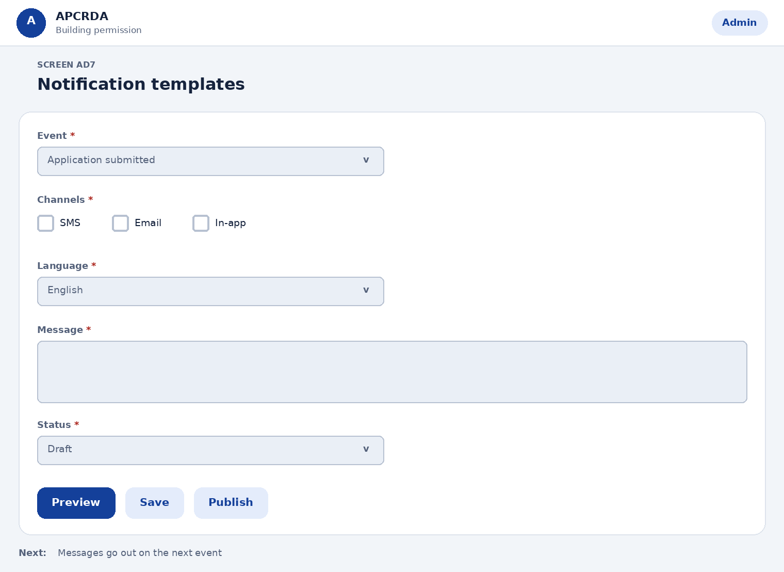
Fields on this page
Field | Type | Required | Notes
Event | Choose one | Yes | Options: Application submitted, Query raised, Fee due, NOC issued, Permit issued
Channels | Choose several | Yes | Options: SMS, Email, In-app
Language | Choose one | Yes | Options: English, Telugu
Message | Long text | Yes | Variables: applicant, application number, stage, due date
Status | Choose one | Yes | Options: Draft, Active
Actions
Action | What happens
Preview | Shows the message with sample values
Save | Saves a draft
Publish | Applies to new events
Next step: Messages go out on the next event

AD8 Audit log and reports
Prototype: Admin audit log
Find who did what, and when.
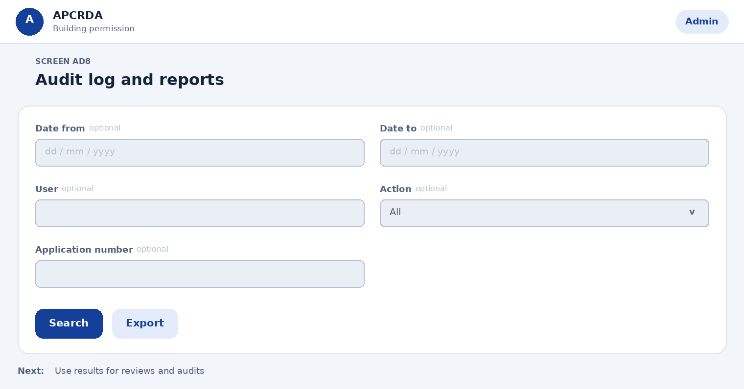
Fields on this page
Field | Type | Required | Notes
Date from | Date | No | -
Date to | Date | No | -
User | Text | No | -
Action | Choose one | No | Options: All, Sign-in, Decision, Payment, Rule change
Application number | Text | No | -
Actions
Action | What happens
Search | Lists matching entries
Export | Downloads the result
Next step: Use results for reviews and audits

AD9 Publish a version
Prototype: Admin: room schedule
Release a rule change safely.
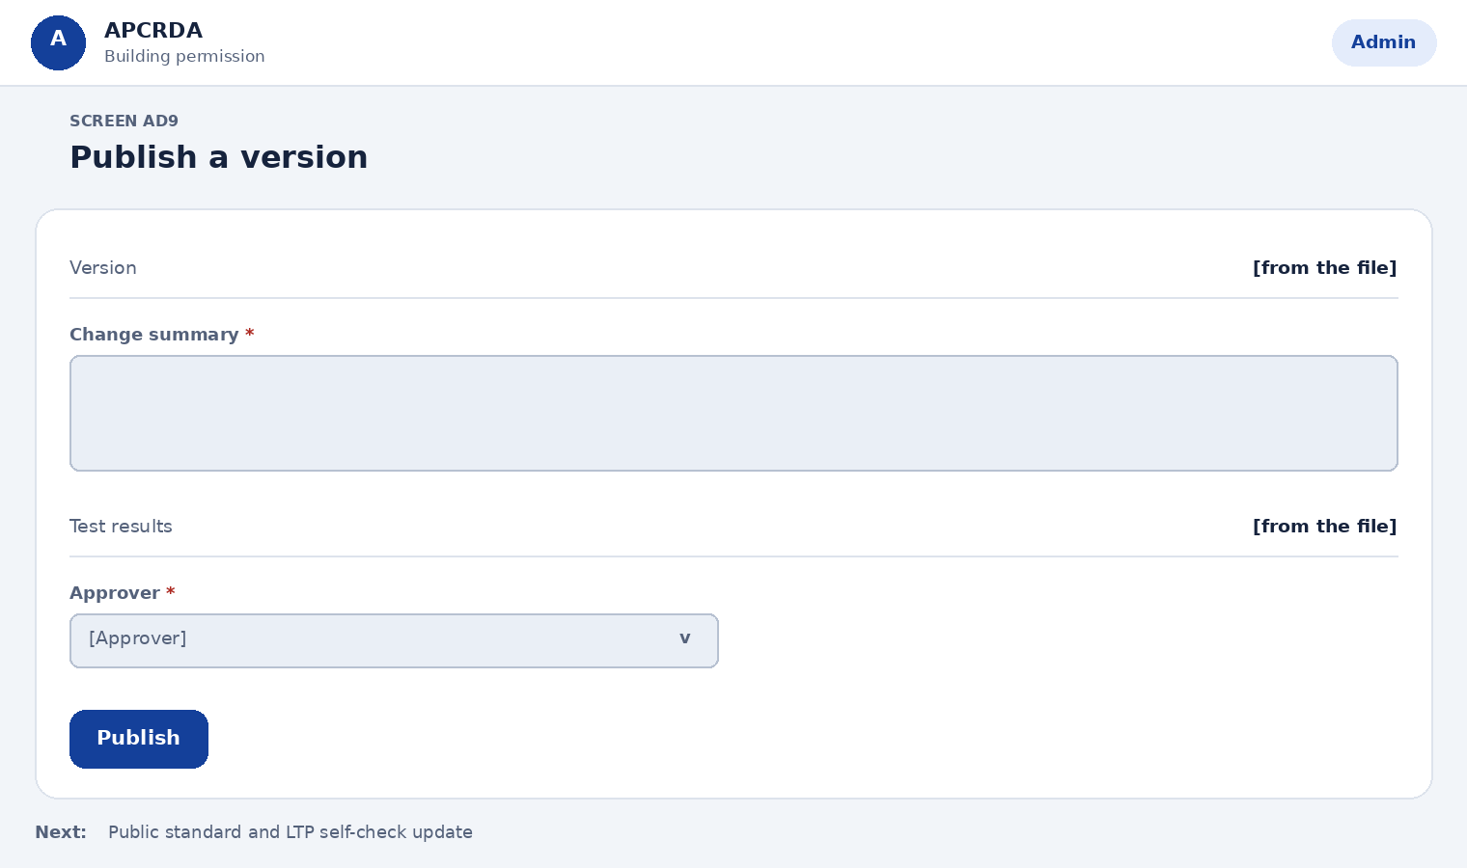
Fields on this page
Field | Type | Required | Notes
Version | Shown, not editable | Yes | Generated
Change summary | Long text | Yes | -
Test results | Shown, not editable | Yes | From the sample drawings
Approver | Choose one | Yes | Options: [Approver]
Actions
Action | What happens
Publish | New version applies to new submissions only; files in progress keep the version they started with
Next step: Public standard and LTP self-check update

15. Capital City scope, zoning, R1 and fees
This section applies the Zoning Regulations of Amaravati Capital City (February 2016) to the portal design. Regulation numbers are given so each rule can be traced. Rates and table values that were not available in public sources are shown as placeholders.

15.1 Scope
Item | Decision in this version
In scope | Buildings in the Amaravati Capital City area: Development Permission Order (DPO), commencement notice and line-out check, inspections, completion and occupancy certificate, conditional uses, variances and appeals.
Out of scope | The wider APCRDA jurisdiction outside the Capital City area, which is not covered by these zoning regulations. Layout and sub-division approval is a separate process.
To confirm | Whether the Amaravati Government Complex is in scope (it has its own 2024 zoning regulations and urban design guidelines). Whether later amendments apply, including the environment-clearance gazette amendment and the R5 affordable housing zone.
Precedence | Urban design guidelines approved by the Commissioner take precedence over the zoning regulations (Reg 305.2). Where Appendix II and III differ, Appendix II prevails (Reg 304.1). The more restrictive rule governs where sections differ (Reg 101.3).

15.2 Zoning districts
The portal looks up the zone from the zoning map and checks the proposal against that zone's table (Reg 301, Table 5). Territory annexed later is treated as R2 until classified (Reg 303).
Code | Zoning district | Group
R1 | Village planning zone | Residential
R2 | Low density zone | Residential
R3 | Medium to high density zone | Residential
R4 | High density zone | Residential
C1 | Mixed use zone | Commercial
C2 | General commercial zone | Commercial
C3 | Neighbourhood centre zone | Commercial
C4 | Town centre zone | Commercial
C5 | Regional centre zone | Commercial
C6 | Central business district zone | Commercial
I1 | Business park zone | Industrial
I2 | Logistics zone | Industrial
I3 | Non-polluting industry zone | Industrial
P1 | Passive zone | Open space and protected
P2 | Active zone | Open space and protected
P3 | Protected zone | Open space and protected
S1 | Government zone | Institutional
S2 | Education zone | Institutional
S3 | Special zone | Institutional
U1 | Reserve zone | Infrastructure reserve
U2 | Road reserve zone | Infrastructure reserve

15.3 R1 village planning zone
Rule | What the regulation says | Where it appears
Purpose | Low-rise housing and complementary public facilities inside existing villages of the Capital City (Reg 401.5). | Zoning check
Abutting road | A road at least 9 m wide must abut the building. The applicant shows road widths on the site plan (Reg 401.5). | Project details, live check
Apartments | Allowed where the site is reached by a 12 m wide existing road (Reg 401.5). | Zoning check
Road handover | Land needed for the road width in the village circulation plan approved by the Commissioner is handed over free of cost (Reg 401.5, 215.1). | Road handover and TDR (A2c)
In return | A TDR certificate, an extra floor of equal built area, or setback concessions (Reg 215.1). TDR up to 200% of the built-up area for road land (Reg 215.2), only after a registered gift deed. | Road handover and TDR (A2c)
Small-plot exemption | Individual residential buildings on plots up to 200 sq.m and up to 7 m high are exempt from the 10% built-up area handover (Reg 215.3). | Review and submit (A5), route rules
Table values | FSI, coverage, height, floors, setbacks and parking come from the R1 zoning table (Appendix III). | Admin zoning table (AD10)

15.4 Timelines and authorities
Item | Rule | Regulation
Decision on application | Commissioner decides within 60 days of the application or of the applicant's reply to a requisition, whichever is later. | 207.2, 212.2
Delay penalty | Rs 10,000 on each responsible staff member, paid to the applicant. | 212.2
Objections | Raised in one go; no new objections after compliance, generally. | 212.3
Start of work | Within one year of the permission order; line-out checked within 7 days of the notice. | 213.1
Occupancy certificate | Decided within 15 days of the completion certificate; deemed approved for occupation after that if built as sanctioned. | 213.6
Appeal | Within 10 working days; an appeal stays proceedings unless there is immediate danger. | 205.2
Who decides | Commissioner sanctions and decides conditional uses. Chief City Planner receives cases and interprets. Executive Committee decides variances and appeals, but cannot allow a prohibited use. | 202 to 205, 214

15.5 Fees, deposits and charges
Item | Rule | Reg | Rate
Application (scrutiny) fee | Paid with the application. Based on gross floor area, including basement and accessory buildings, excluding parking. Forfeited if the proposal is rejected. | 210.1, 210.3 | [rate]
Exemption | No development permission fee for EWS, LIG and slum redevelopment schemes with tenement carpet area up to 50 sq.m. | 210.2 | None
Development charges | Fees and charges for development permission, as notified by APCRDA. | 210.5 | [rate]
Impact fee | Payable where FSI exceeds 1.75, as levied by APCRDA. | 210.5 | [rate]
Mortgage | Ten percent of gross floor area mortgaged by registered deed; released when the occupancy certificate is issued. | 210.4, 213.9 | 10% of GFA
Handover of built-up area | Ten percent of built-up area (5% of units for row, detached or cluster housing) by notarised affidavit before sanction, unless exempt. | 215.3 | 10% or 5%
Compounding fee | For setback violations other than front, non-high-rise only, up to 10%; rate equal to the registered land value of the violated portion. | 215.4 | Land value
Orders to cite | Impact fee for buildings on major roads was set by G.O.Ms.No.117 dated 11 August 2022. Confirm the current schedule before loading rates. | - | Confirm

15.6 Drawings and documents
Requirement | Rule (Reg 208 and 209)
Sheet sizes | A0 to A5, metric dimensions only.
Scales | Key plan not less than 1:10000, site plan 1:500, building plans 1:100.
Colour notation | Table 3: plot lines thick black, proposed work red filled, existing street green, roads and setbacks burnt sienna, and so on.
Computer-readable copy | Required in addition to prints, as prescribed by the Commissioner.
Ownership | Attested LPOC, or an equivalent document outside land pooling. Originals are shown before sanction. Statement of area by triangulation with the owner's affidavit.
Clearances | Fire, environmental, and other agencies such as airports, railways and electricity where required.
Special buildings | Commercial above 15 m, residential 18 m and above, and public congregation buildings above 500 sq.m plot or 6 m need extra fire and services details and NOCs (Reg 209.7).
Design brief | Required for lands above 2000 sq.m in residential, commercial and industrial zones (Reg 209.8).

15.7 What changes for admin users and placeholders
Area | Change | Screen
Roles | Add Chief City Planner and Executive Committee member. Keep Commissioner, scrutiny officer, NOC officer, accounts and admin. | AD1, AD1b
Zoning table | New: one row per zone and plot-size band with use status, FSI, coverage, green coverage, height, floors, setbacks and parking. Test with a sample plot before publishing. | AD10
Village (R1) settings | New: village roads with approved widths, 9 m and 12 m road rules, 200 sq.m and 7 m exemption, 200% TDR limit. | AD11
Zoning map and land records | New: map version, village boundaries and LPOC register import. | AD12
Route and trigger rules | Replaces the BuildNow-style categories. Triggers such as height, plot area and public use decide NOCs, design brief and exemptions. | AD4
Fee schedule | Fee names follow the regulations, each with basis, condition, exemption, effective date and source order. Mortgage and compounding are set separately. | AD5, AD5b
Workflow and SLA | Fixed regulatory limits shown beside the editable ones: 60 days, 7 days, 15 days, 10 working days. | AD3
Notifications | Add events: hearing notice, line-out check due, occupancy decision due, mortgage release. | AD7
Offices | Add Planning (Chief City Planner) and Executive Committee as office types. | AD2
Remaining placeholders | Zoning table values, fee rates and order numbers, SLA days for internal stages, file size limits, helpdesk number, office and village names. | Various

15.8 Points to confirm with CRDA
- The current zoning table values for every zone, including any amendments since February 2016.
- Public reporting says the state self-certification scheme for small residential buildings applies to local bodies except in CRDA's jurisdiction. The prototype no longer offers a self-certified route; confirm this is right.
- The regulation says the application is accompanied by the fee receipt. The portal takes payment after the drawing passes the live check and before final submission. Confirm this order is acceptable.
- Whether the printed sets and cloth-mounted completion plans are replaced by digital files.
- Who keeps the TDR register and whether it becomes an admin screen.
- Whether the impact fee schedule of 2022 applies inside the Capital City area.

